***Practical 7:*** ***Querying, Sorting, aggregating data using HiveQL***

**Steps involved how to Querying, Sorting, aggregating data using HiveQL below in the following order-**

**What is HIVE:**

Hive is a data warehouse system which is used to analyze structured data. It is built on the top of

Hadoop. It was developed by Facebook.

Hive provides the functionality of reading, writing, and managing large datasets residing in

distributed storage. It runs SQL like queries called HQL (Hive query language) which gets

internally converted to MapReduce jobs.

Using Hive, we can skip the requirement of the traditional approach of writing complex

MapReduce programs. Hive supports Data Definition Language (DDL), Data Manipulation

Language (DML), and User Defined Functions (UDF).

**Features of Hive:**

These are the following features of Hive:

* Hive is fast and scalable.
* It provides SQL-like queries (i.e., HQL) that are implicitly transformed to MapReduce or Spark jobs.
* It is capable of analyzing large datasets stored in HDFS.
* It allows different storage types such as plain text, RCFile, and HBase.
* It uses indexing to accelerate queries.
* It can operate on compressed data stored in the Hadoop ecosystem.
* It supports user-defined functions (UDFs) where user can provide its functionality.

**Limitations of Hive**

* Hive is not capable of handling real-time data.
* It is not designed for online transaction processing.
* Hive queries contain high latency.

Before the perform the practical first perform **3 steps** of the given following-

1. **sudo /home/cloudera/cloudera-manager --force –express**

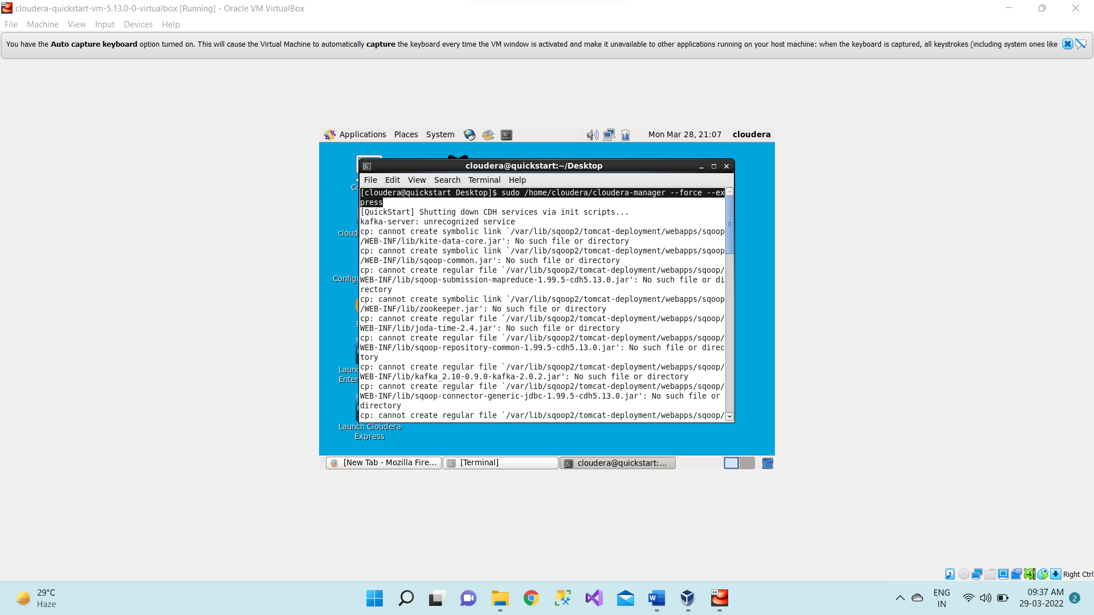

1. **Start all services**

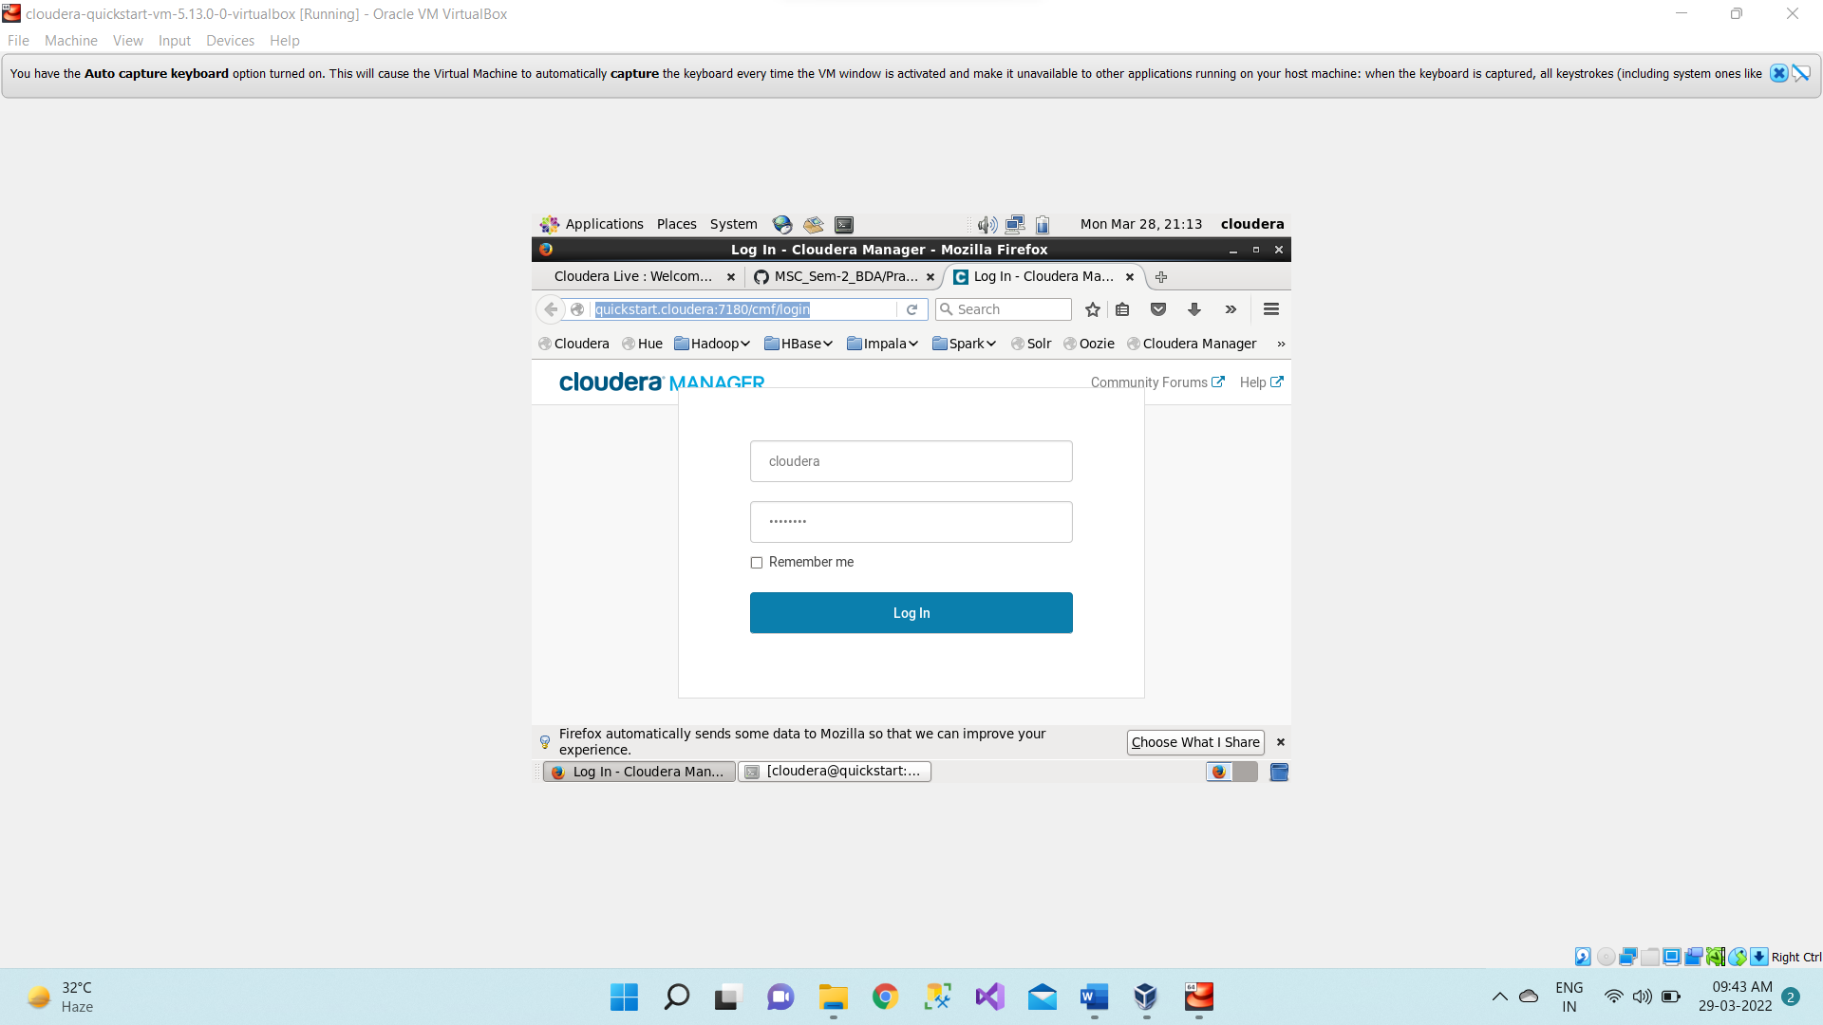

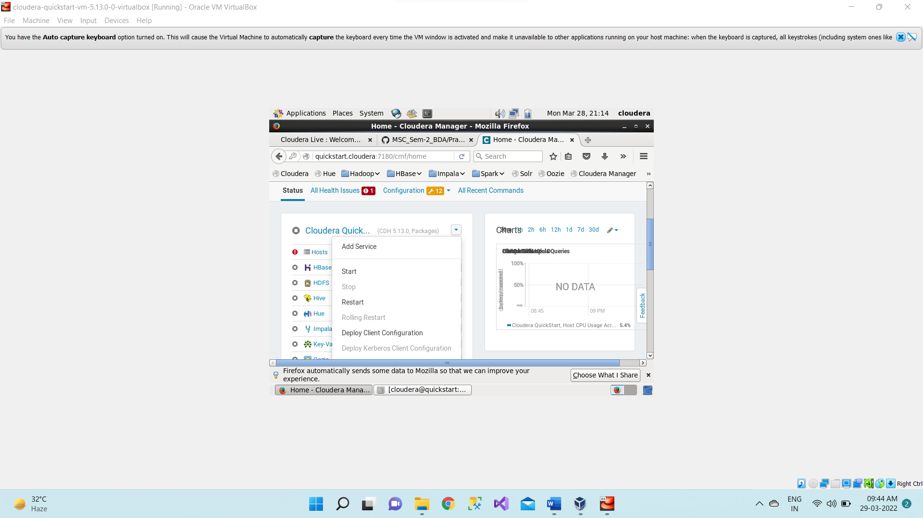

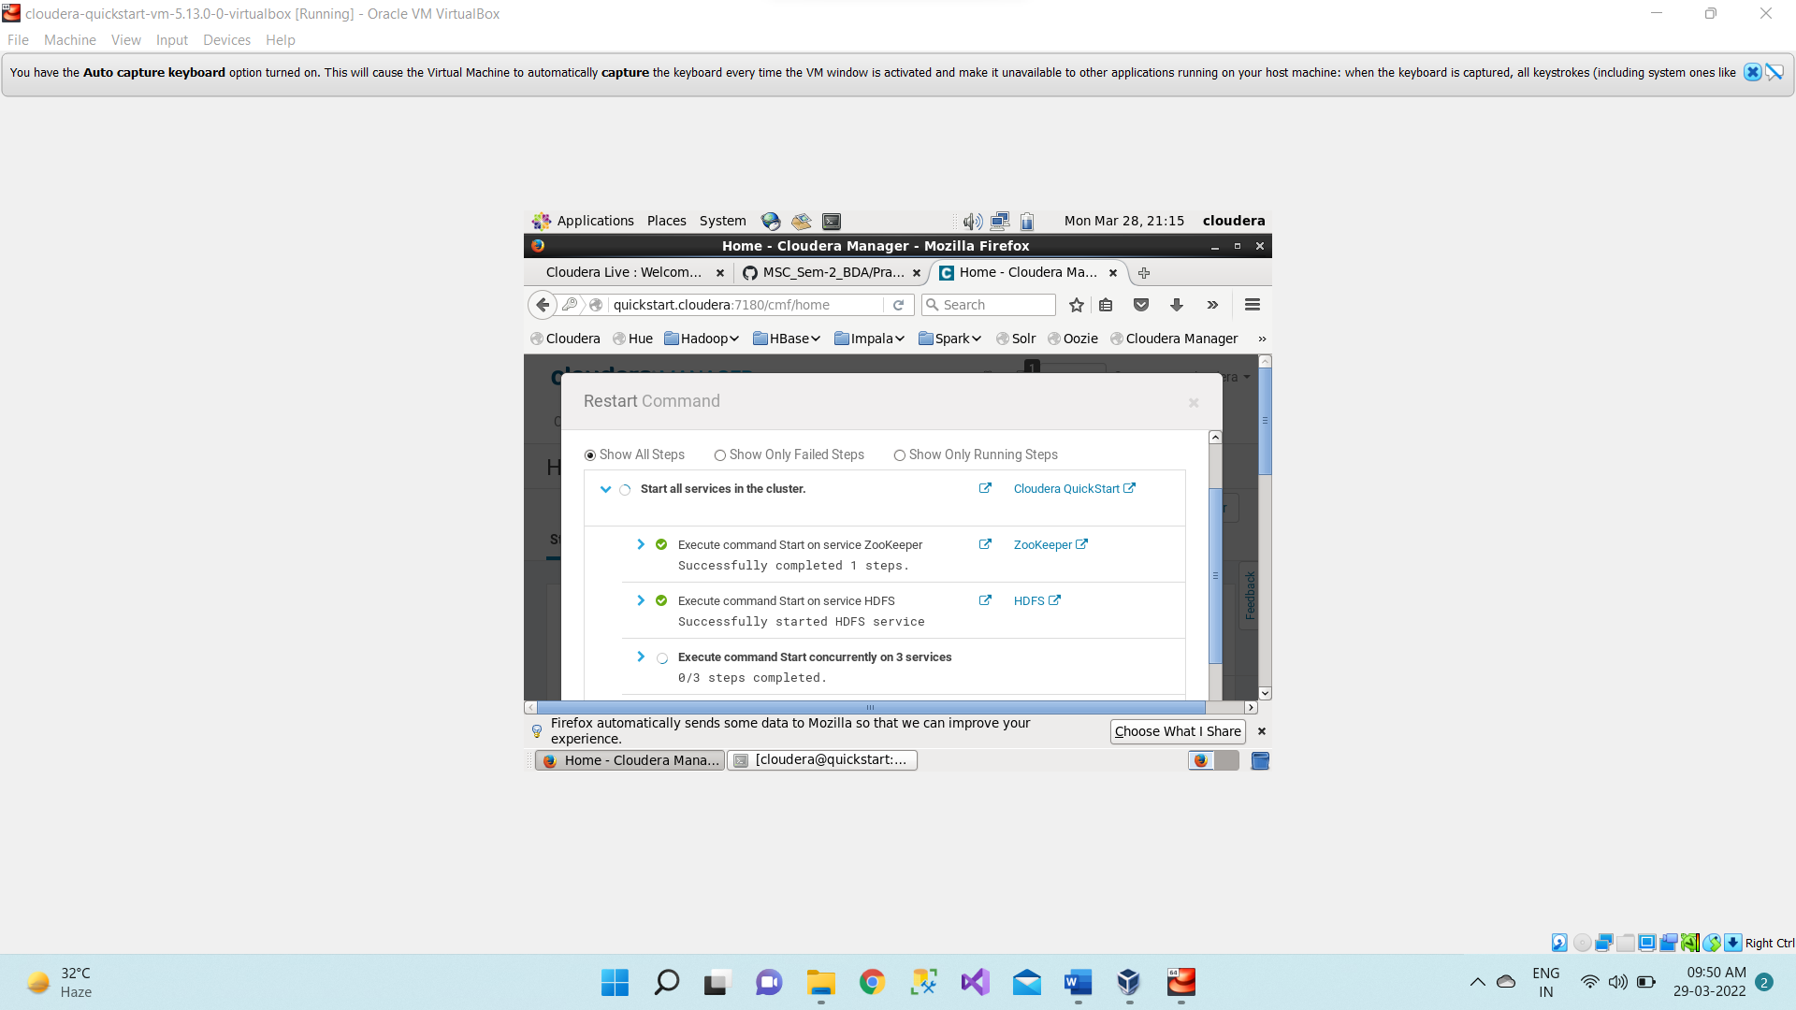

1. **sudo -u hdfs hadoop dfsadmin -safemode leave**

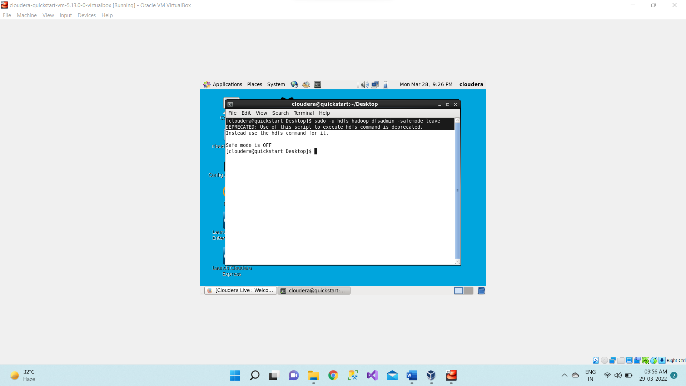

1. Open the terminal, now we use hive command to enter the hive shell prompt and in hive shell we could execute all of the hive commands.

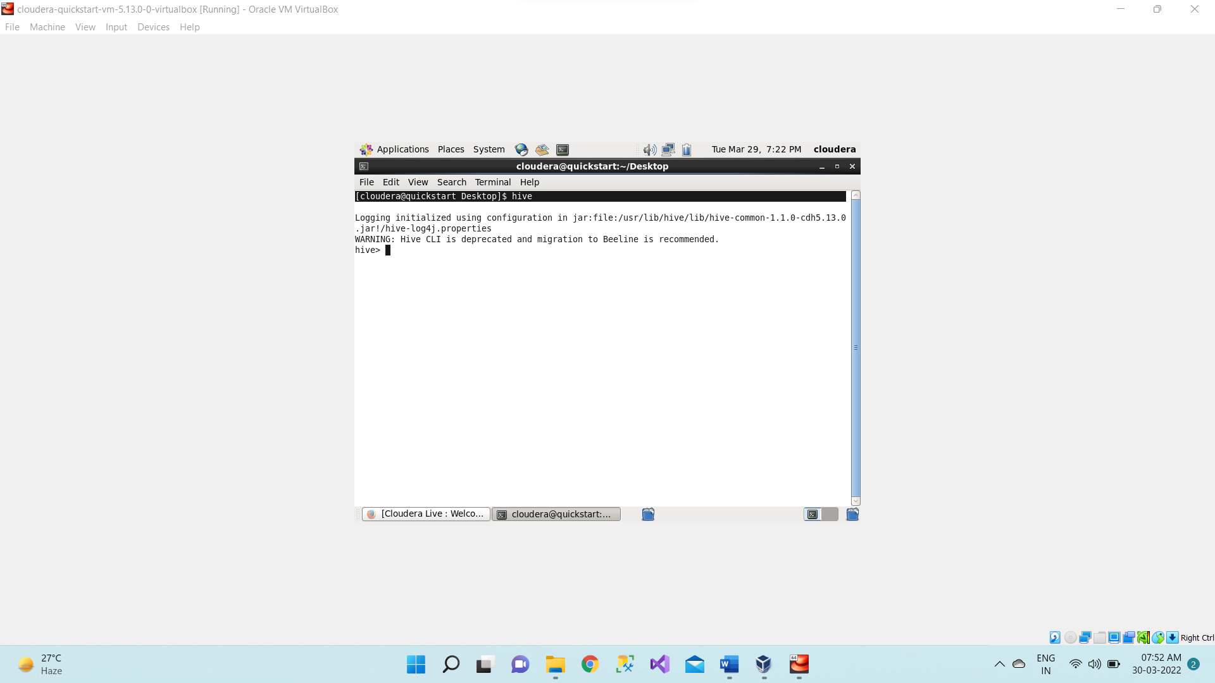

1. Now we will see the databases which are already existing using below command.

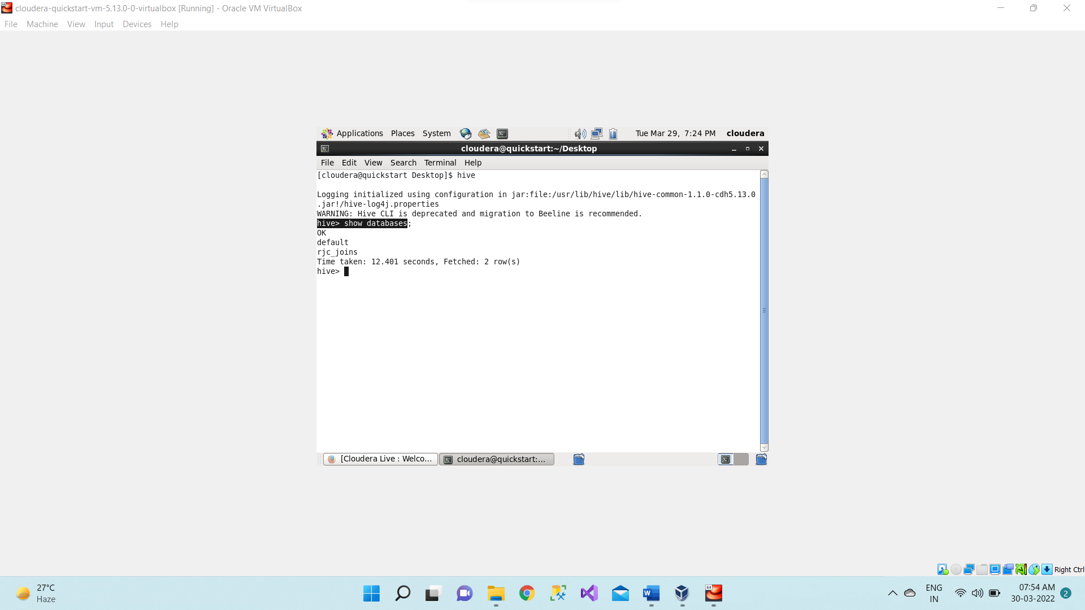

**Note:** If remove database already present in hive then drop database <database_name> cascade;

1. Creating a database name ‘**RJC21’** using below command.

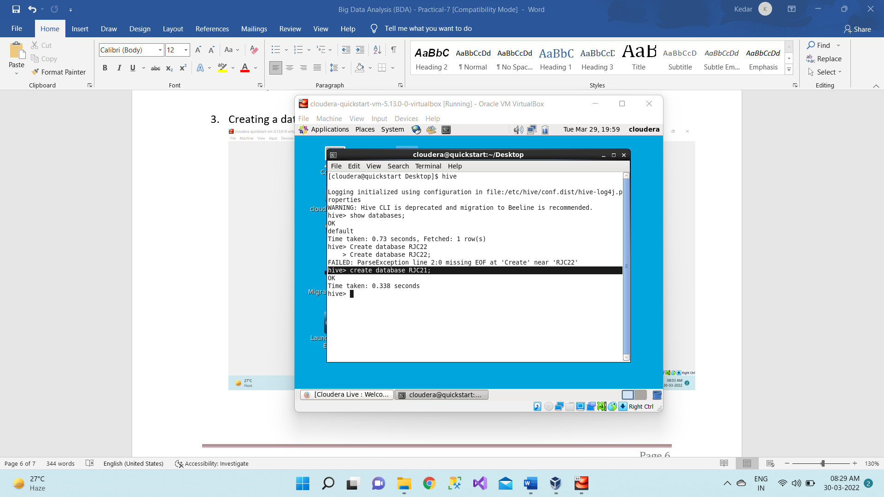

1. So, if we want to see whether this RJC database is created or not we will use below command.

**show databases;**

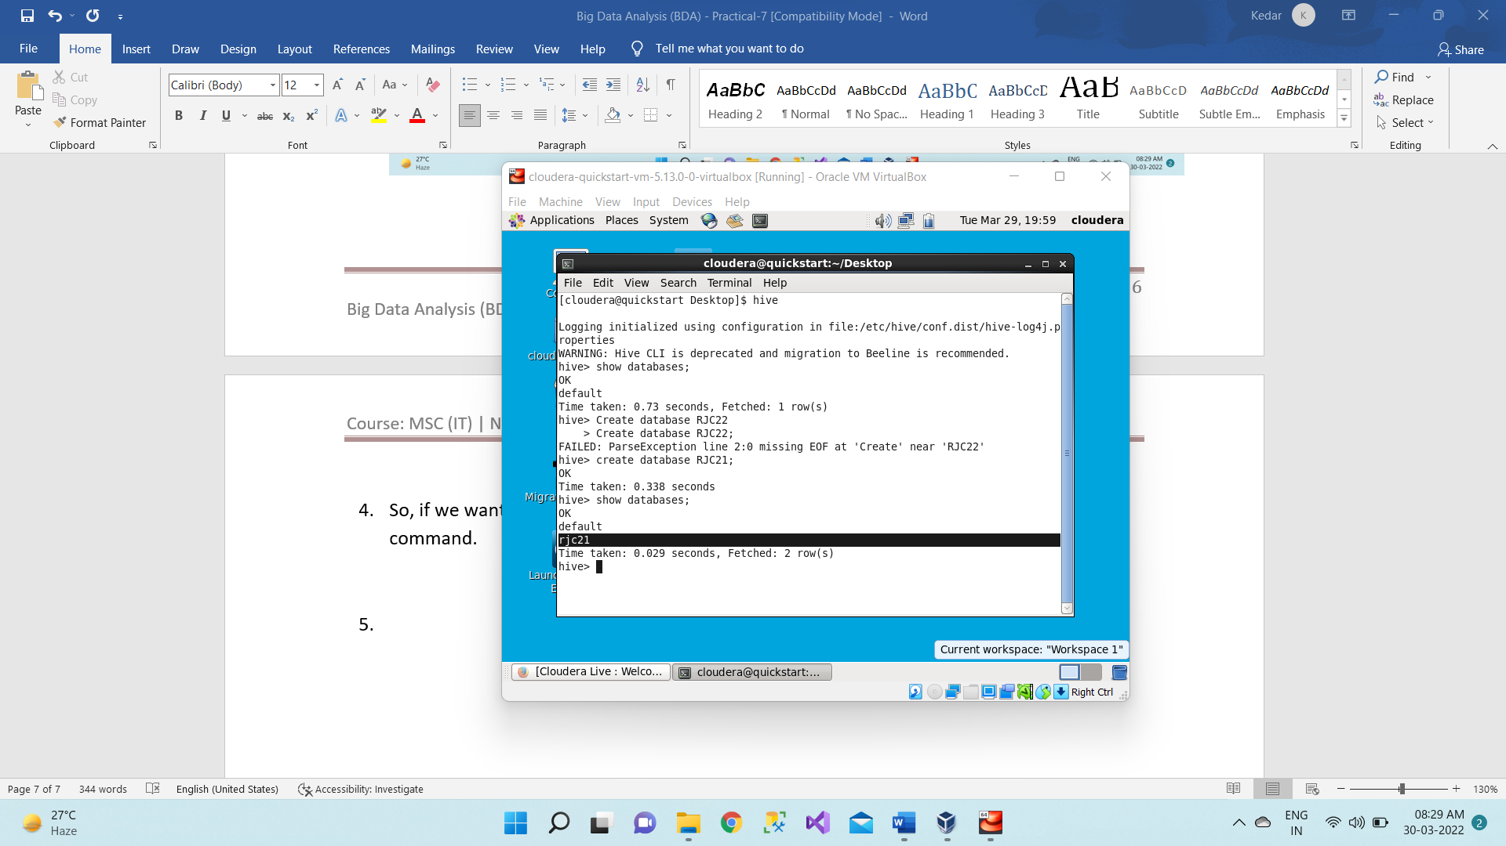

1. Now we want to check whether we have any tables inside this rjc21 database or not. So first we will move to this database rjc21 using below command.

**Use rjc21;**

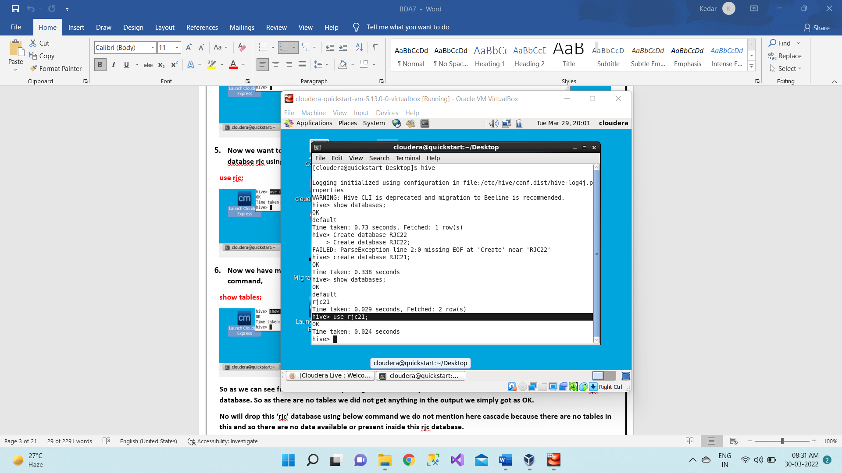

1. Now we have moved inside this rjc database. Now we will check out which are the tables available using below command.

Show tables;

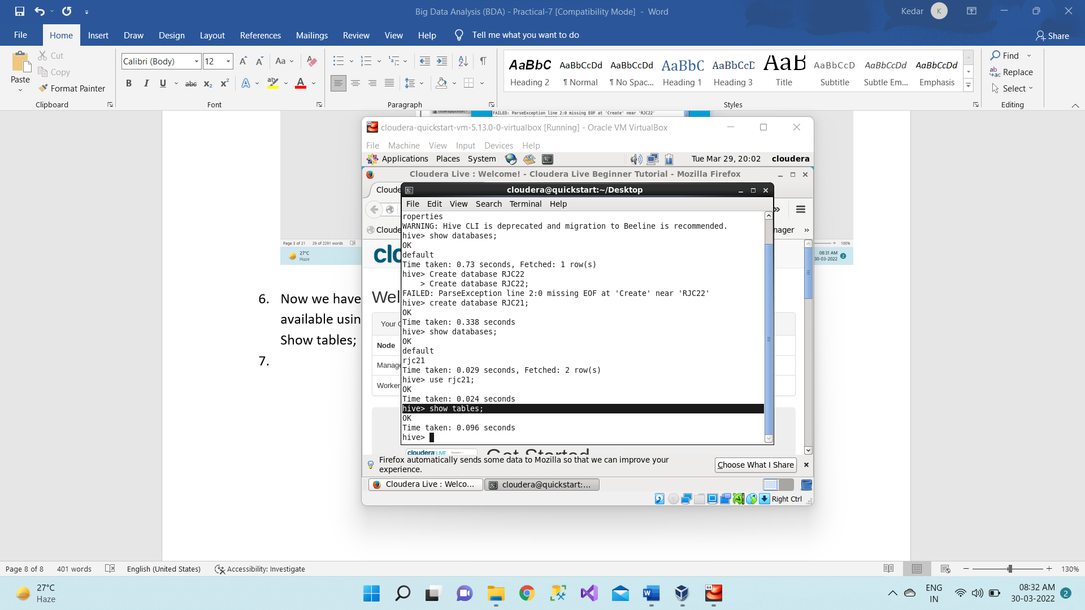

So, as we can see from the above output it gives us OK as output because there are no tables created inside this **rjc21** database. So as there are no tables, we did not get anything in the output we simply got as OK.

No will drop this ‘**rjc21**’ database using below command we do not mention here cascade because there are no tables in this and so there are no data available or present inside this **rjc21** database.

drop database **rjc21**;

and to check whether the data base dropped or not using below command,

show databases;

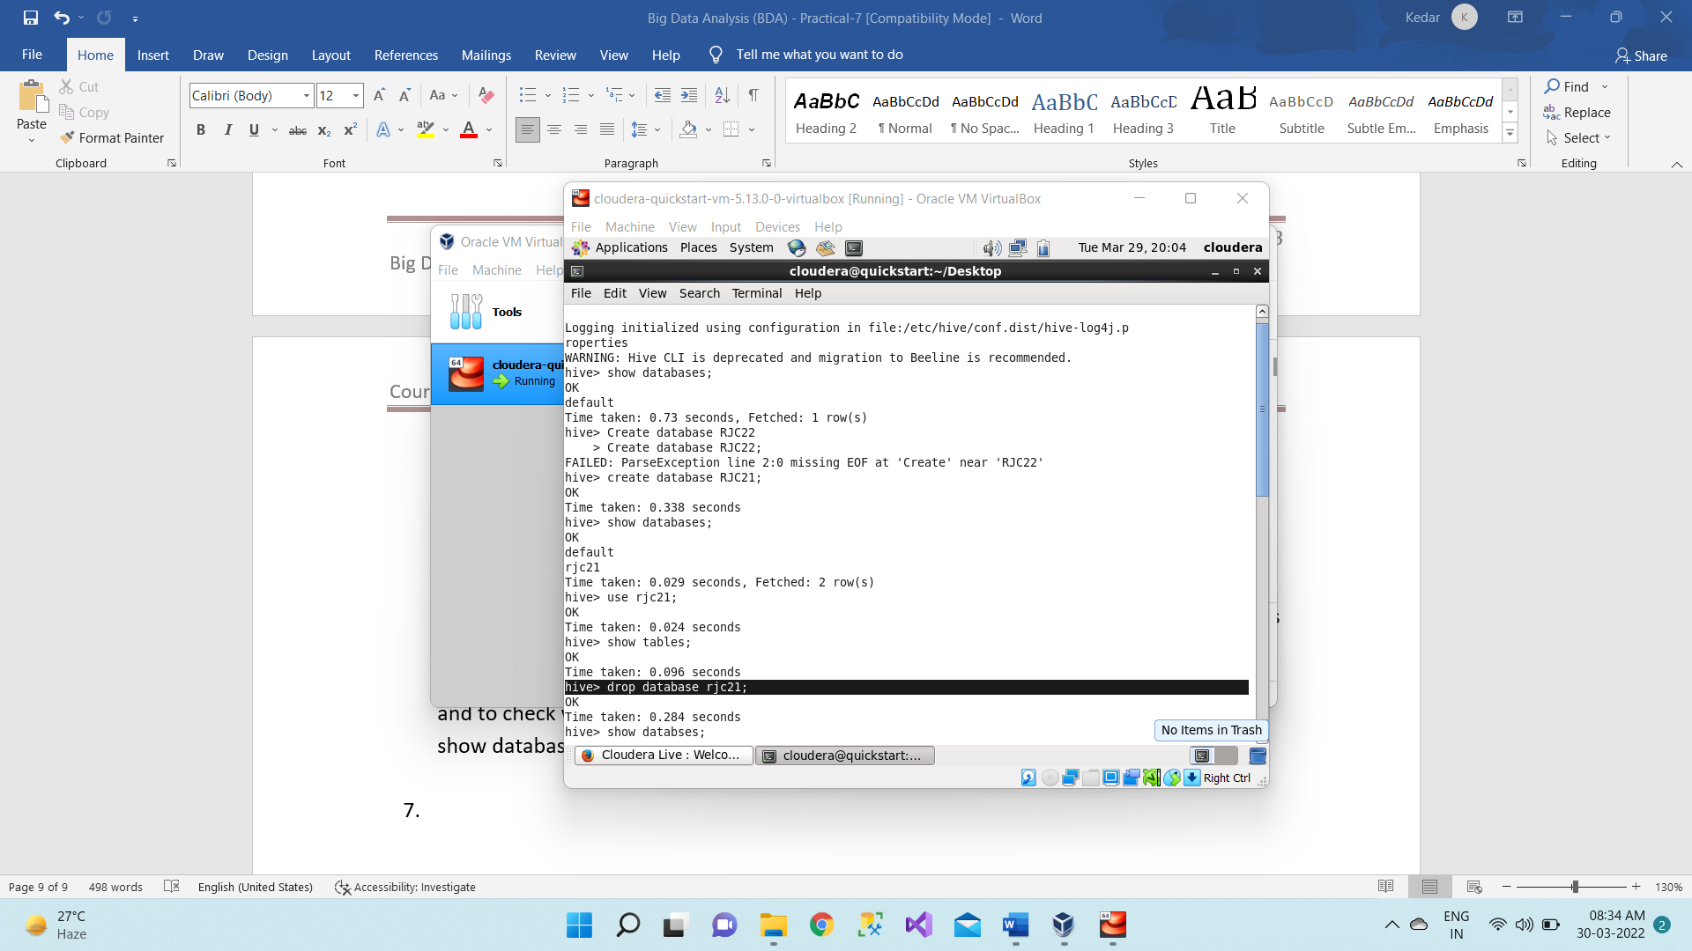

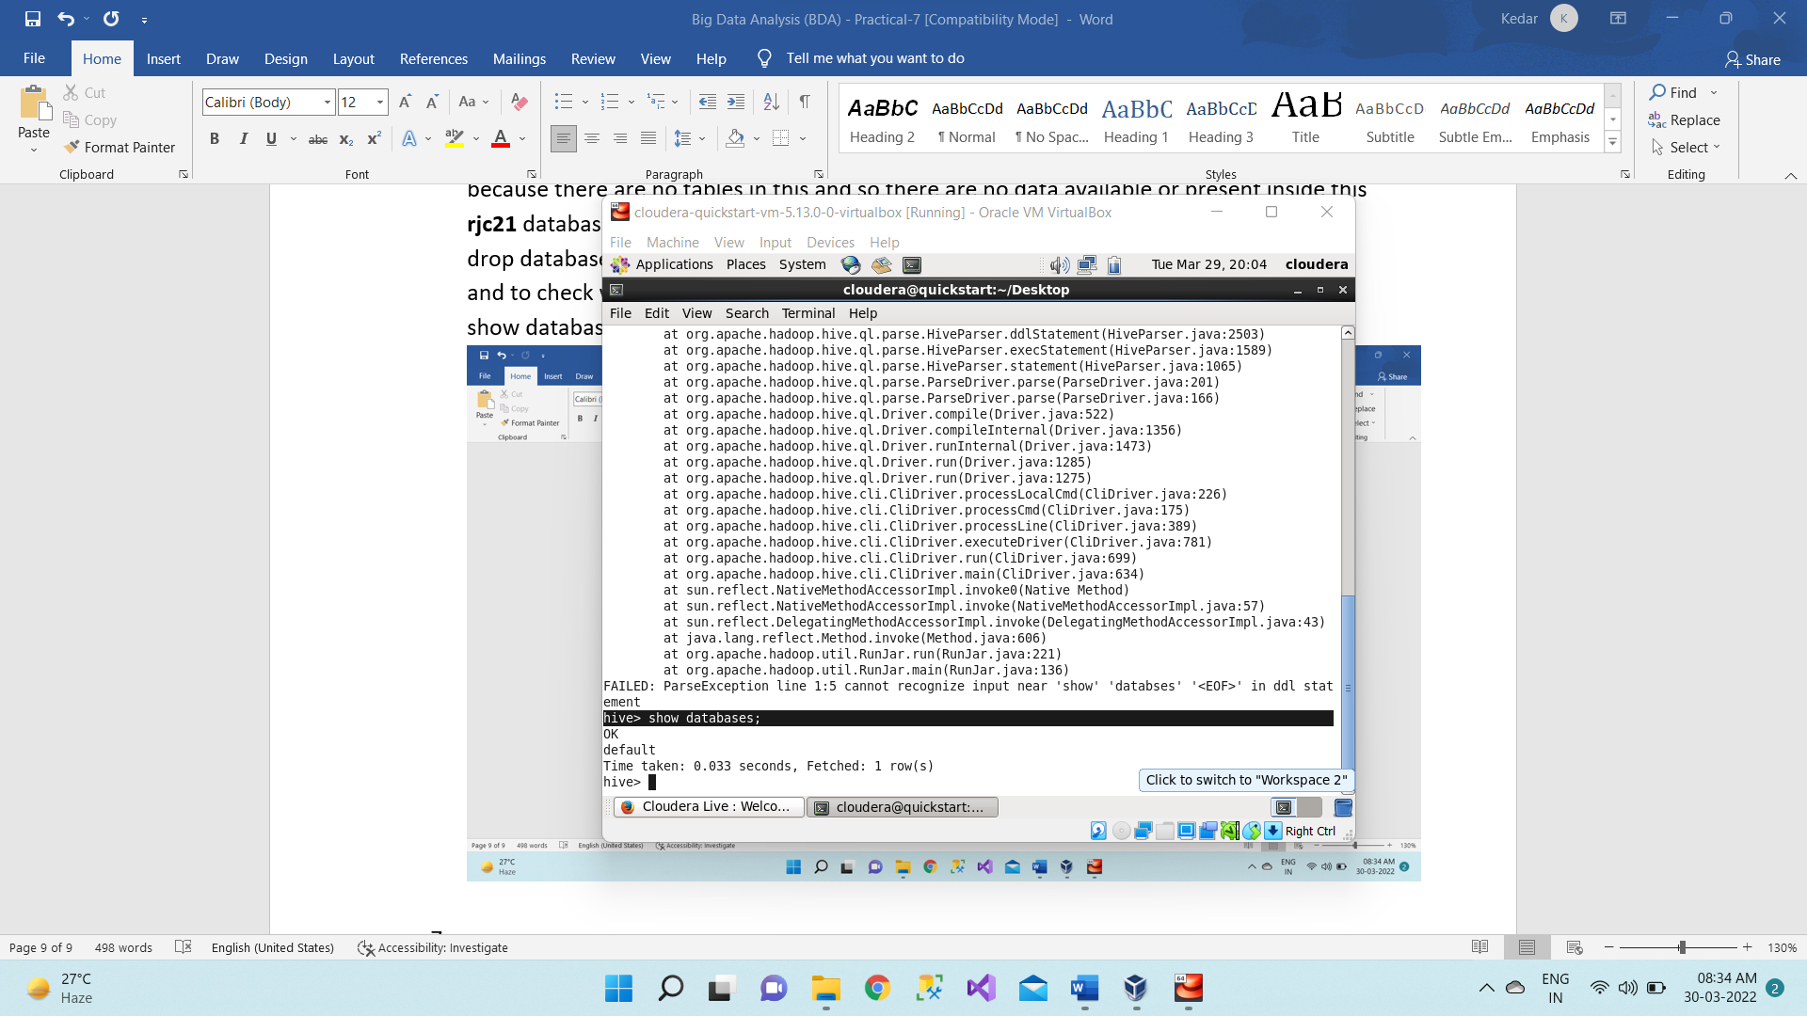

1. Creating a database “rjc21”.

**create database rjc21;**

Now let’s move to this database using below command so now all the work we will do or

perform it should be done within this rjc21 database.

**use rjc21;**

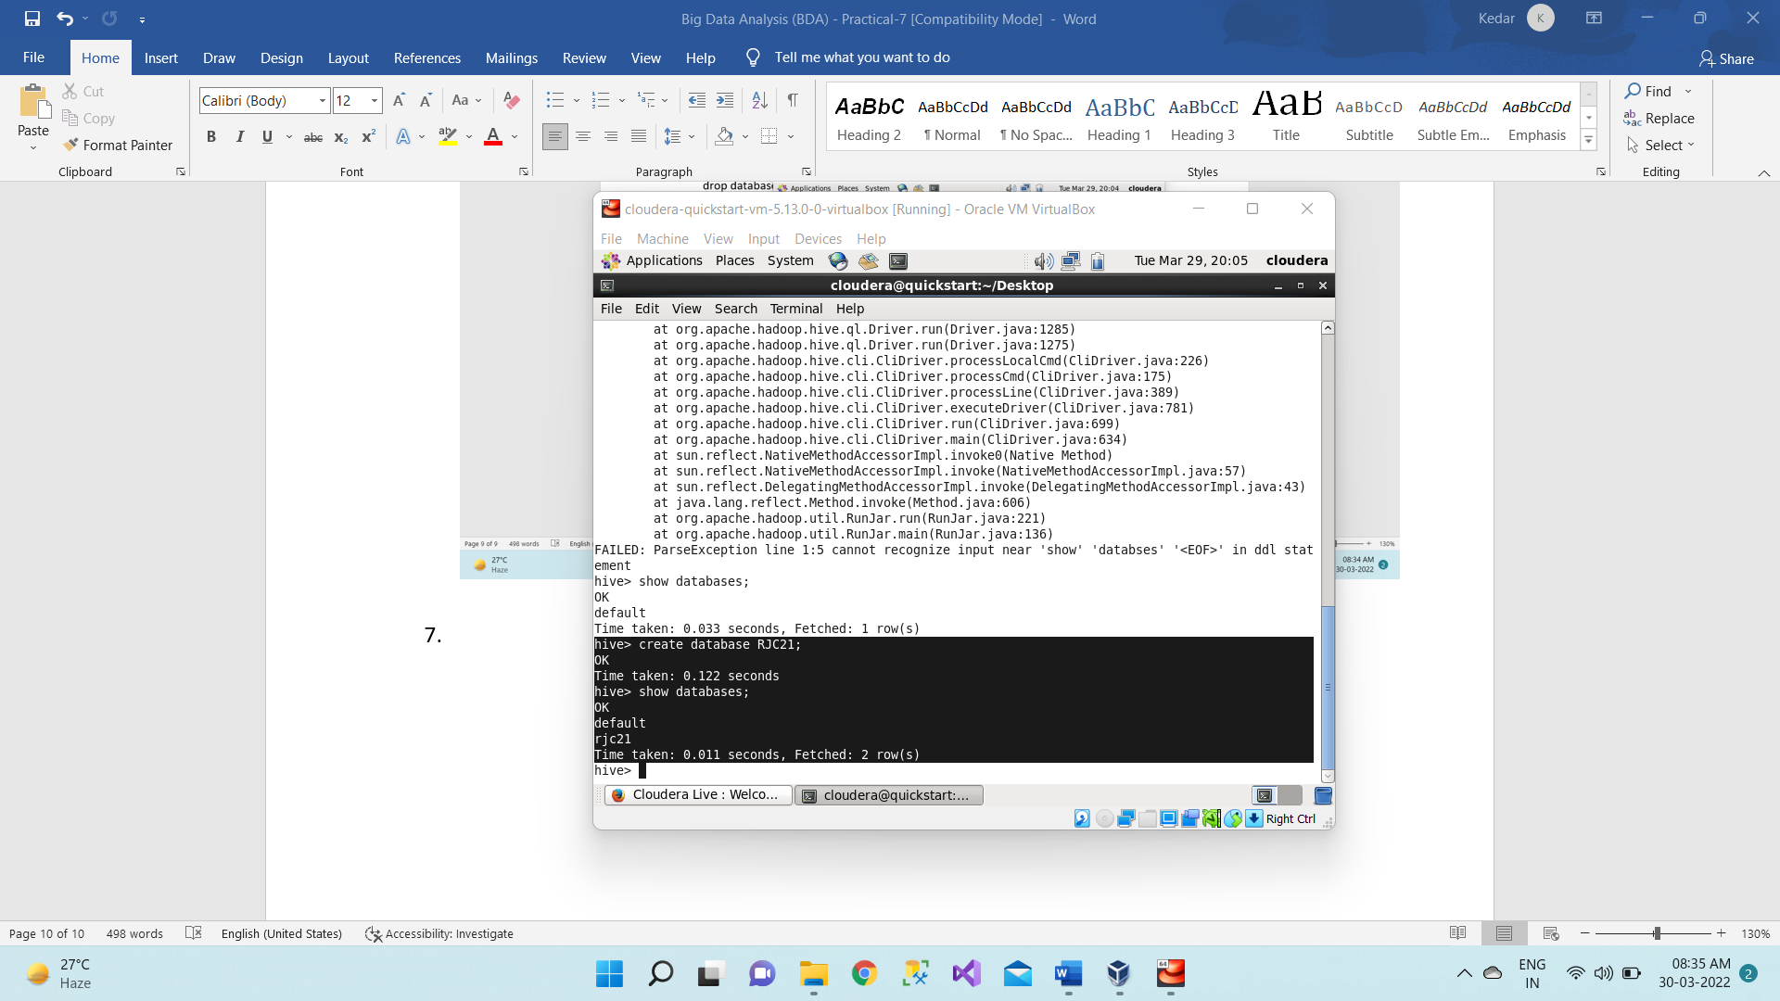

1. Now we will create a table inside this rjc21 database named as employee using below command,

**create table employee (ID int, name string, salary float, age int)**

Note: After this we will not put semicolon, when we will be loading the data from some existing csv file or maybe some other text files so we have to mention that how that data has to be loaded here. We are simply creating the schema of the table with some certain fields or attributes along with their datatypes and then I’m mentioning

**row format delimited**

**fields terminated by ',';**

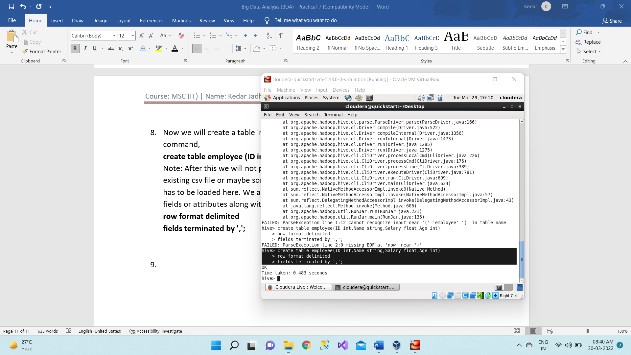

1. So now we will see the schema of the table using below command,

**describe employee;**

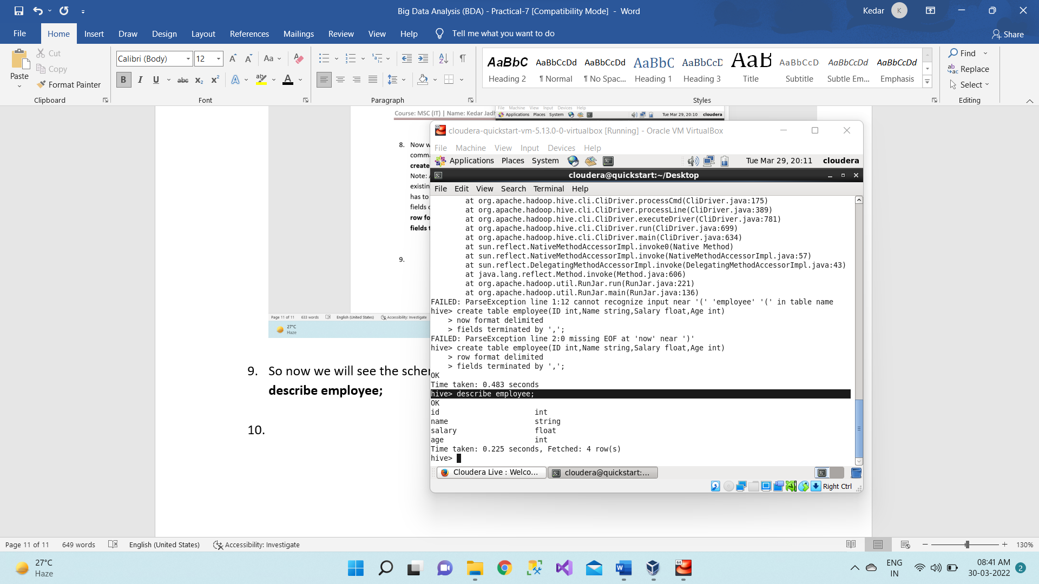

1. By default, the internal table would store in the warehouse directory of hive. Whereas the external tables are available in the hdfs. And if we drop the internal table so then the table data and the metadata associated with that table will be deleted from the hdfs. Whereas when we drop the external table then only the metadata associated with that table will be deleted whereas the table data will be untouched by hive as it would be residing in the hdfs and it would be outside the warehouse directory of the hive. So Now we will check how the table which we will be created is internal table or external table using below command,

**describe formatted employee;**

By default, hive creates Internal table or Managed Table.

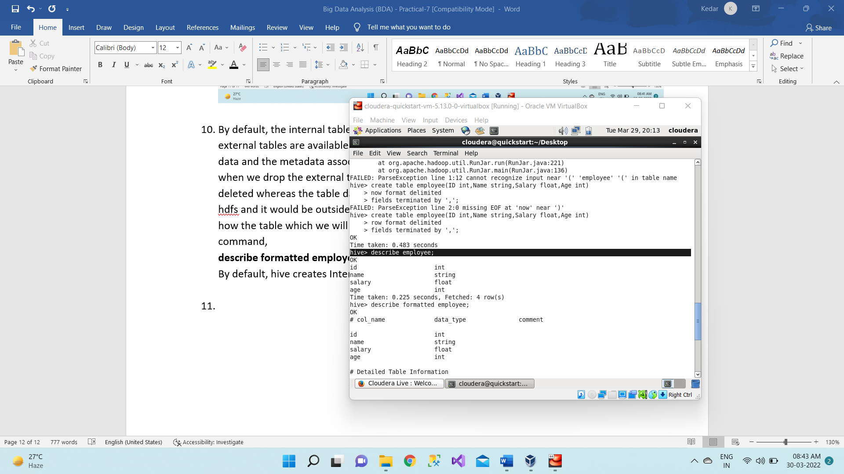

1. Now we will create the external table using below command,

Note: external

Do this

**create external table employee_2(ID int, name string, salary float, age int)**

**row format delimited**

**fields terminated by ','**

**stored as textfile;**

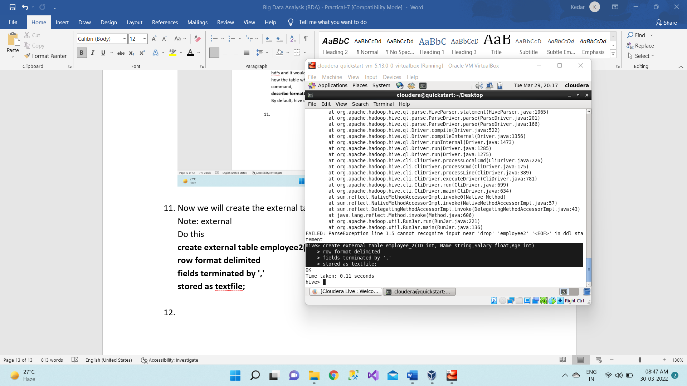

**Don’t this**

create table employee2(ID int, name string, salary float, age int)

row format delimited

fields terminated by ','

stored as textfile;

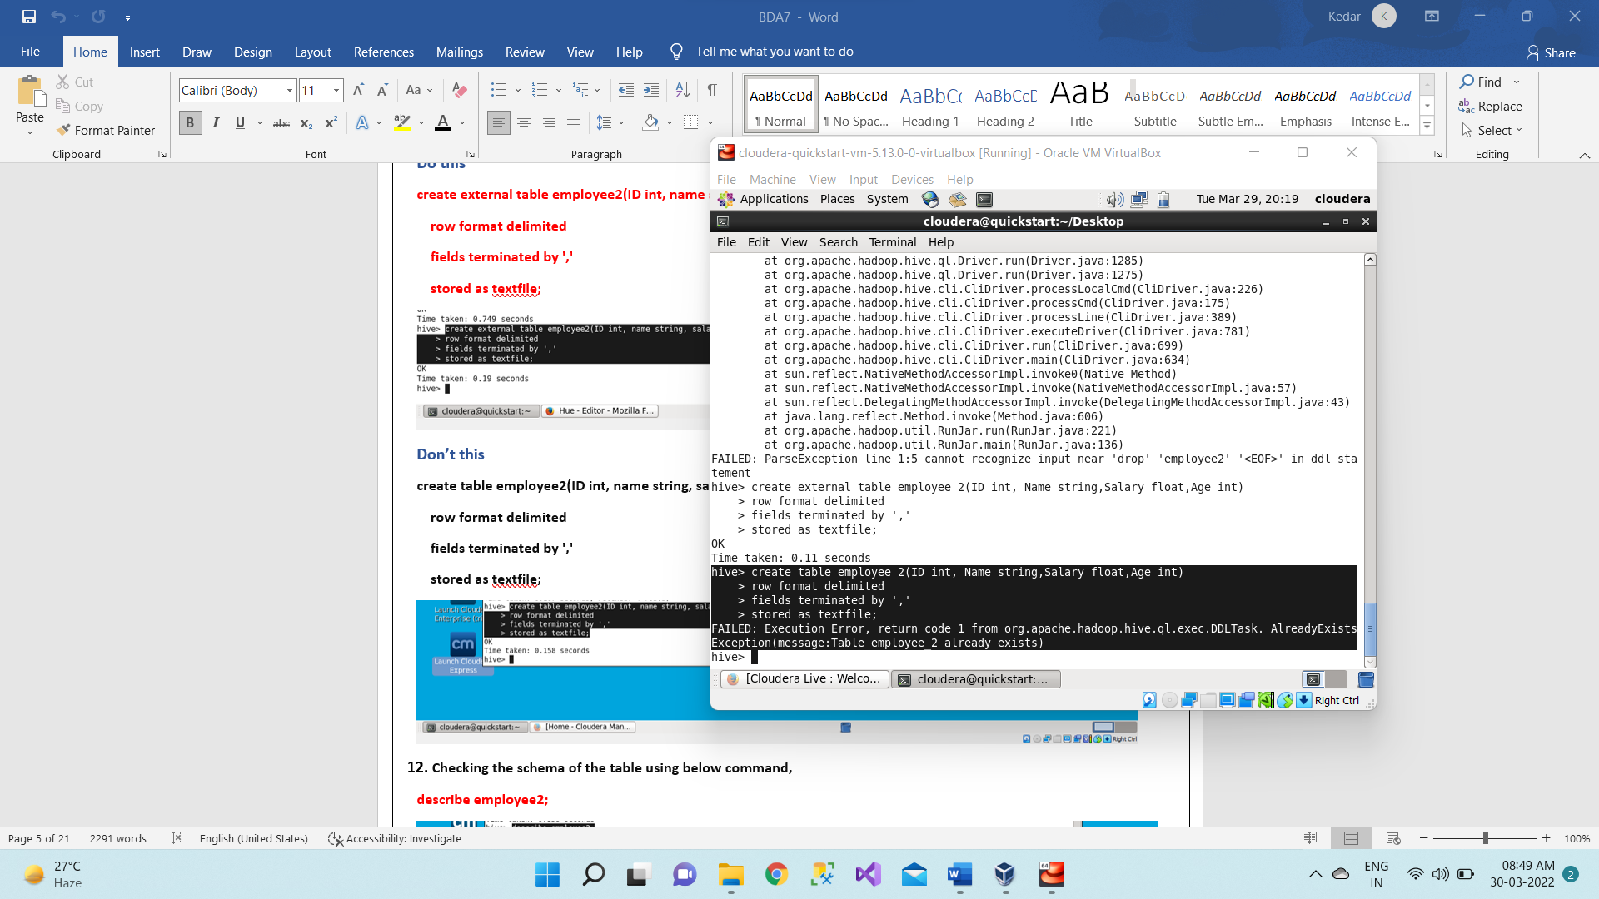

1. Checking the schema of the table using below command,

**describe employee2;**

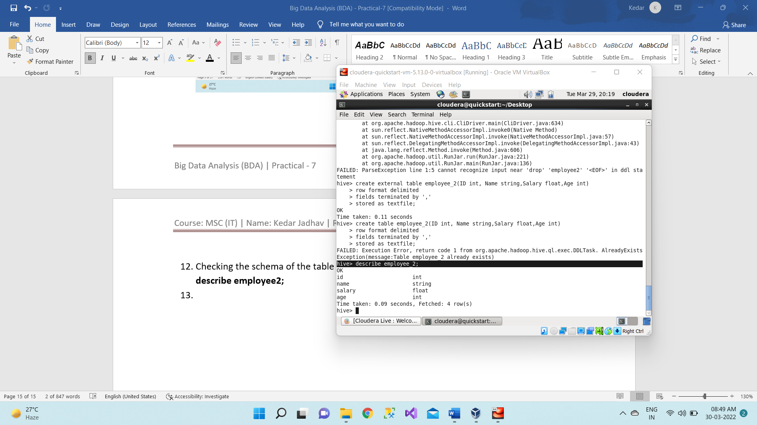

1. So now we will check how the table which we will be created is internal table or external table using below command,

**describe formatted employee2;**

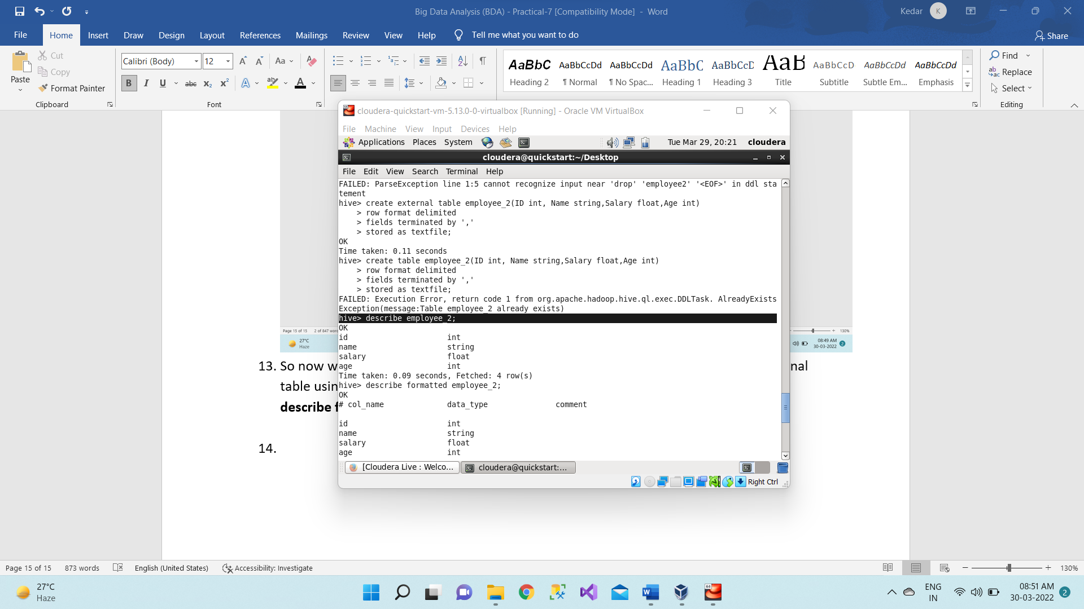 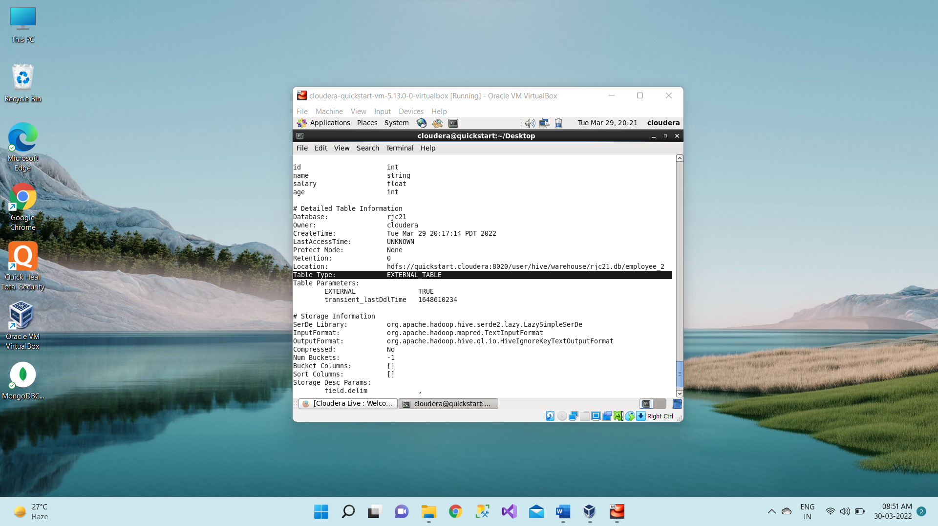

1. So, whatever we have done in terminal the same thing we can see in the browser as well.

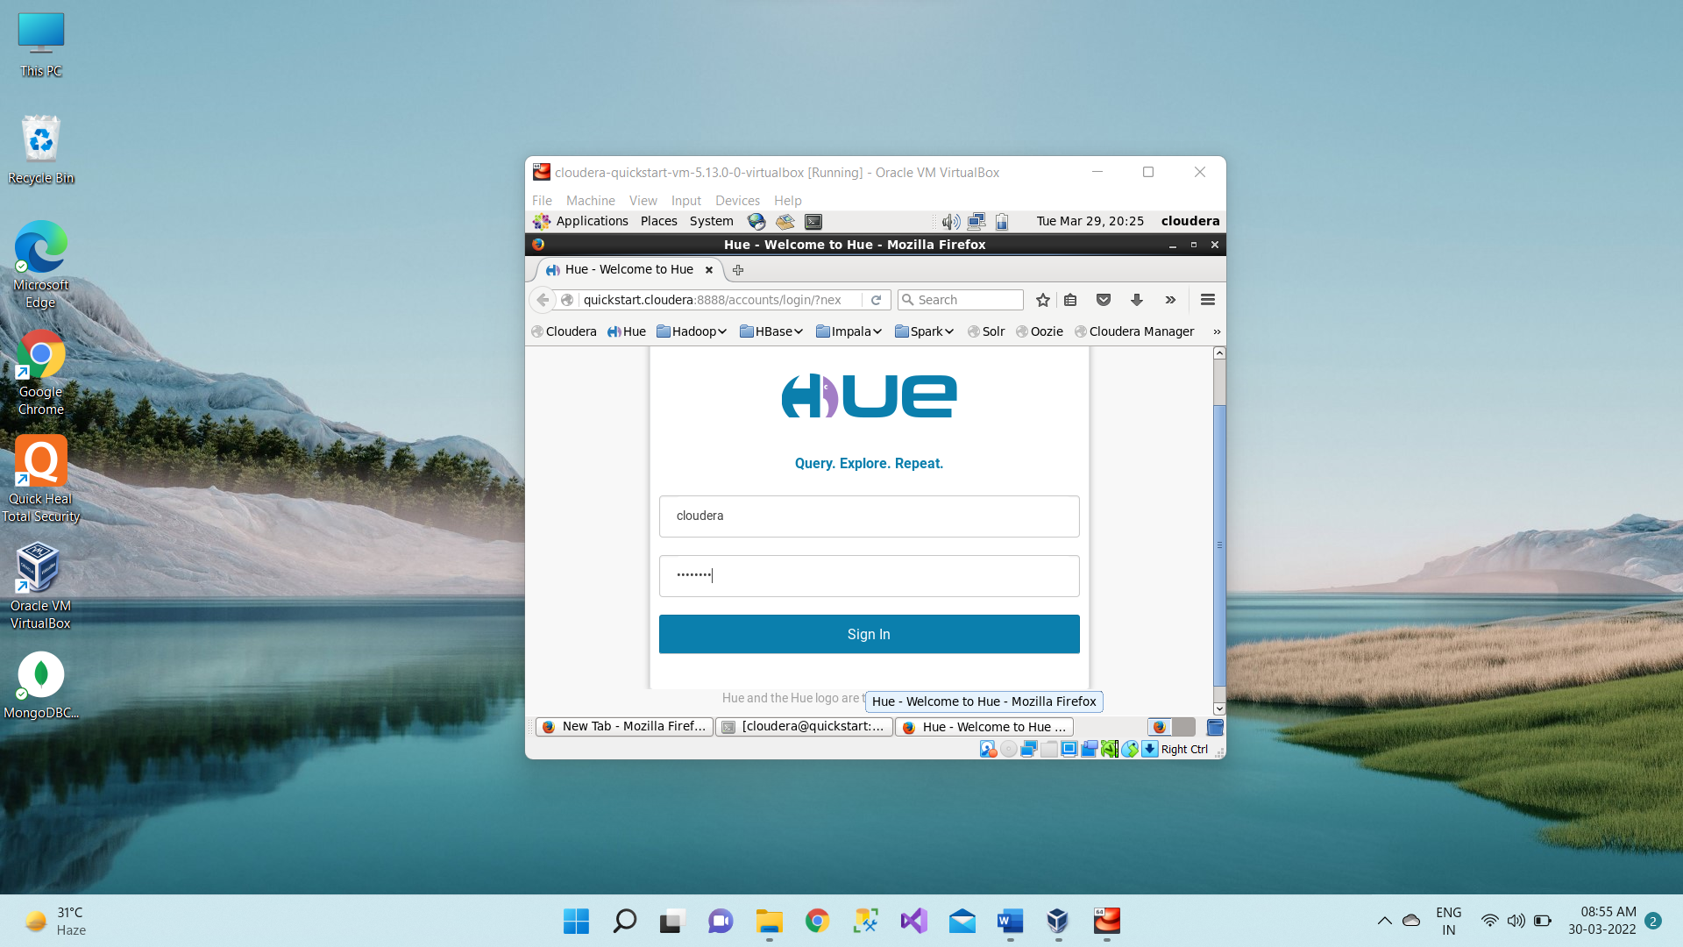

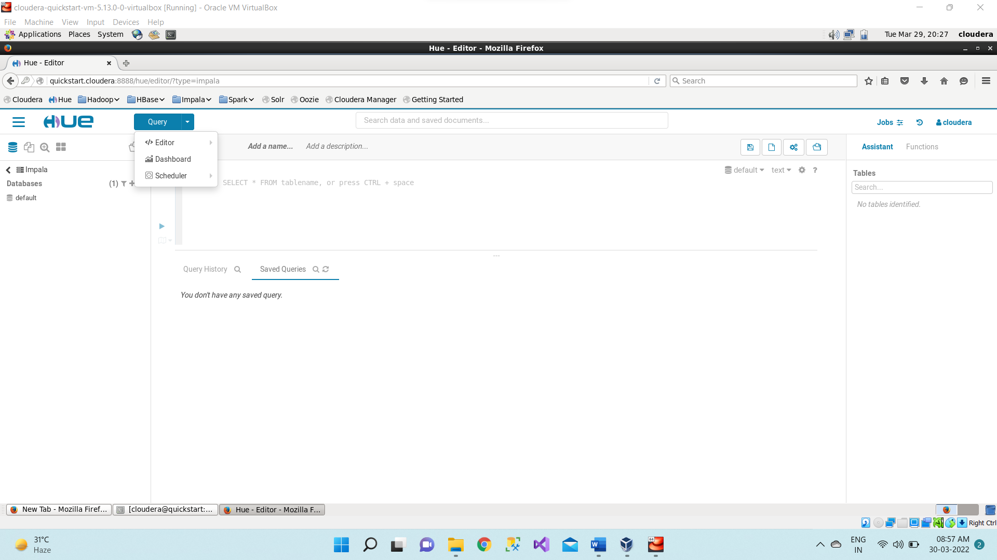

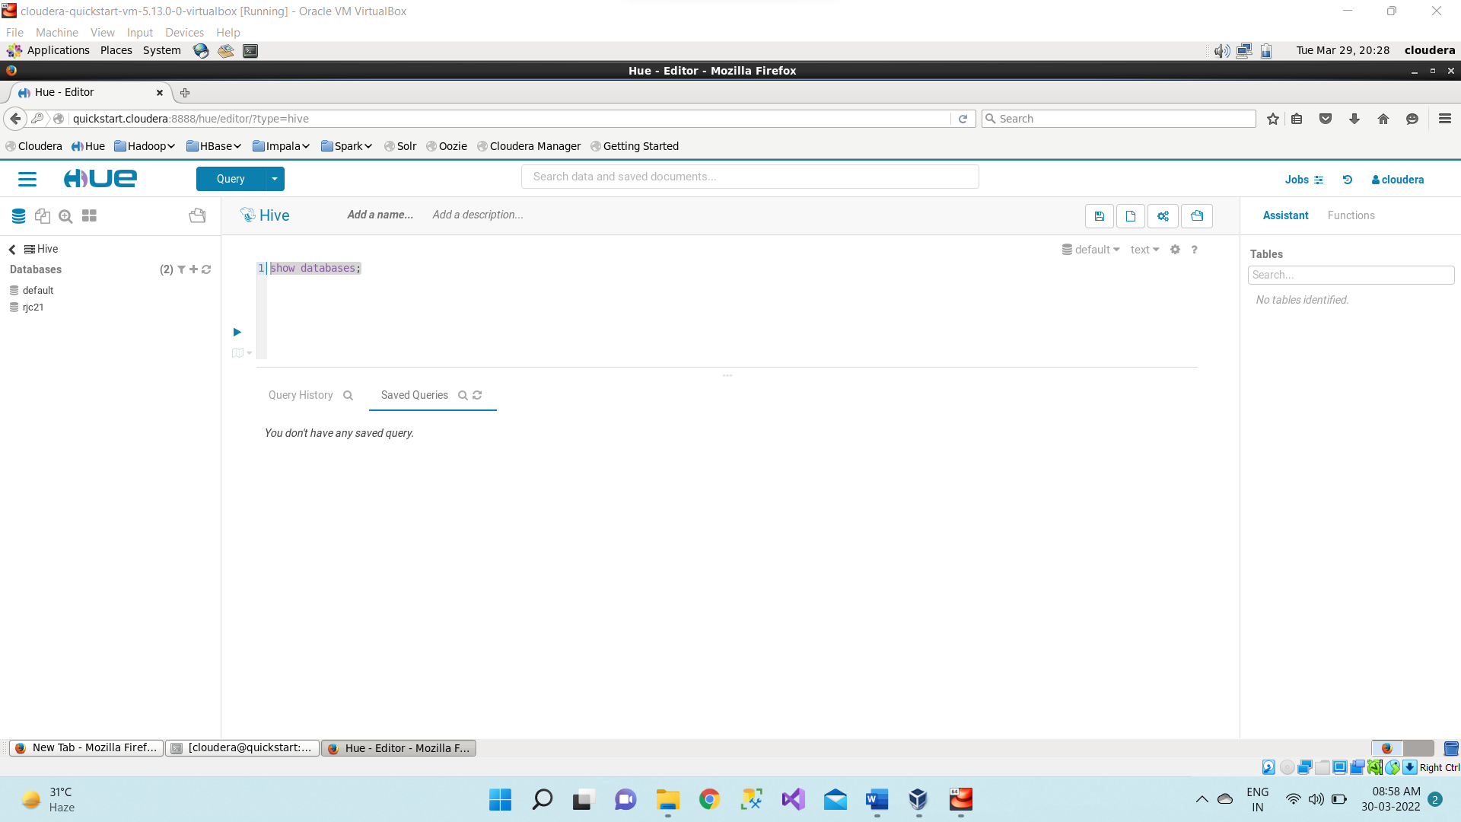 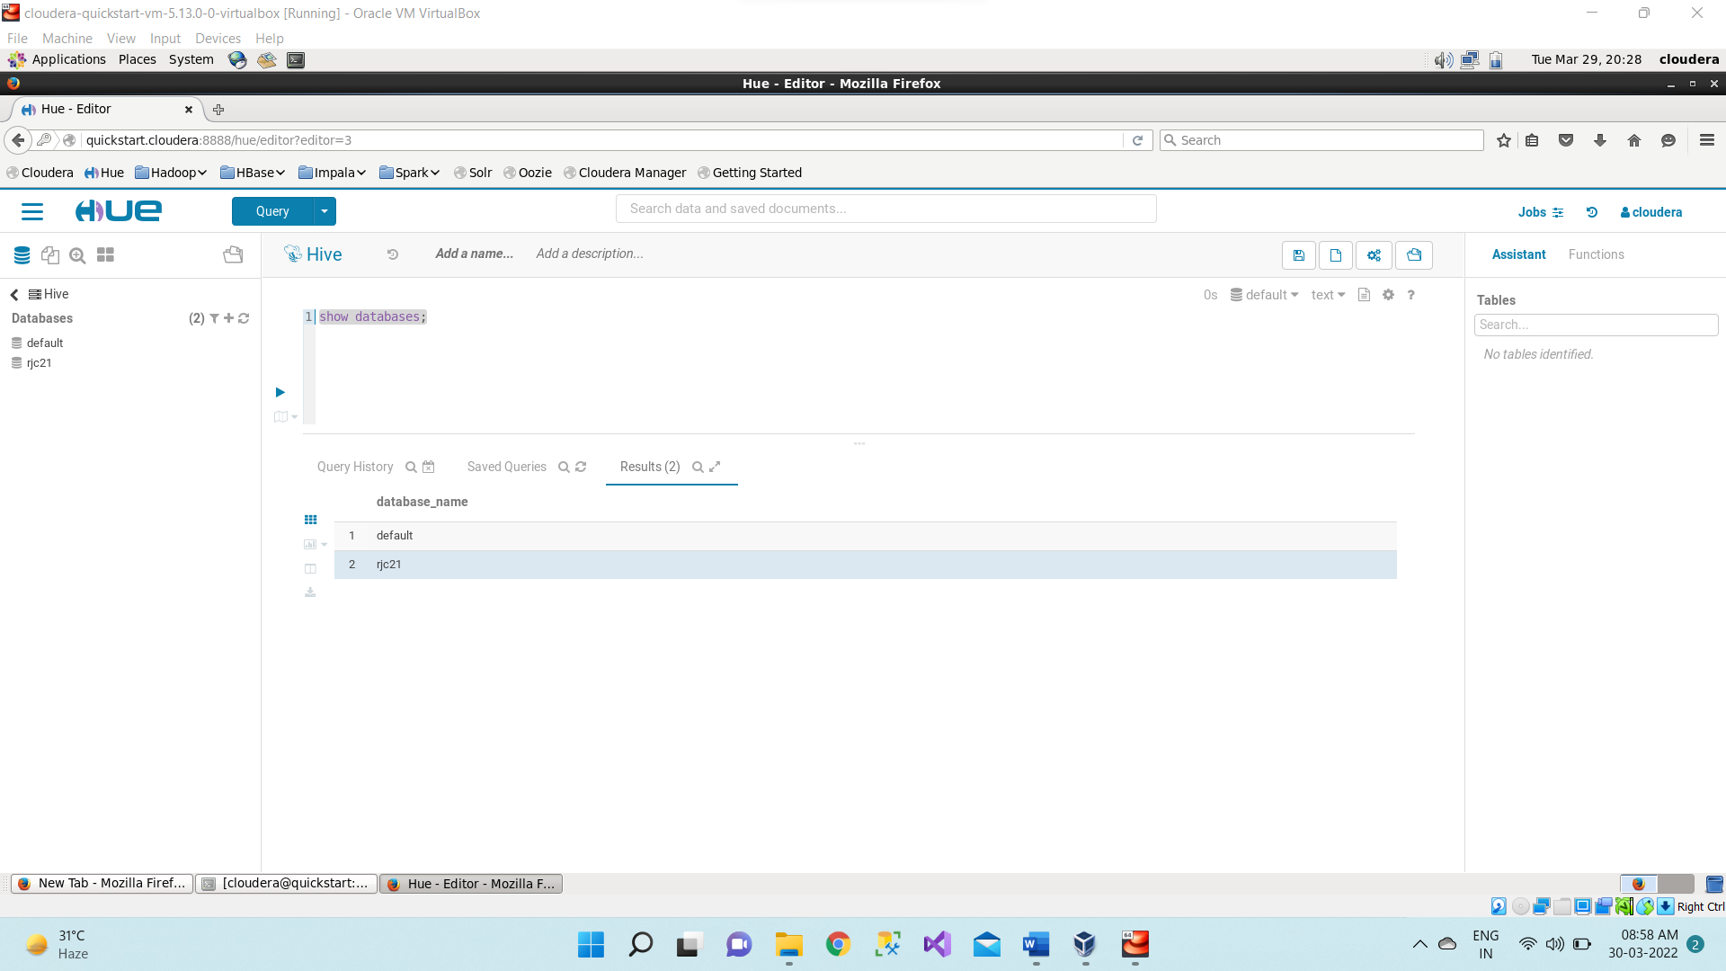

There are only two databases present i.e. default and rjc which we created earlier. We can also see the list of databases in left side corner. And after clicking on the database name here it is “rjc21” it will give the list of all tables present inside “rjc” database.

**Click on the rjc21 database**

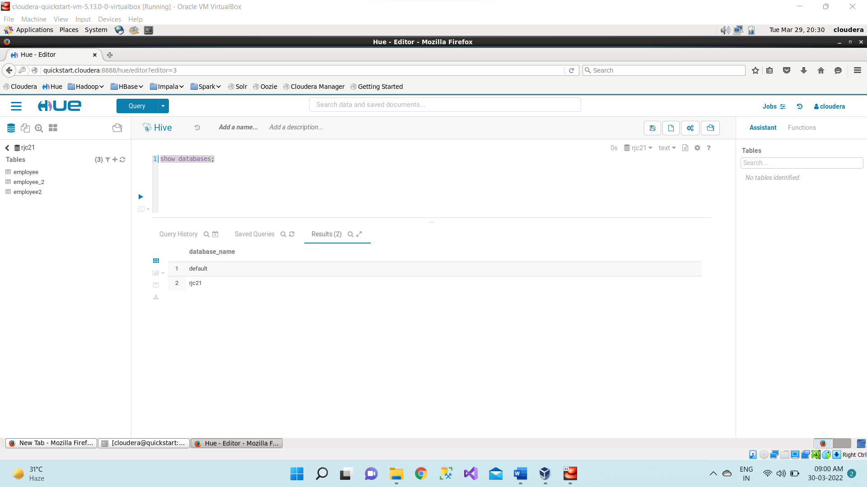

We can also Preview the sample data. Here it is showing blank because we have not inserted anything or data inside this employee table.

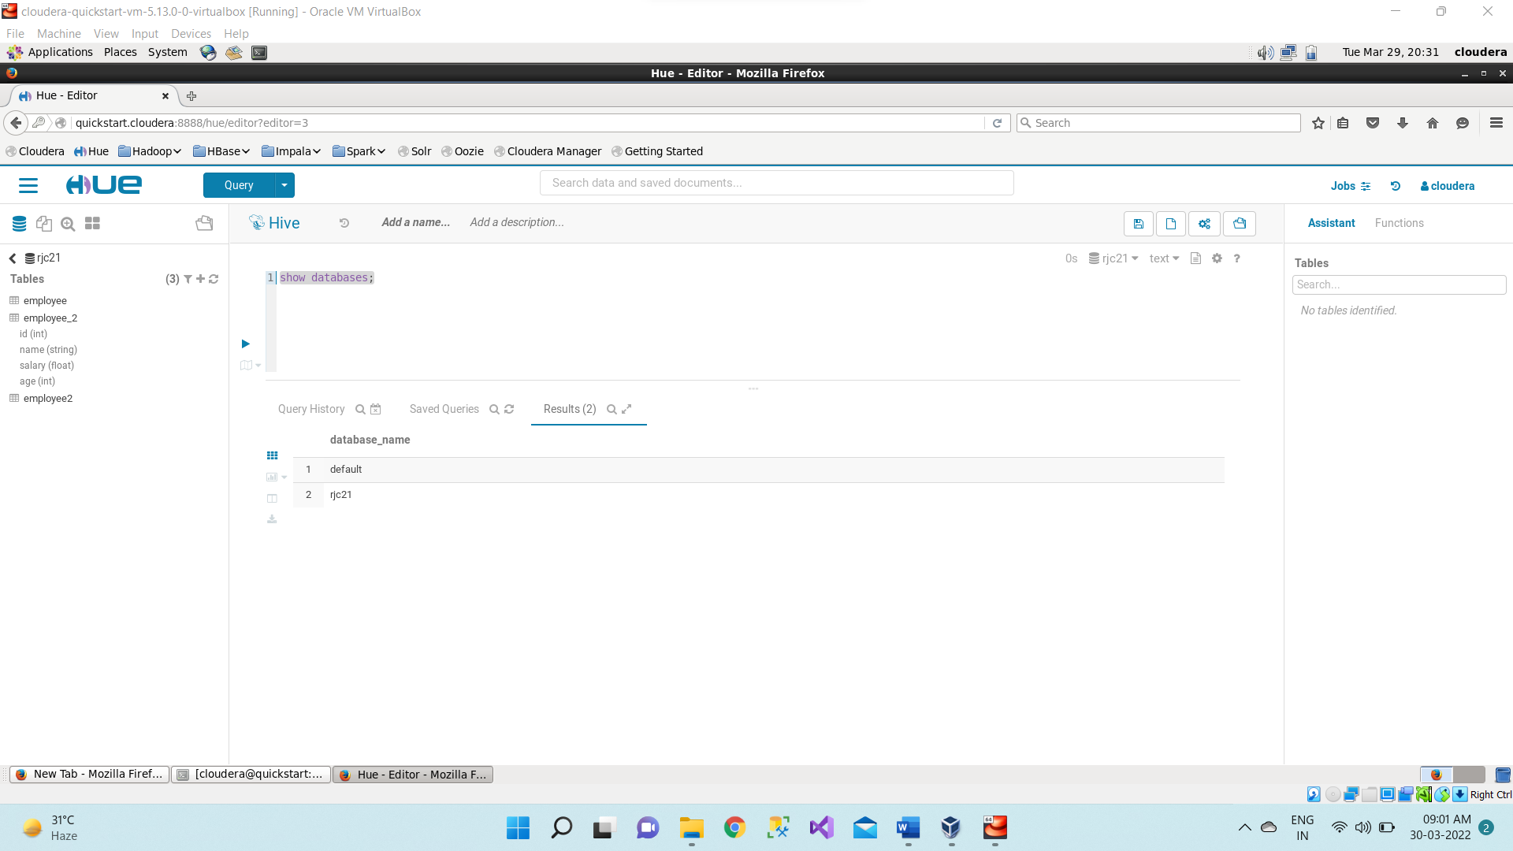

When we click on employee table it will give the fields of employee table.

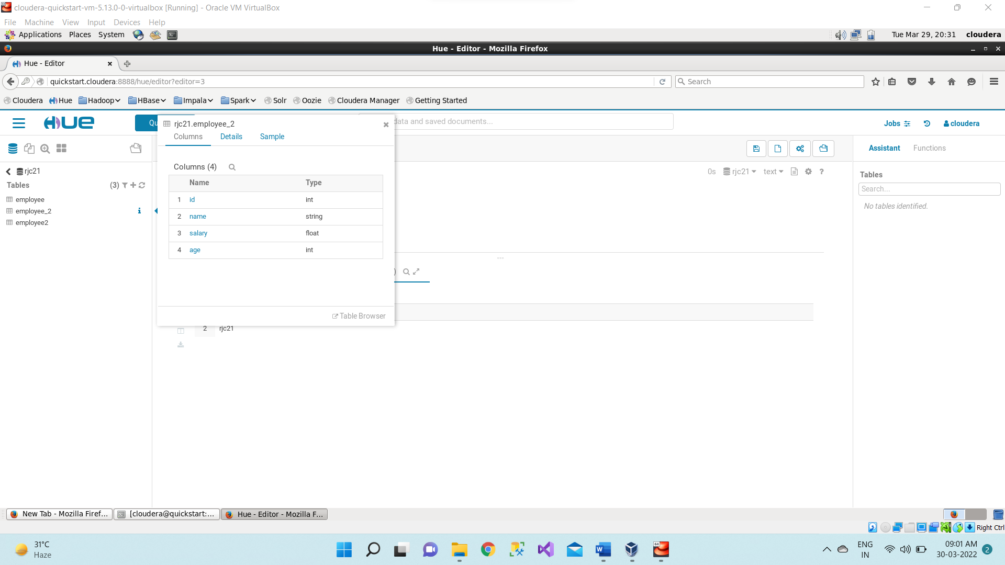

Above if not created external table then first drop the table

**drop table employee_2;**

If view the properties describe command give the properties of employee2 table.

**describe formatted employee_2;**

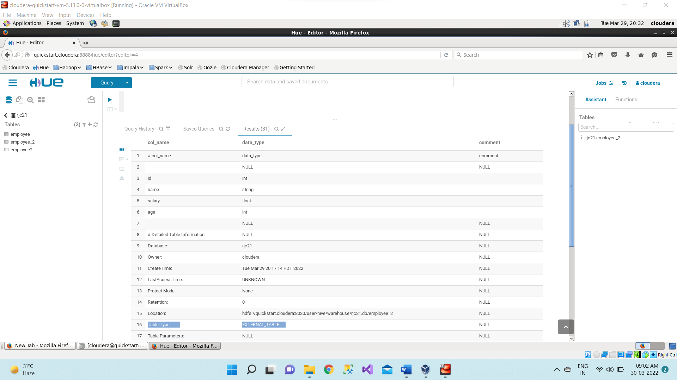

1. Creating a new external table named as employee3 in the specific location using below command,

create external table employee3(ID int, name string, salary float, age int)

row format delimited

fields terminated by ','

location '/user/cloudera/vj';

It will first create 'vj' directory inside the /user/cloudera and then inside 'vj' the employee3 table get stored.

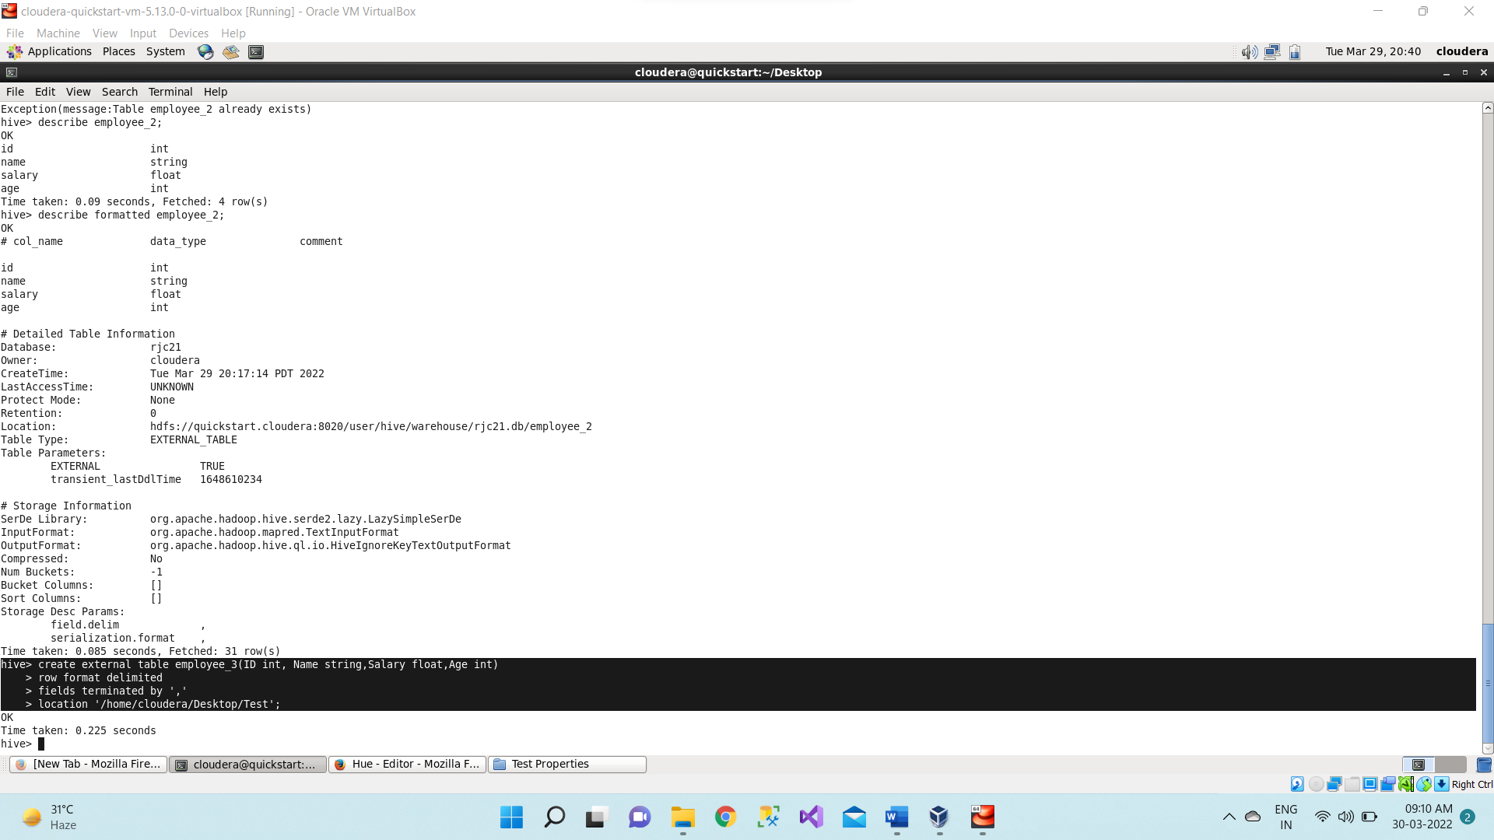

1. To see the schema of the employee3 table we use below command,

**describe employee_3;**

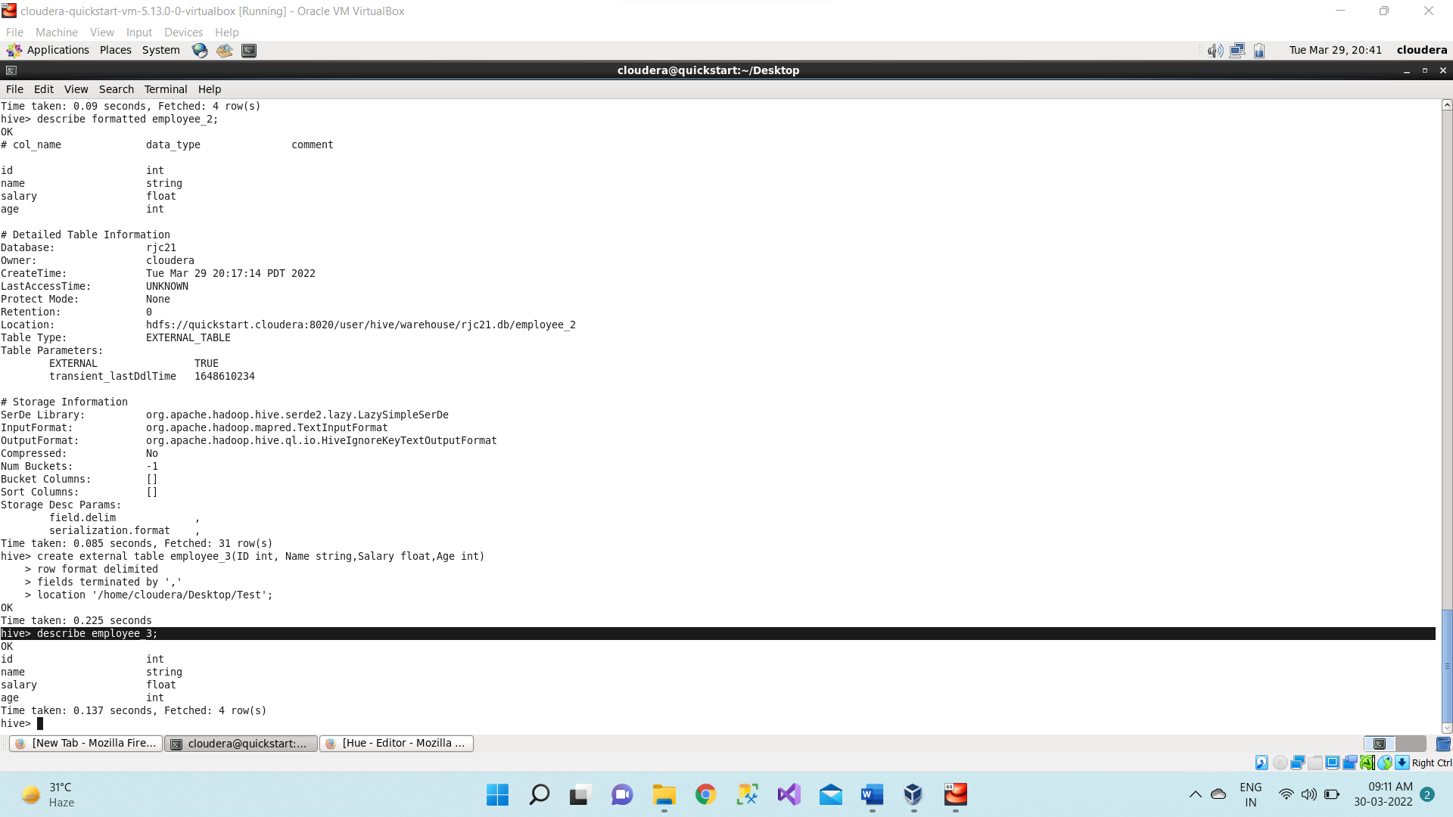

1. Then switch to browser and refresh and select the Test database and refresh, now it will display the employee3 table along with other two tables which we have created earlier.

**describe formatted employee3;**

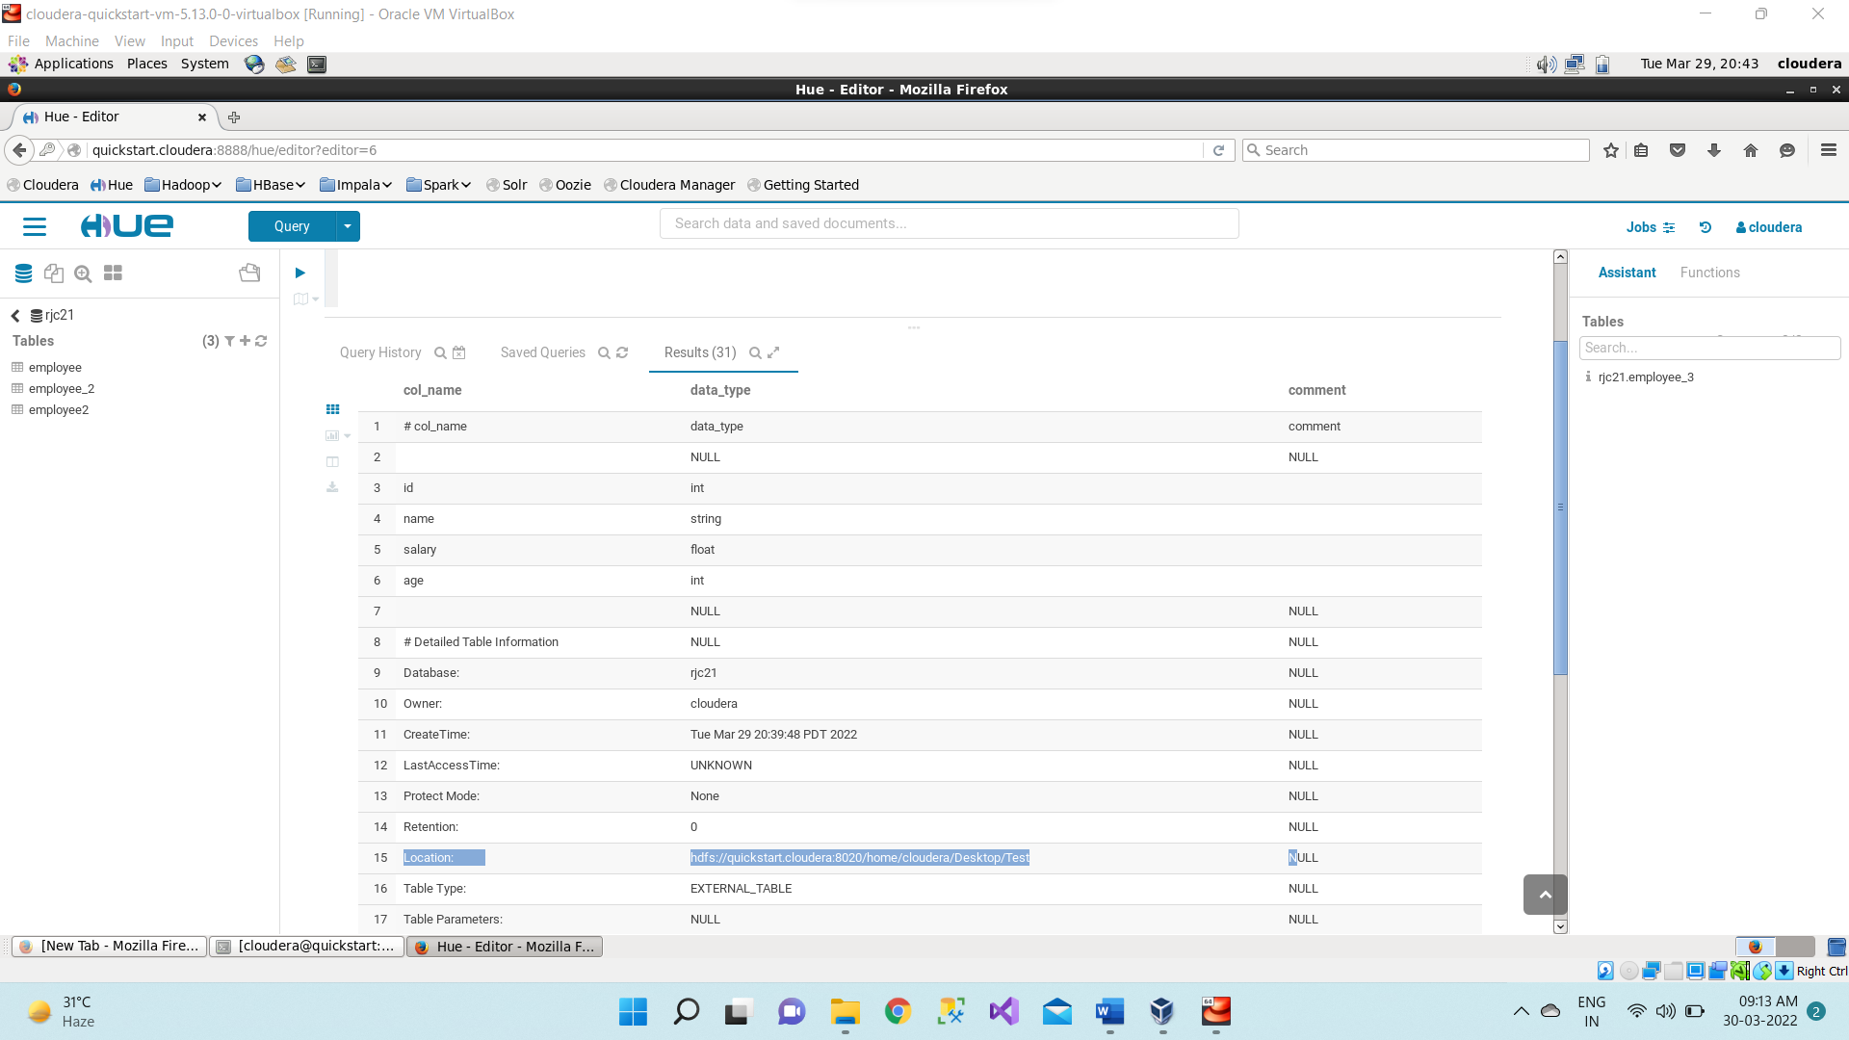

1. Now move to terminal and listing out all the tables using below command;

**show tables;**

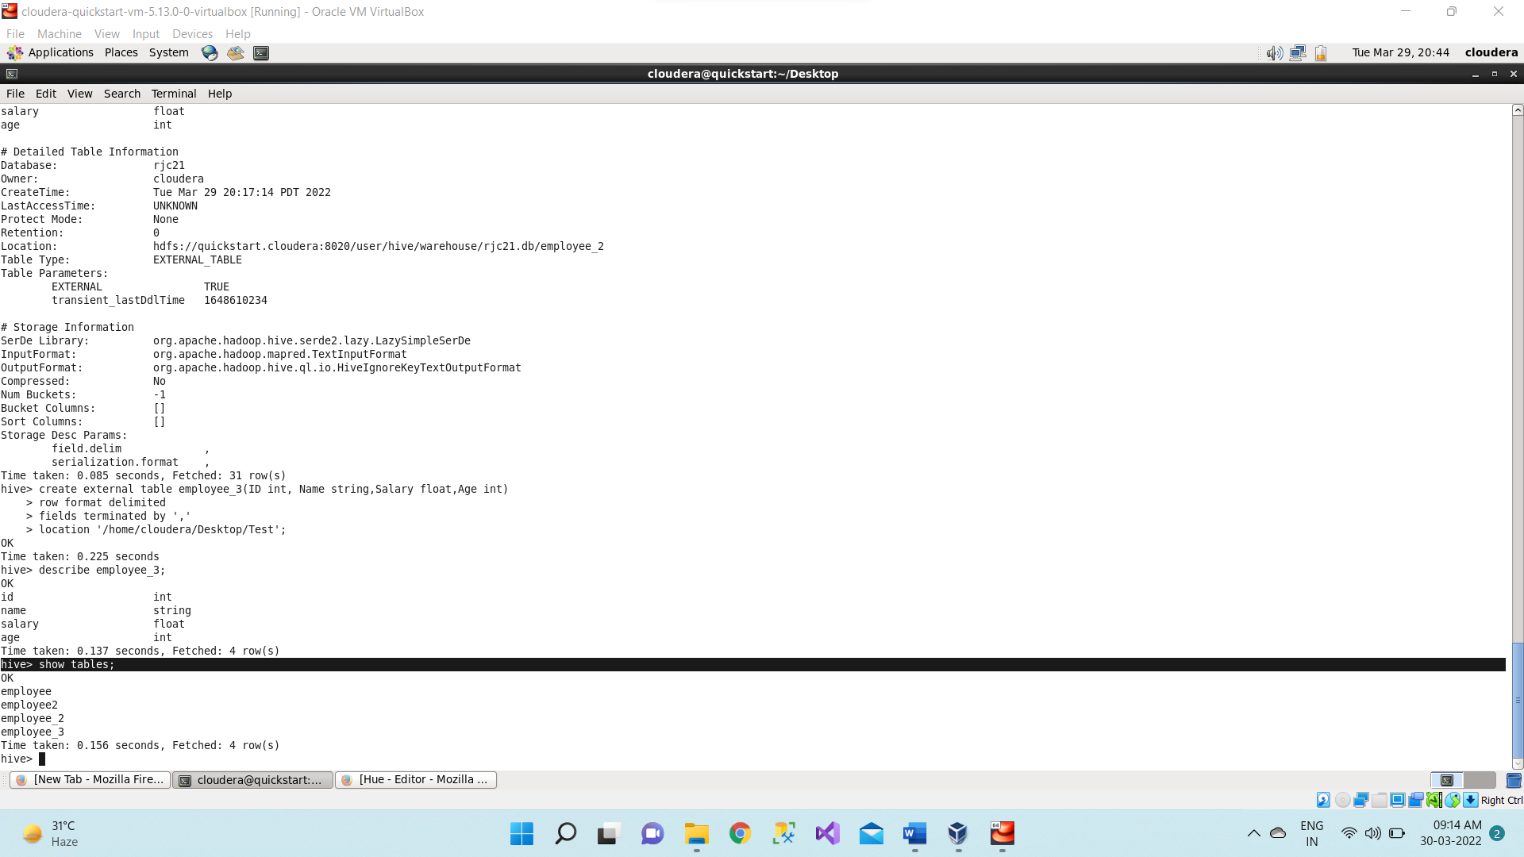

1. ALTER COMMANDS

If changing the name of the employee3 table to emptable using below command,

**alter table employee_3 RENAME TO emptable;**

1. First, we will see the fields of employee3 then we will add new column as surname in employee3 using below command,

**alter table employee3 add columns(surname string);**

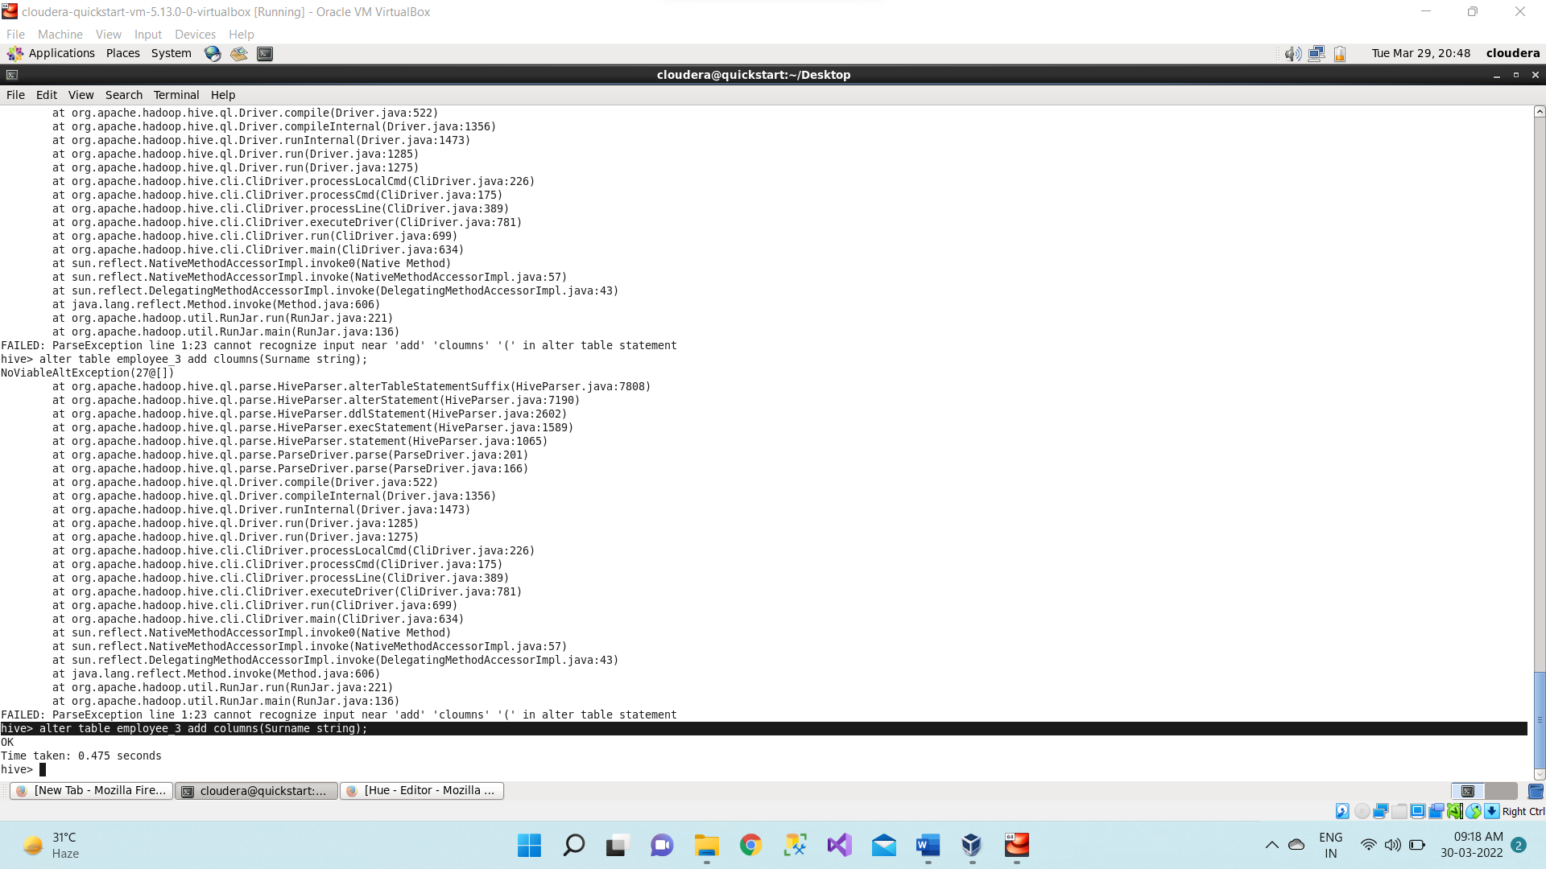

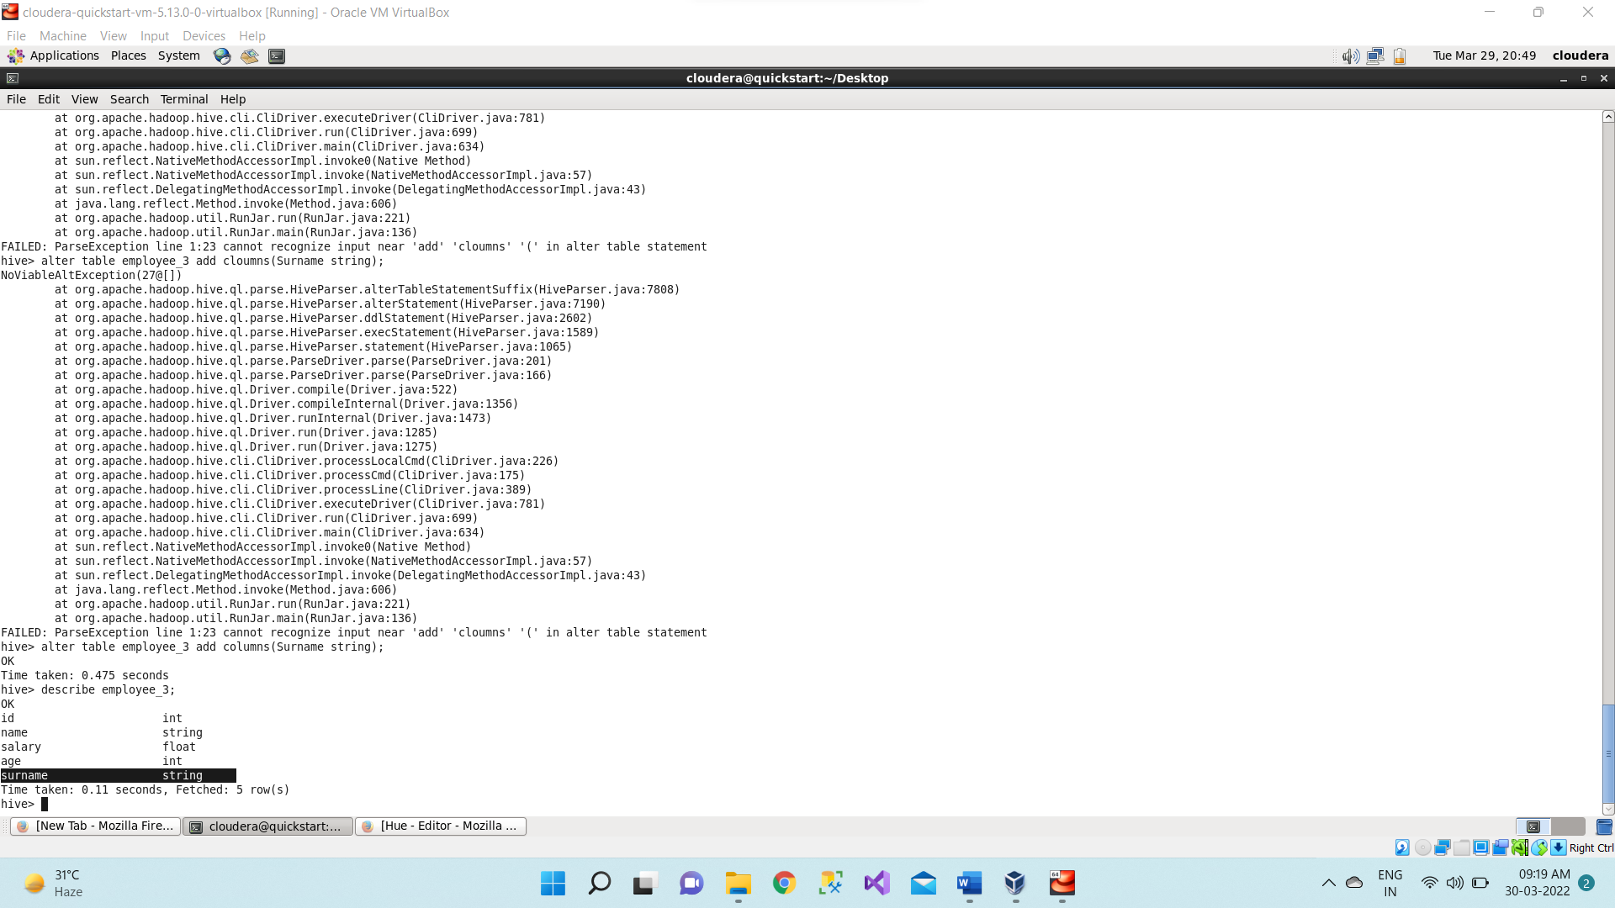

1. Now we will change field name of the emptable to first_name using alter command,

**Syntax: alter table <table_name> change <old_coln_name> <new_coln_name> string;**

**alter table employee_3 change name first_name string;**

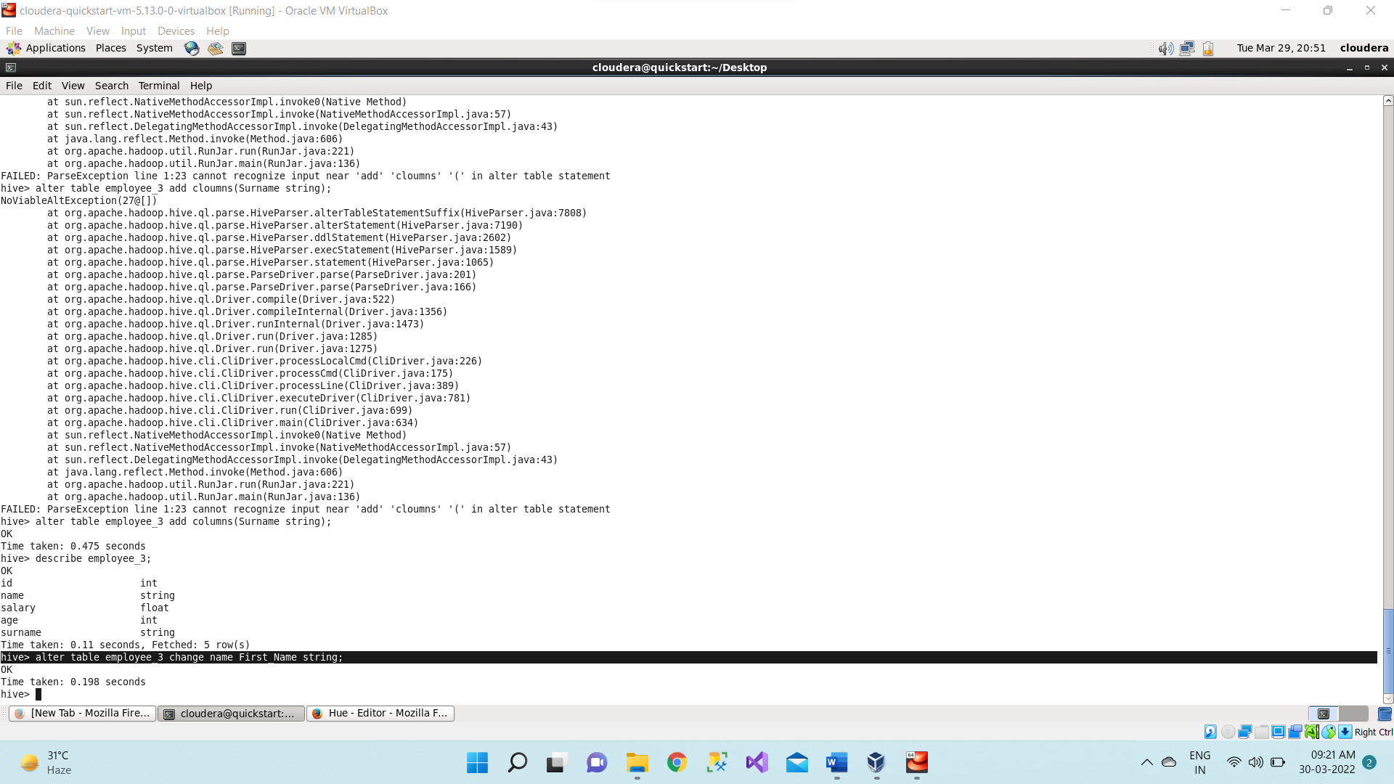

1. Before loading the data in the table, we will first create the csv file. Now open the new terminal, using ls command list out all the directories --> change the directory to document directory --> use ls command to list all the files present inside the document folder or directory

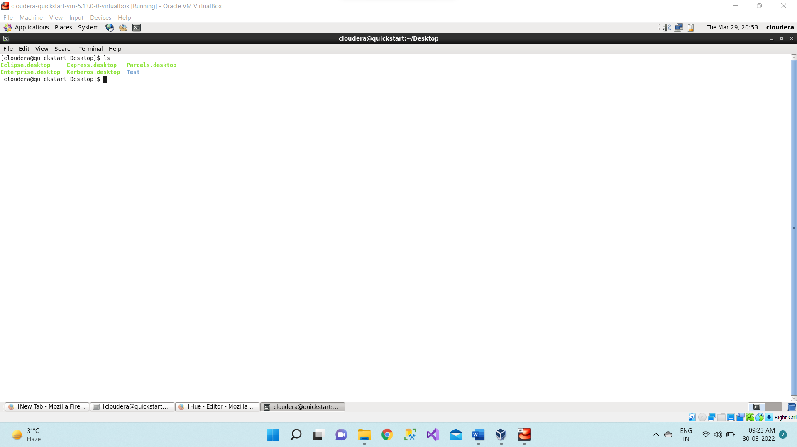

1. Now creating new file as Student.csv using below command,

**gedit Student.csv**

As soon as we hit enter it will create a Student.csv file as it was not existing earlier.

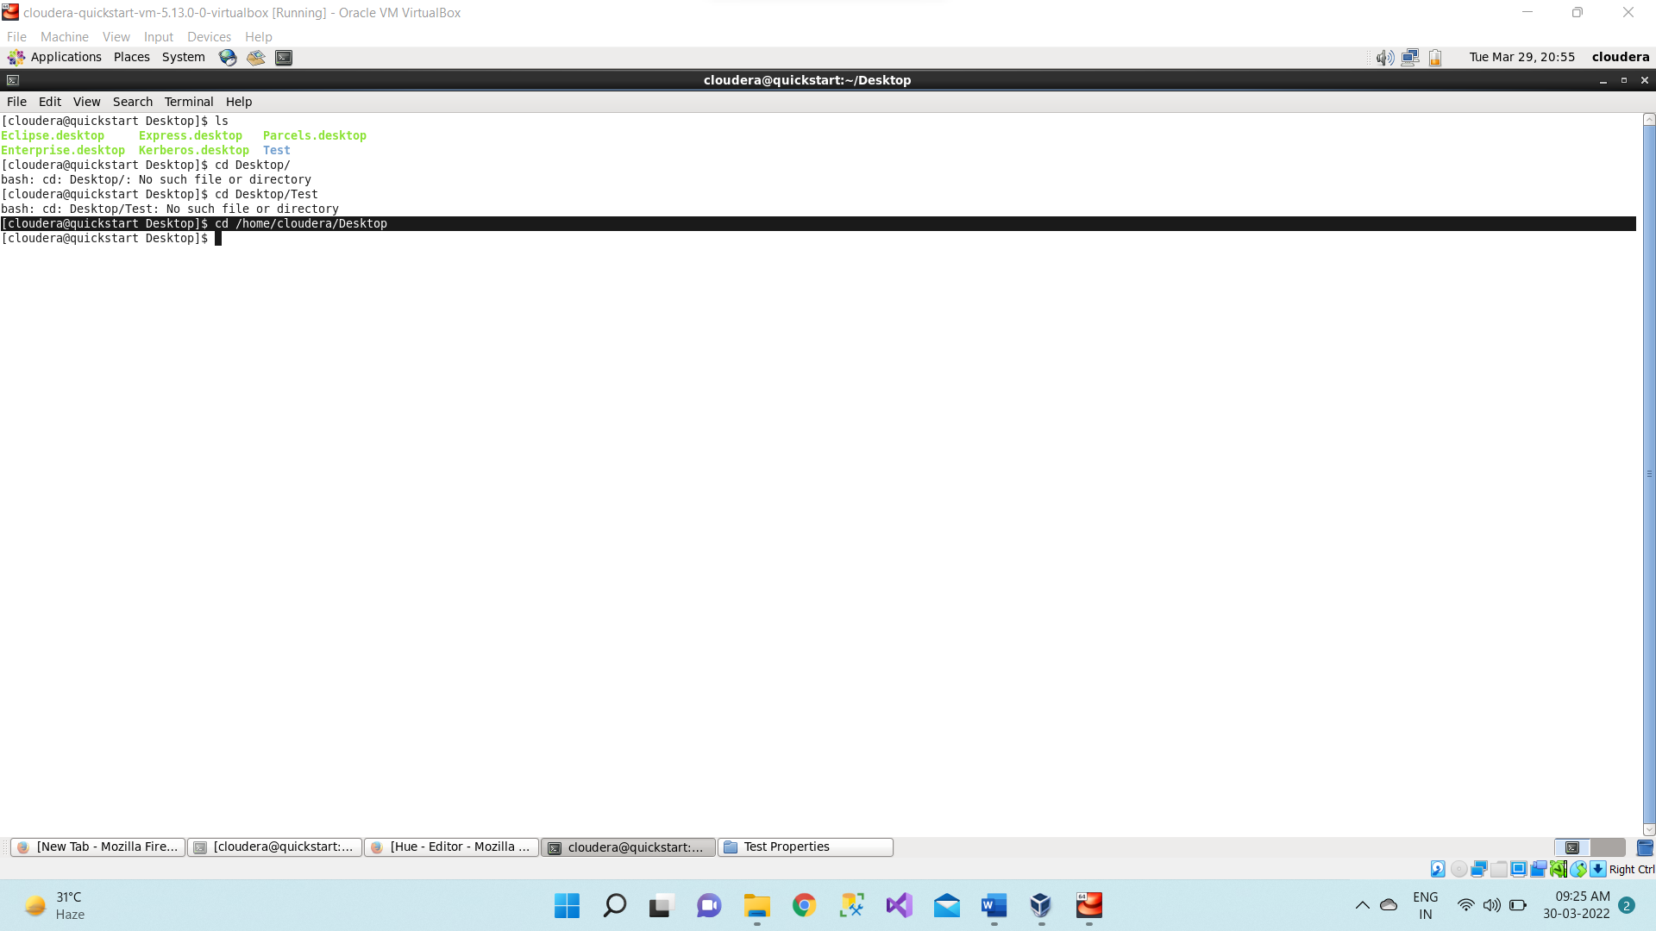

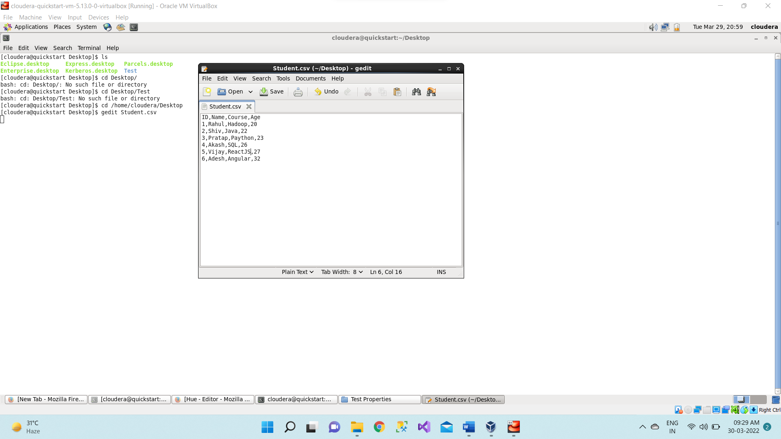

1. Creating a new database as **rjcstudents**.

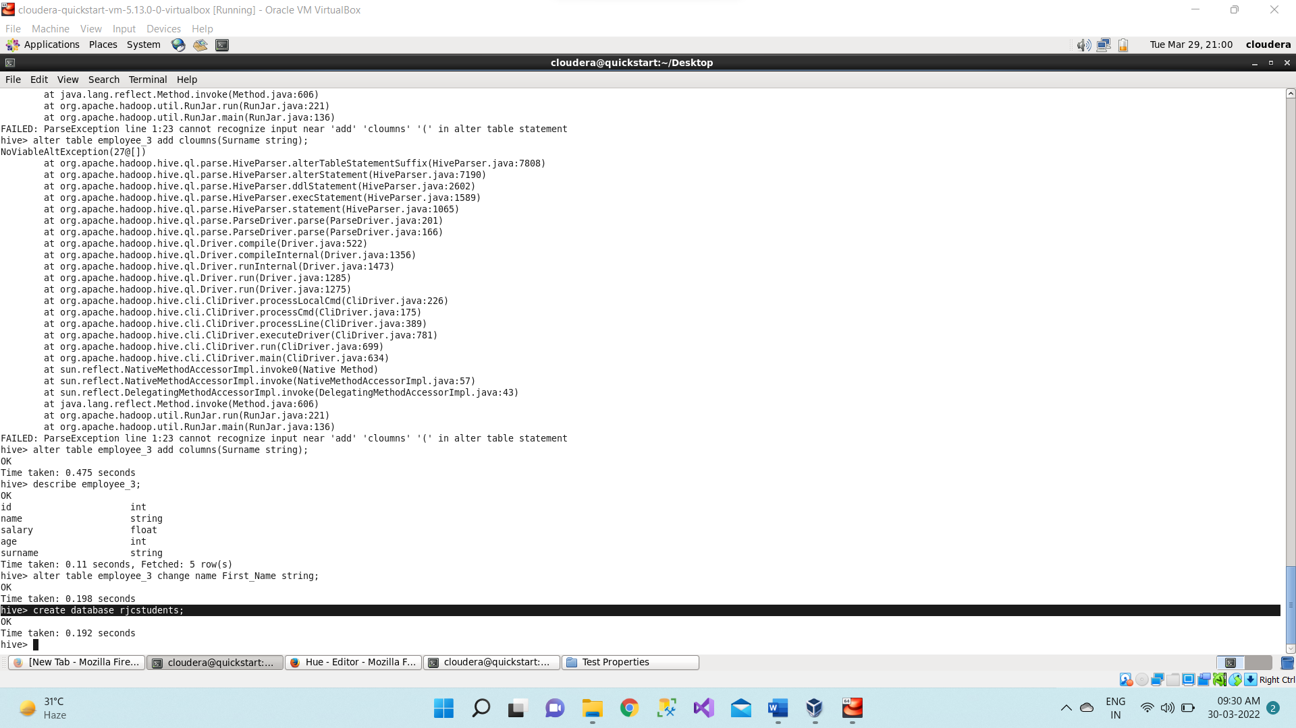

1. Using **rjcstudents** database.

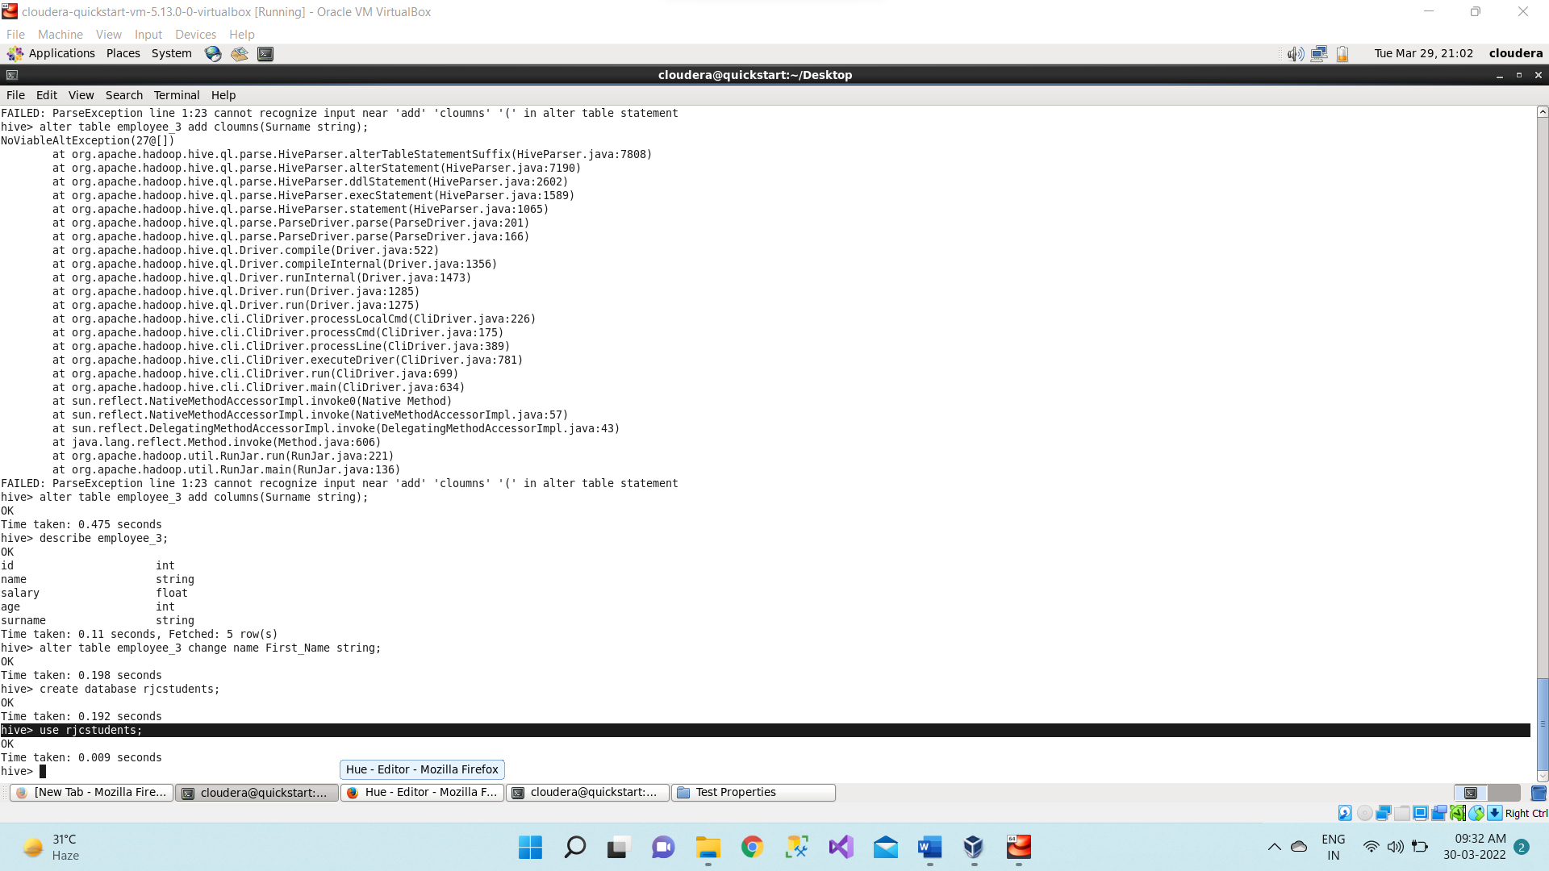

1. Creating new **table** student inside **rjcstudents** database.

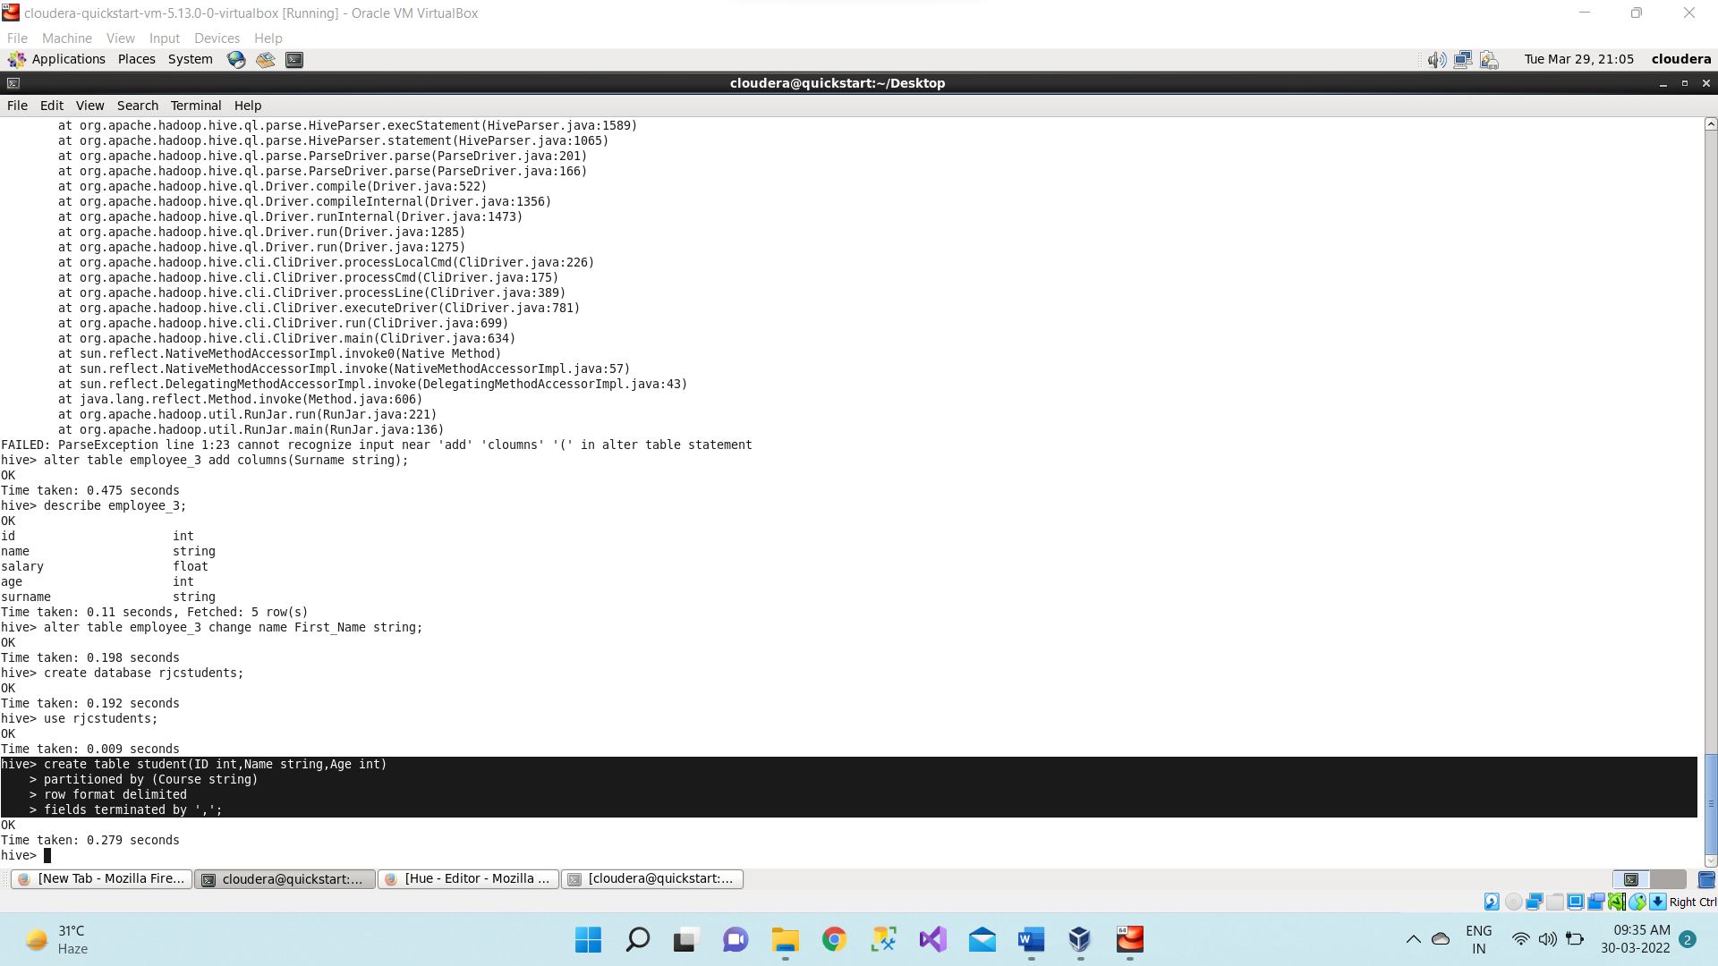

1. To see the structure or schema of the table,

**describe student;**

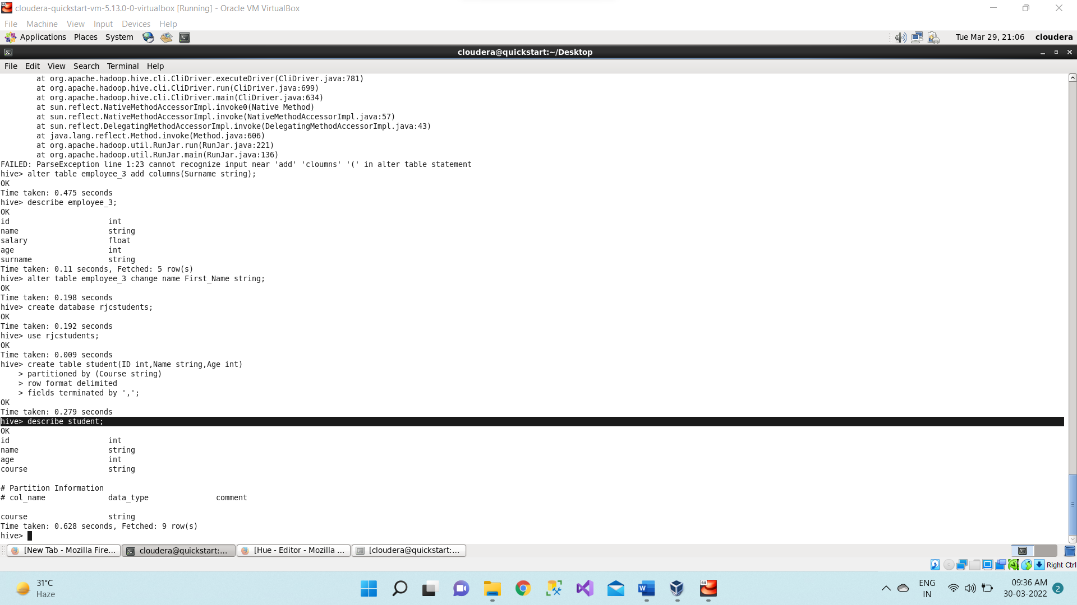

1. Loading data in the student table from Student.csv file which we have created in document directory. Here we are partitioning based on course = ‘Hadoop’.

**load data local inpath "/home/cloudera/Desktop/Student.csv" into table student**

**partition(Course="Hadoop");**

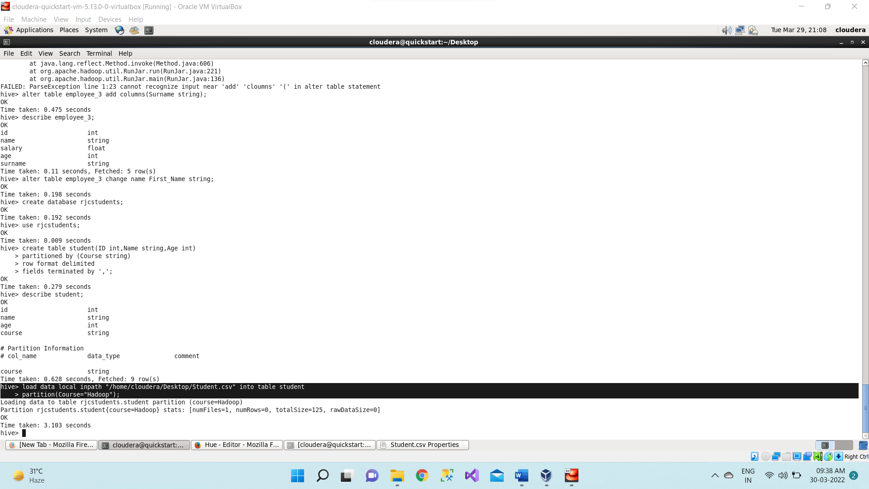

It is partitioning based on Hadoop.

**select * from student;**

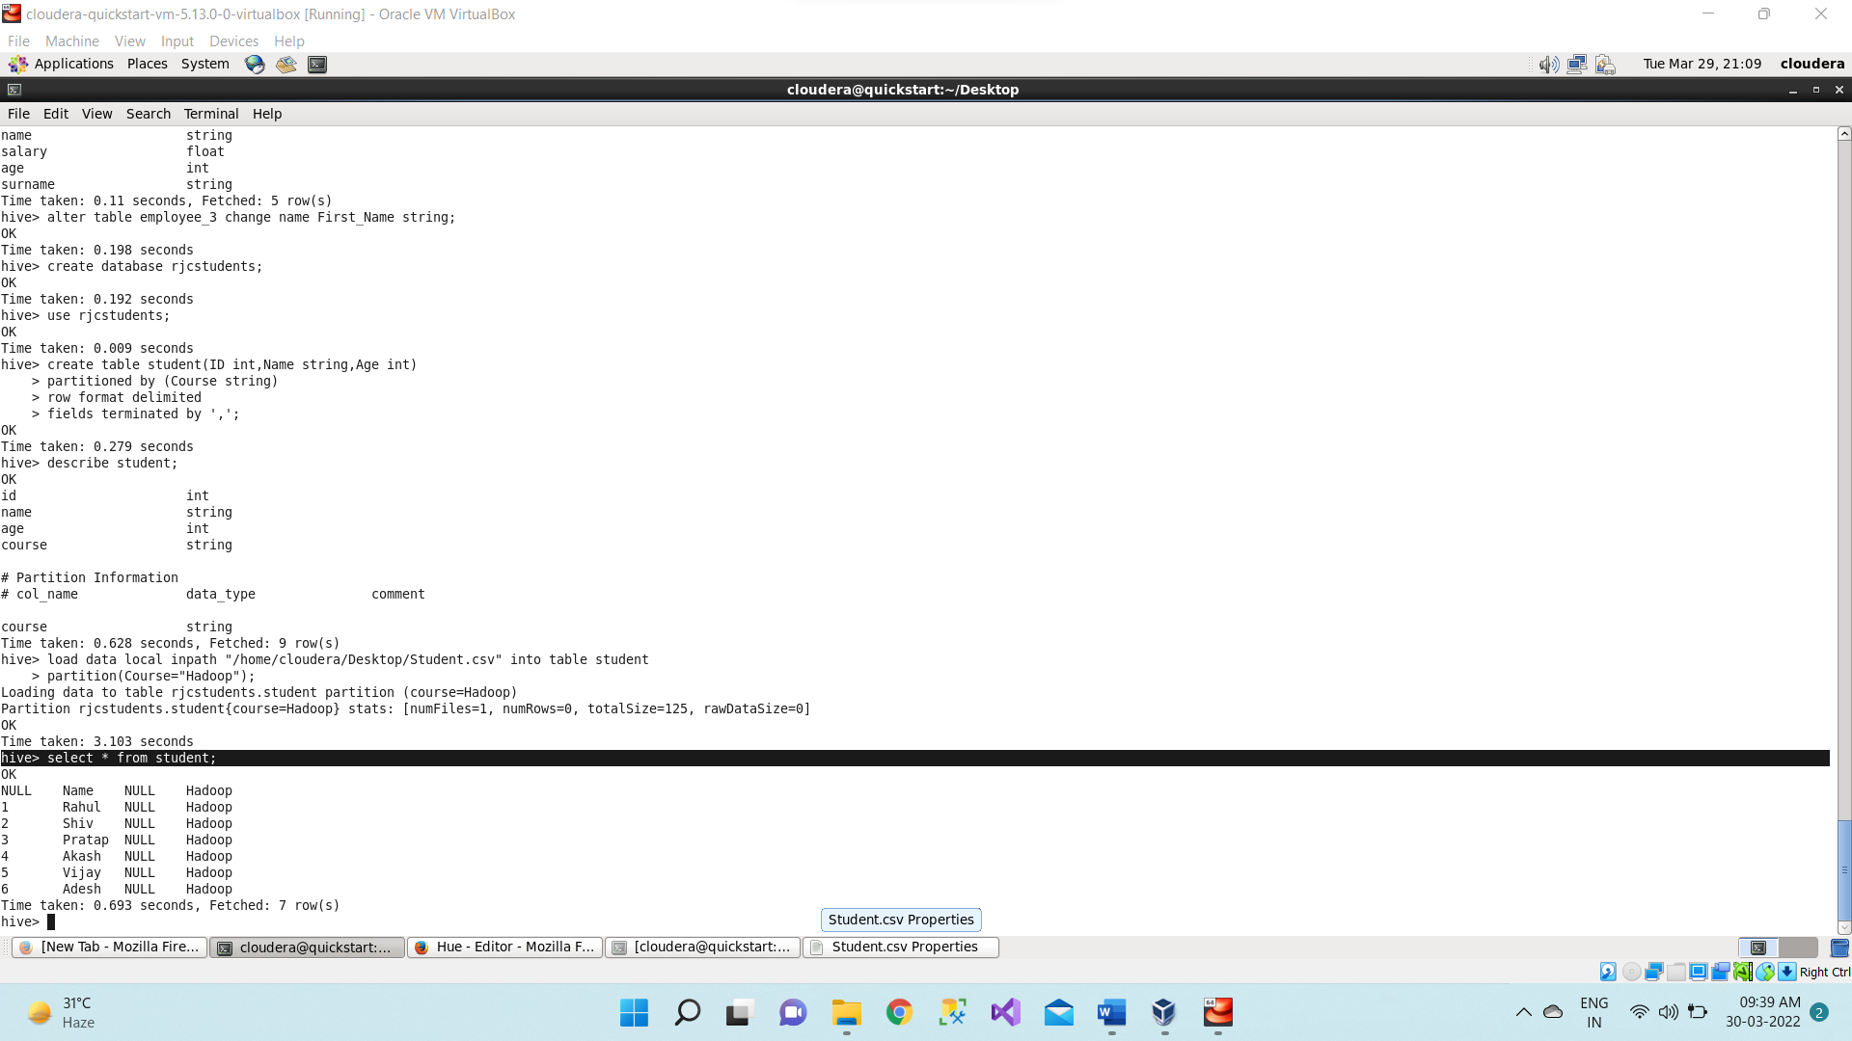

1. Now we similarly partition for course = Java and course = Python.

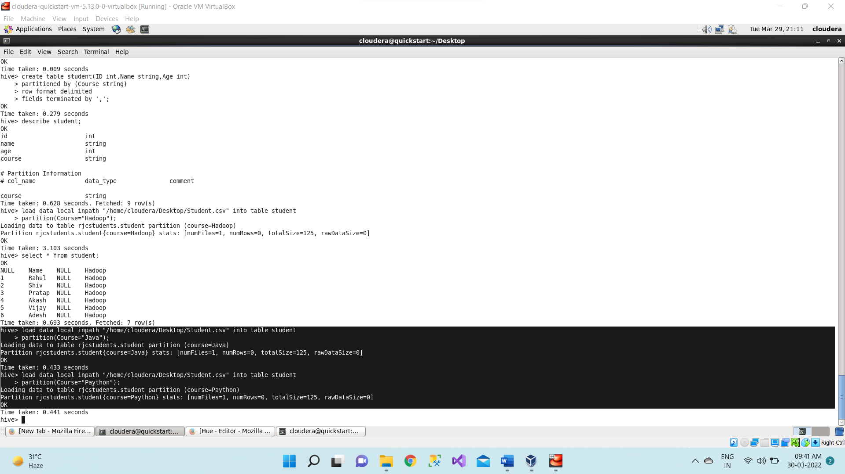

1. Now go to browser refresh the page and select database as **rjcstudent** and click in

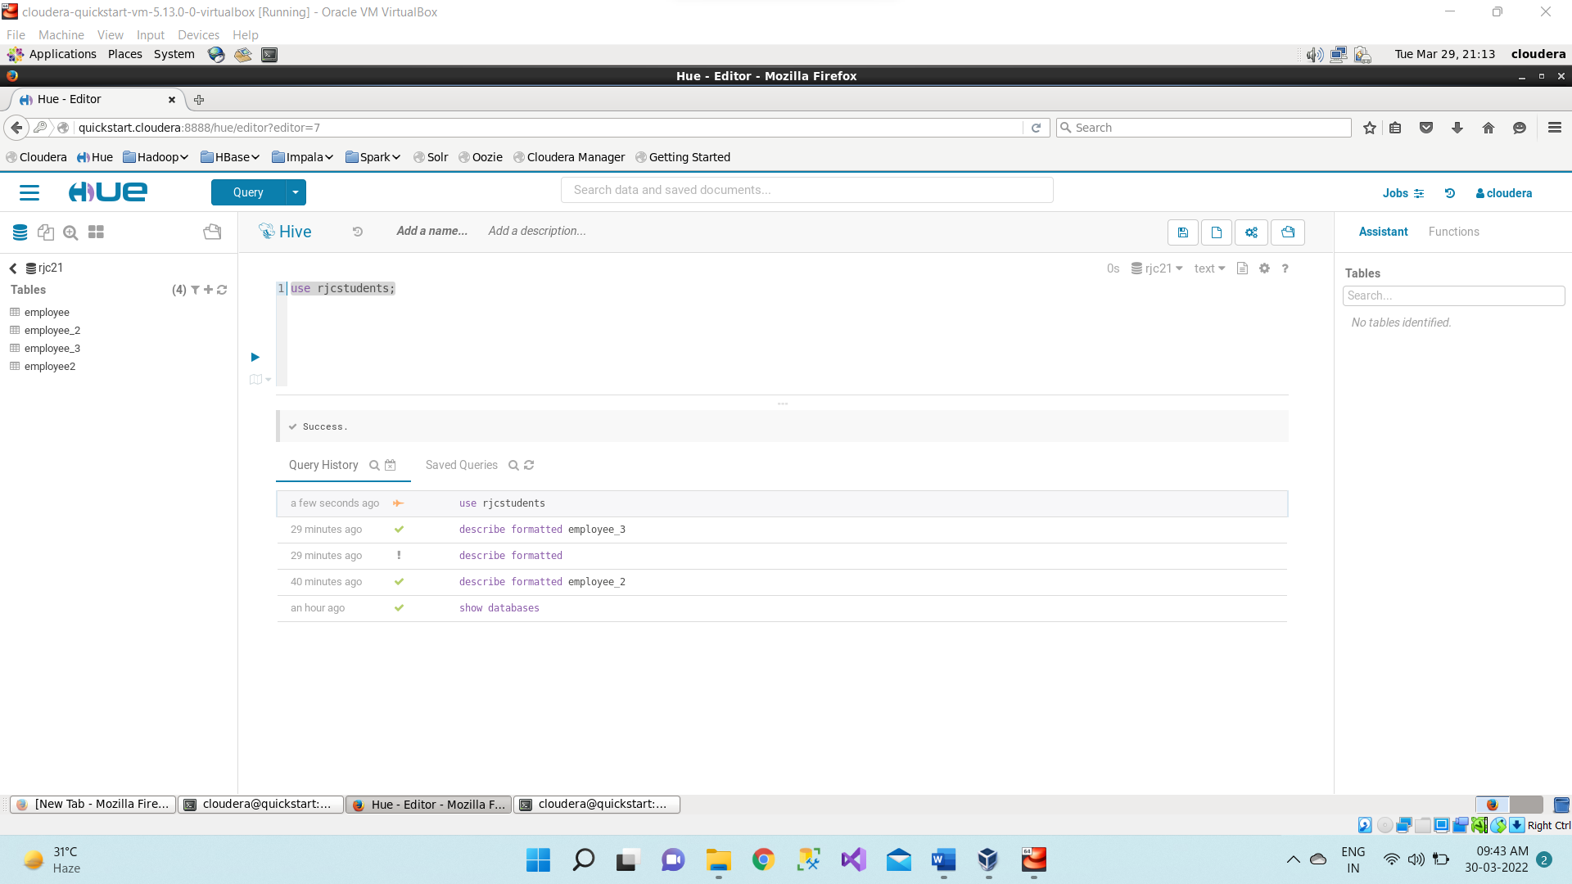

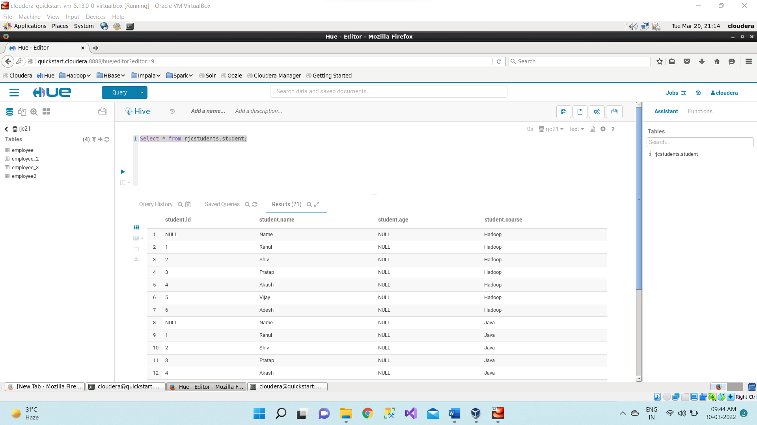

1. Now dropping the table student and creating the student table again normally (i.e. without partitioning).

**drop table student;**

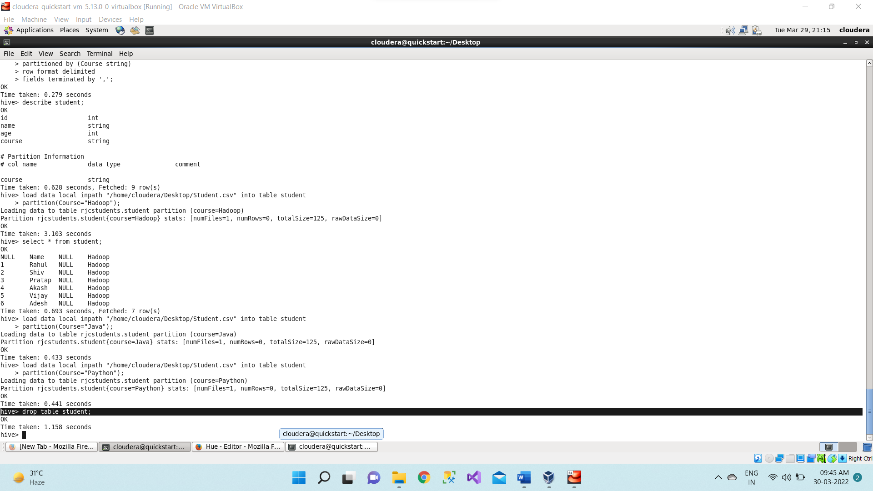

**create table student(ID int, Name string, Course string, Age int)**

**row format delimited**

**fields terminated by ','**

**tblproperties("skip.header.line.count"="1");**

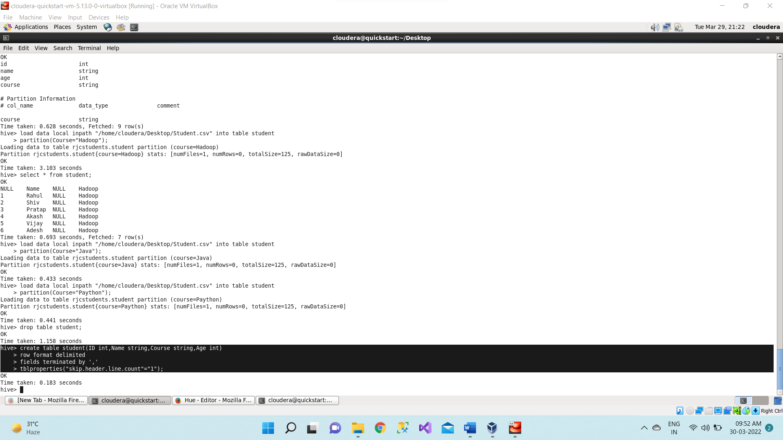

1. Loading data in the student table from Student.csv file which present inside

/home/cloudera/Desktop directory.

load data local inpath "/home/cloudera/Desktop/Student.csv" into table student;

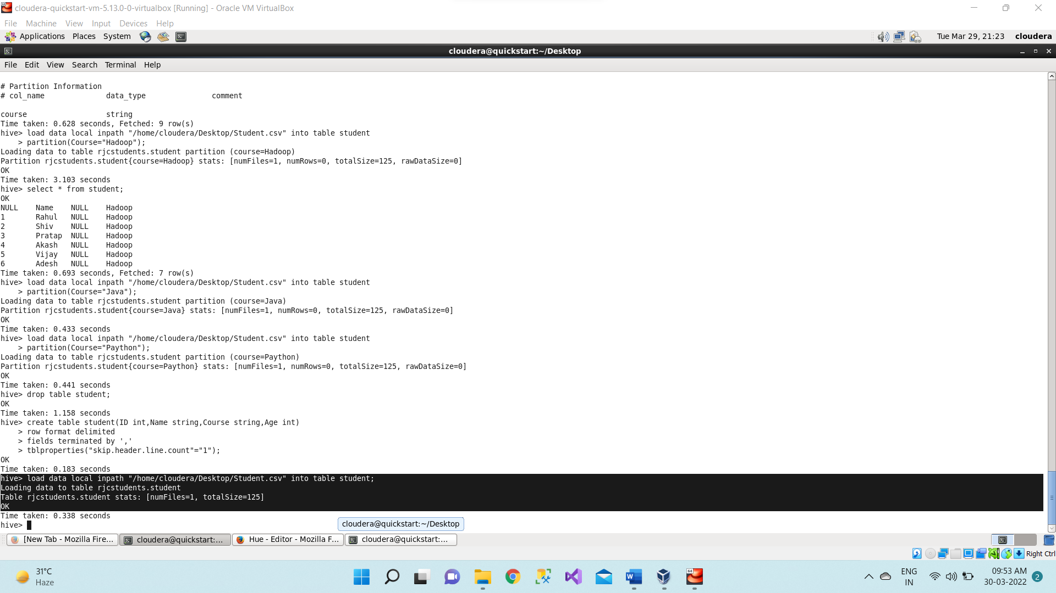

**select * from student;**

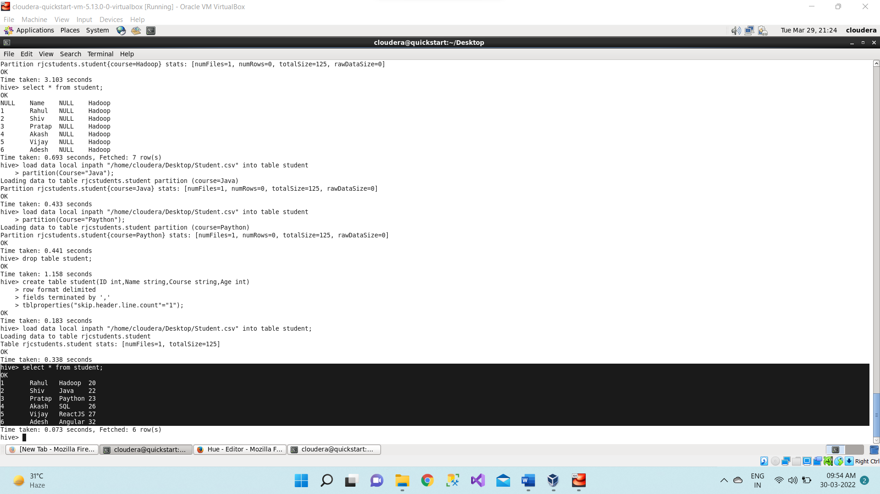

1. Now creating **employee.csv** file.

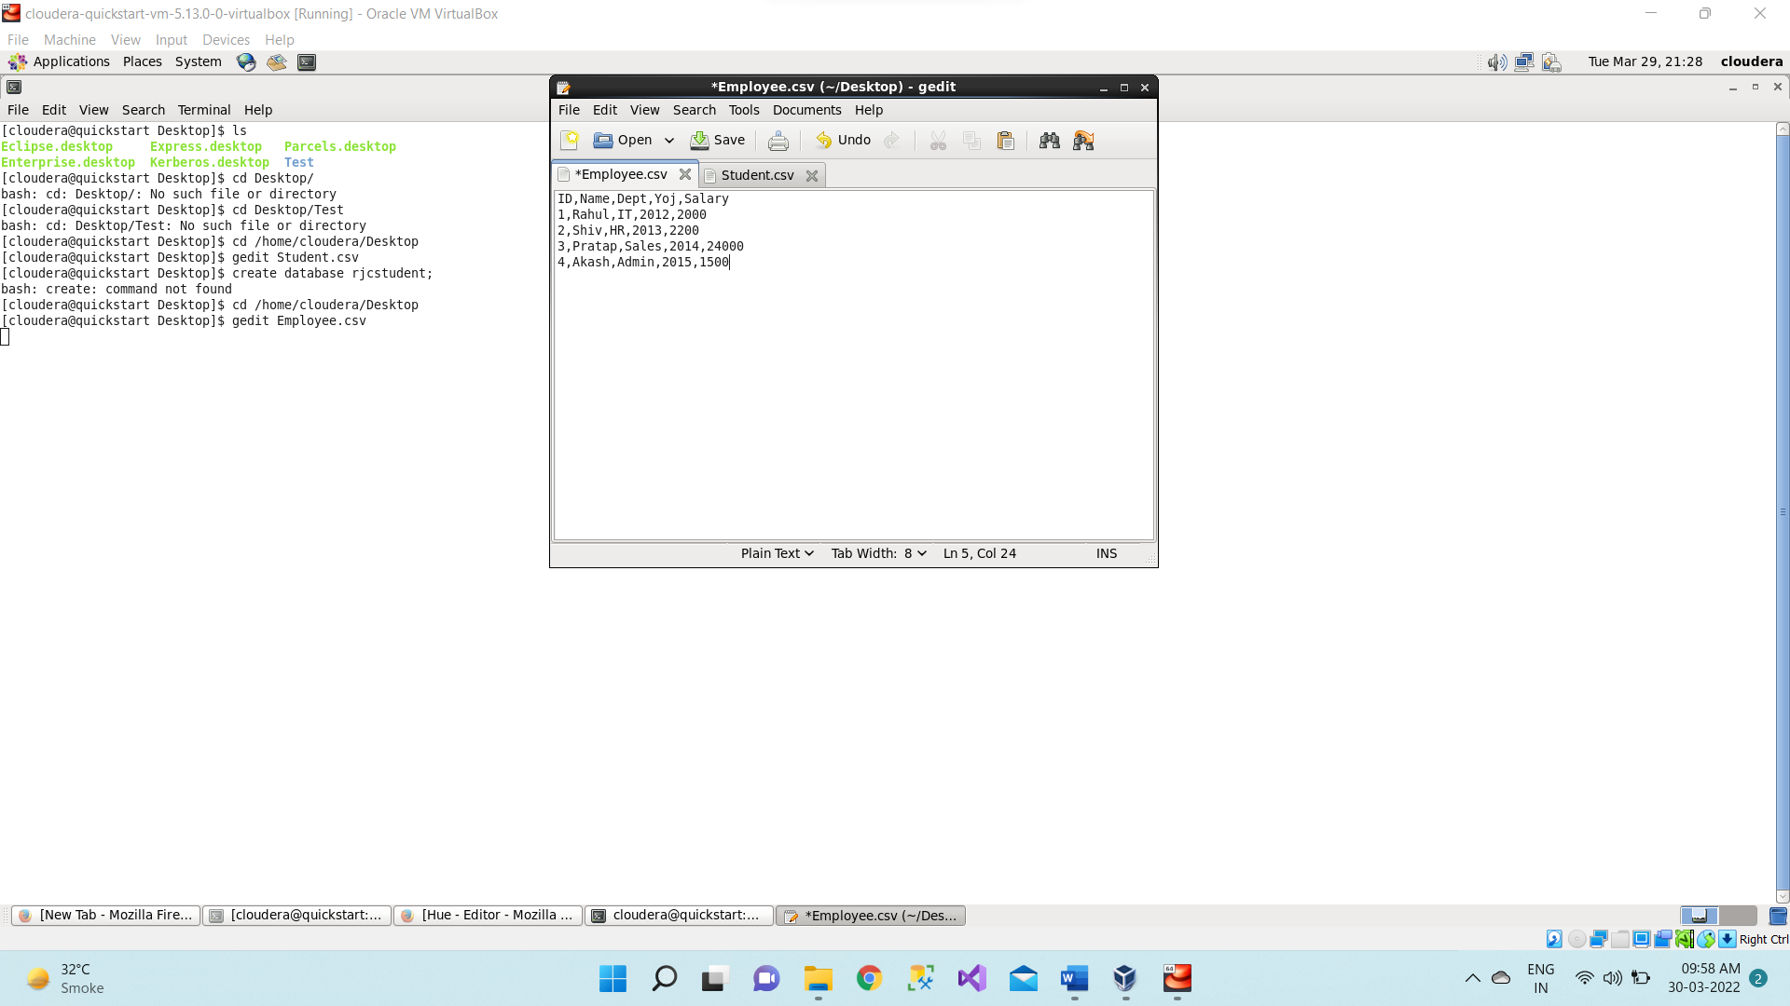

1. Creating new database for performing querying operations.

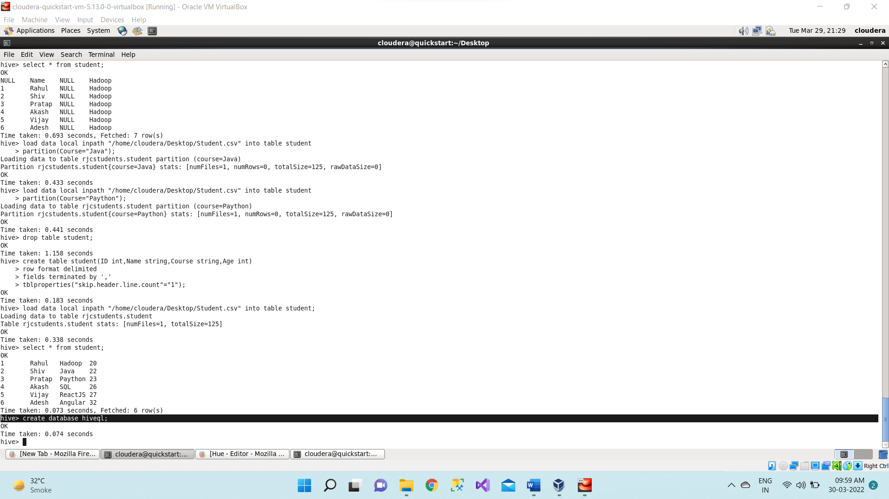

1. Using database hiveql and creating table employee inside the hiveql datanase.

**create table employee(ID int, Name string, Department string, YOJ int, Salary float)**

**row format delimited**

**fields terminated by ','**

**tblproperties("skip.header.line.count"="1");**

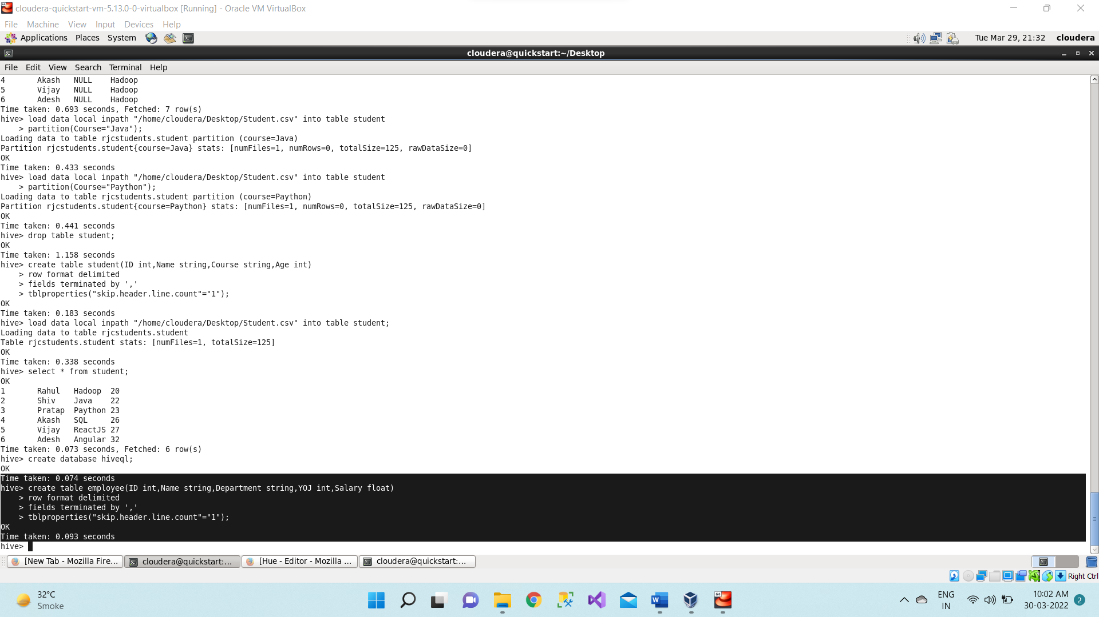

**Describe employee;**

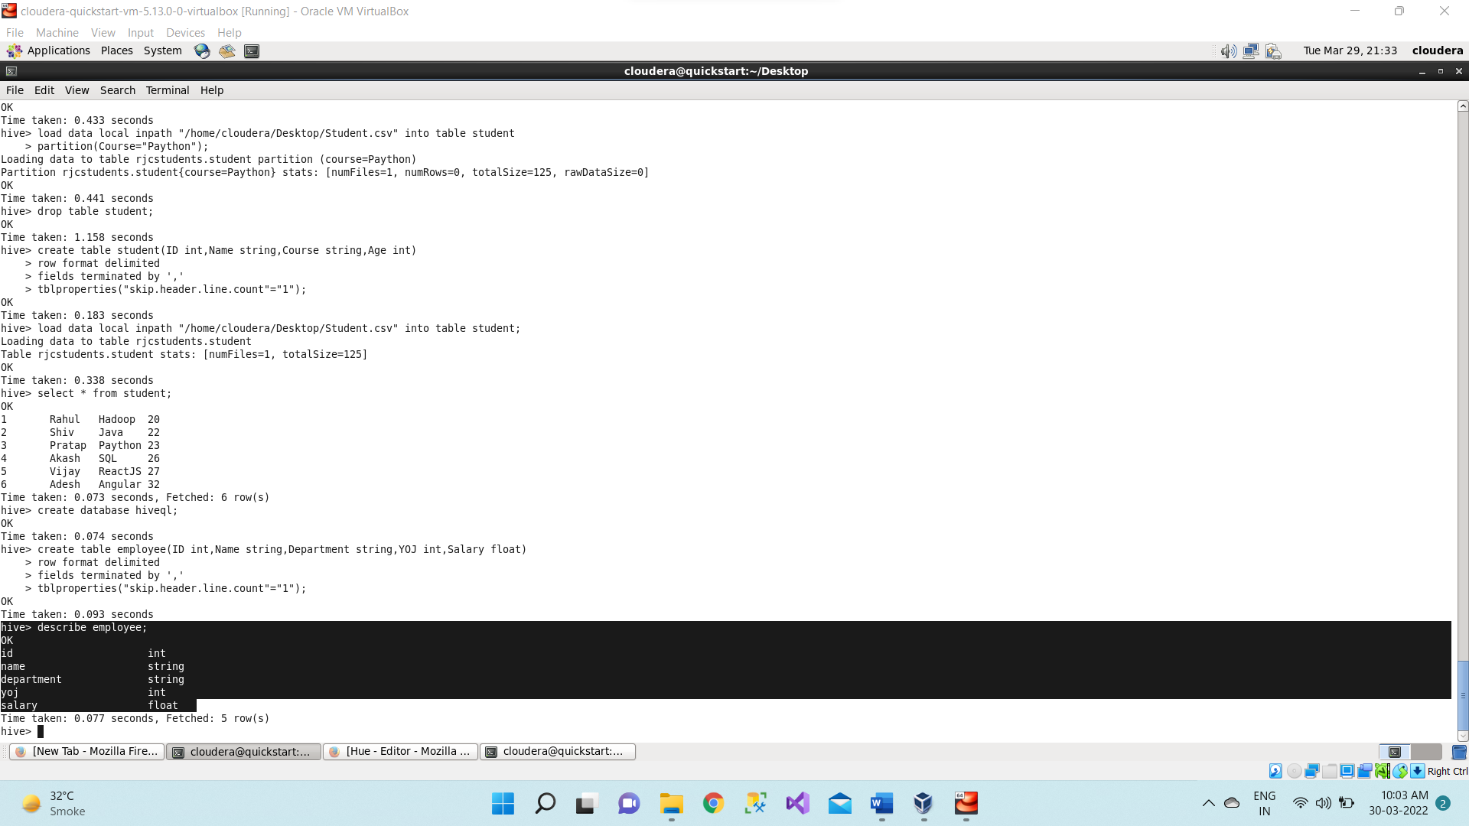

1. Loading the data into employee table from employee.csv file which we have created

earlier and it is present in /home/cloudera/Documents directory.

**load data local inpath "/home/cloudera/Desktop/Employee.csv" into table employee;**

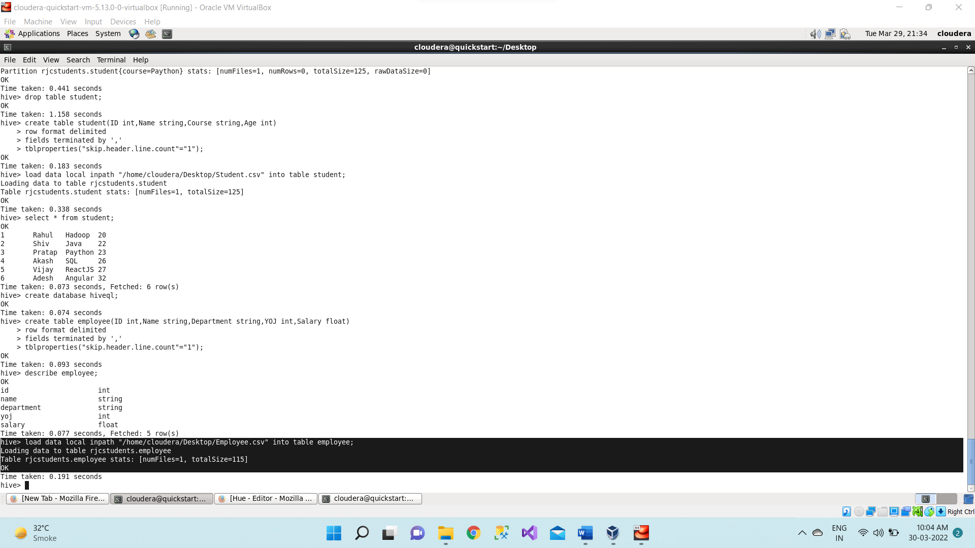

Displaying the table using below command,

**select * from employee;**

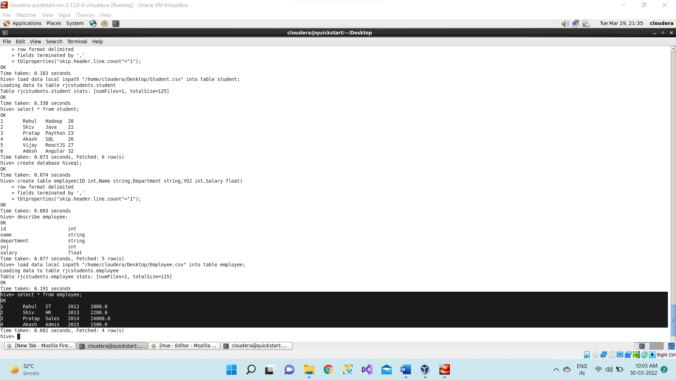

1. We are printing or displaying the rows or records of employees whose salary is greater than and equal to 25000.

**select * from employee where salary >=24000;**

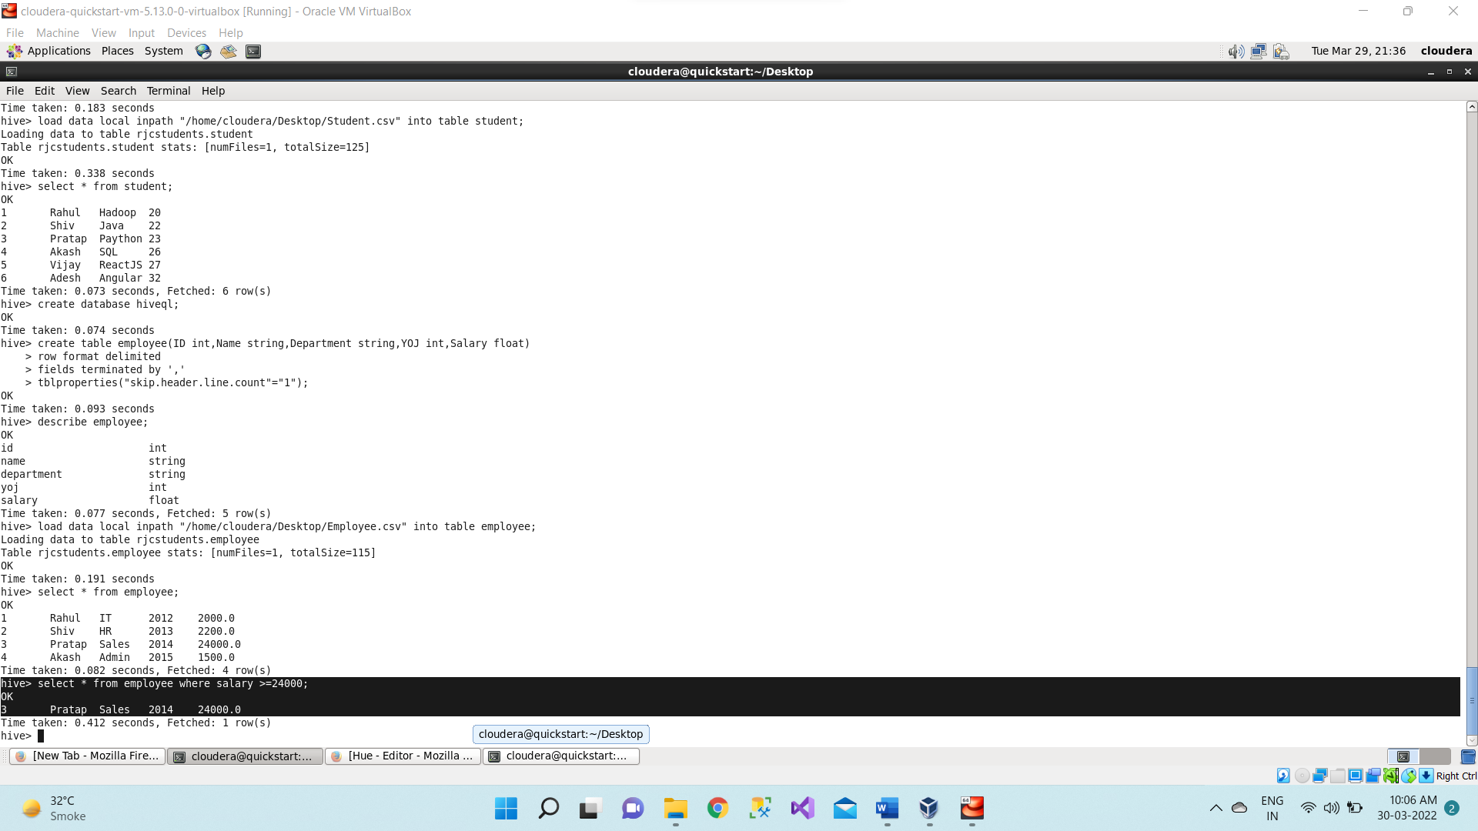

1. Now we are printing or displaying the rows or records of employees whose salary is less than 24000.

**select * from employee where salary <24000;**

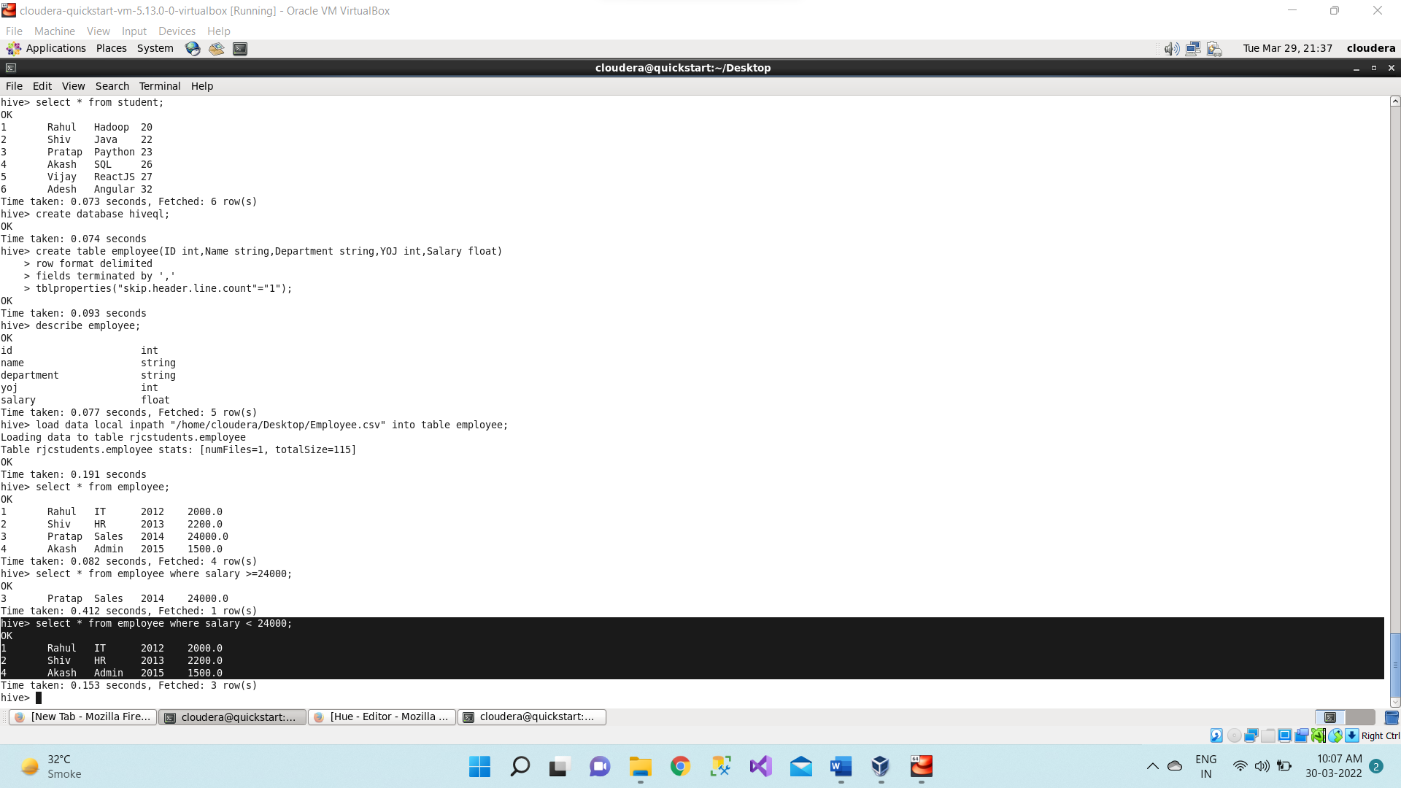

1. Arithmetic operations:

We are adding 2000 in existing salary and displaying specific columns using below command,

**select ID, Name, salary + 2000 from employee;**

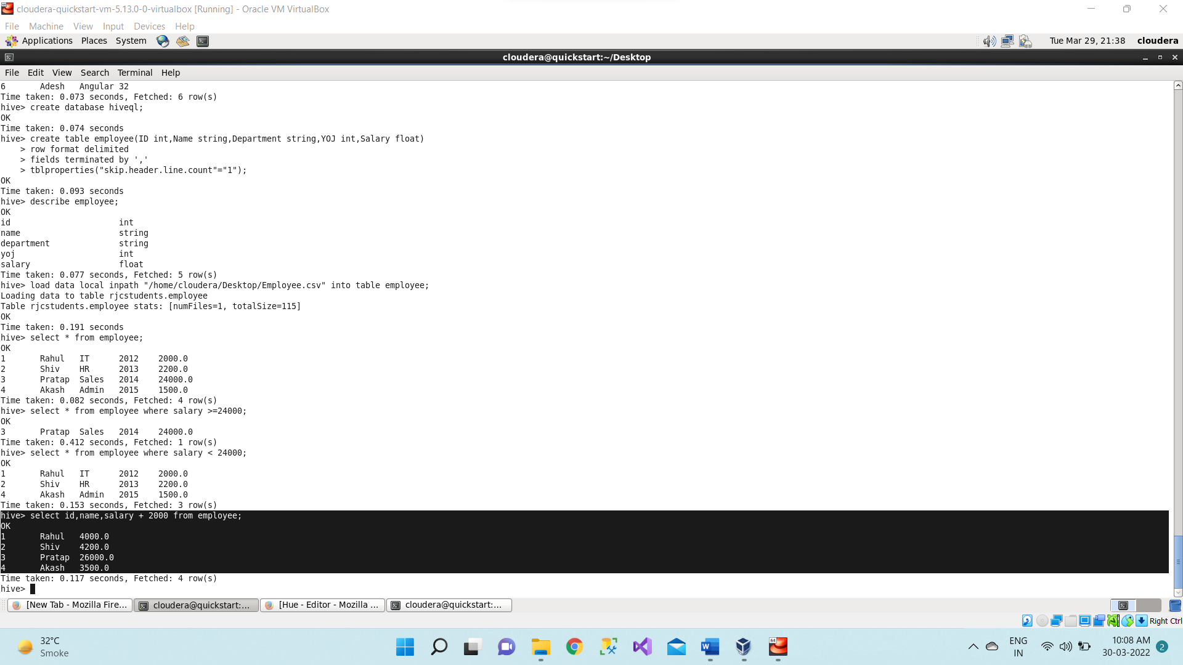

1. Displaying the **maximum salary** using below command,

**select max(salary) from employee;**

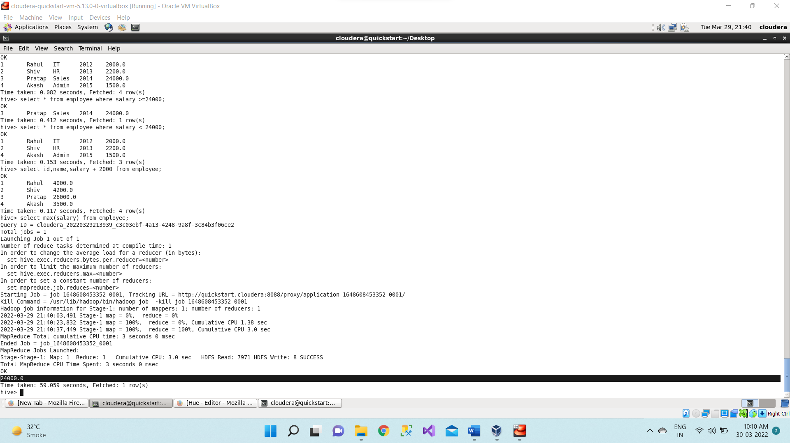

1. Displaying the **minimum salary** using below command,

**select min(salary) from employee;**

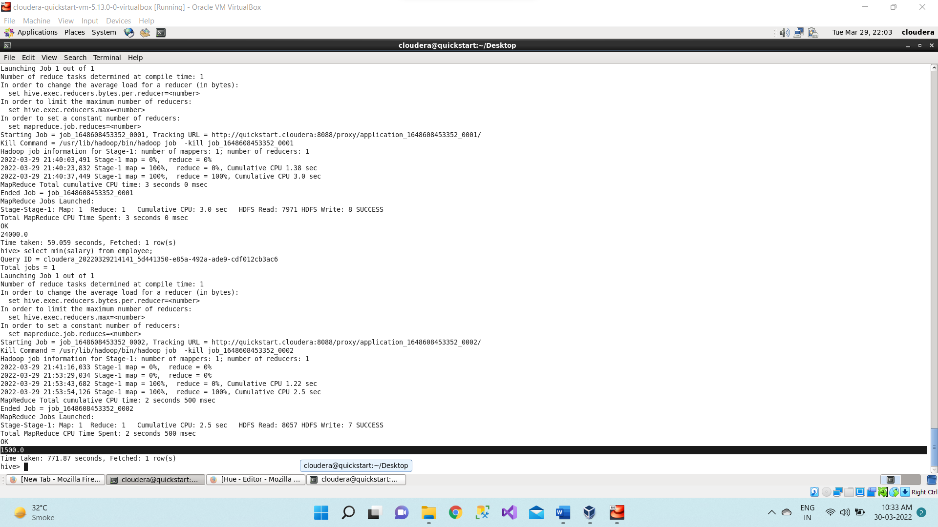

1. Now finding the **square root of salary** using below command,

**select ID, Name, sqrt(salary) from employee;**

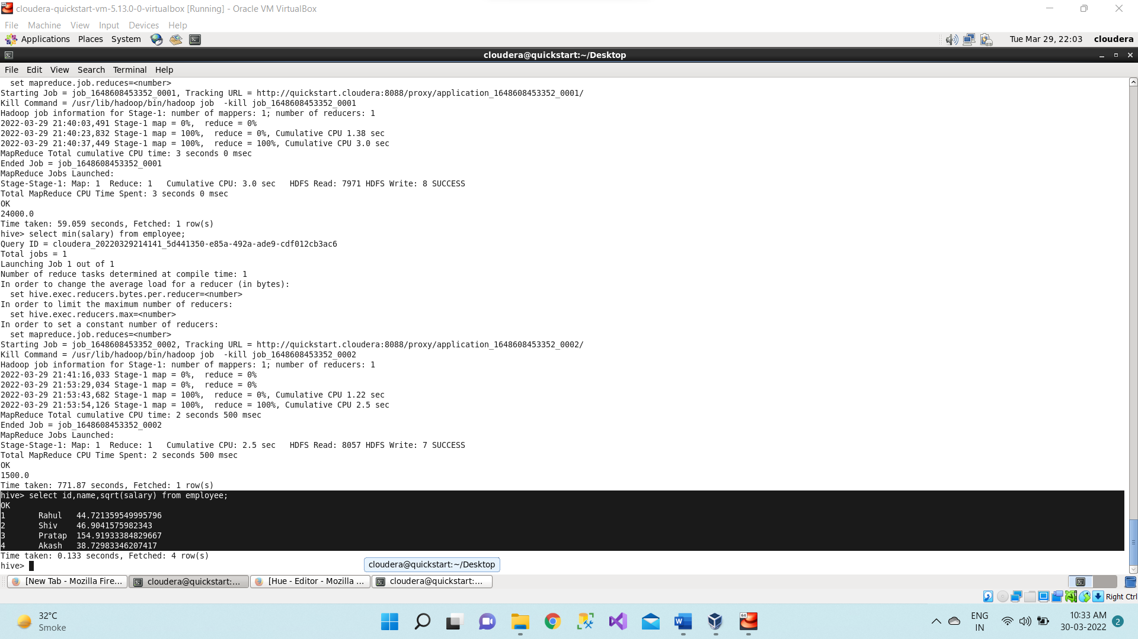

1. Now we are showing the name column in **upper case u**sing below command,

**select ID, upper(name) from employee;**

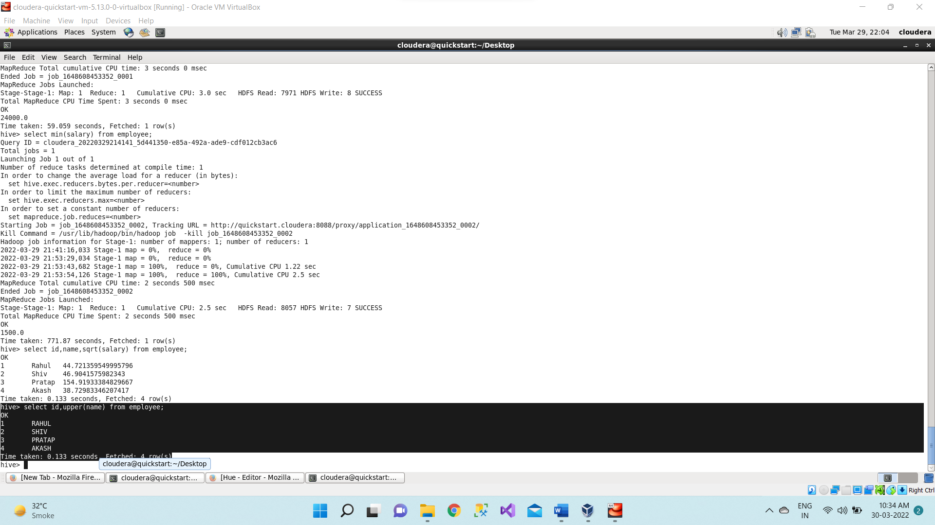

1. Now we are showing the name column in **lower case u**sing below command,

**select ID, lower(name) from employee;**

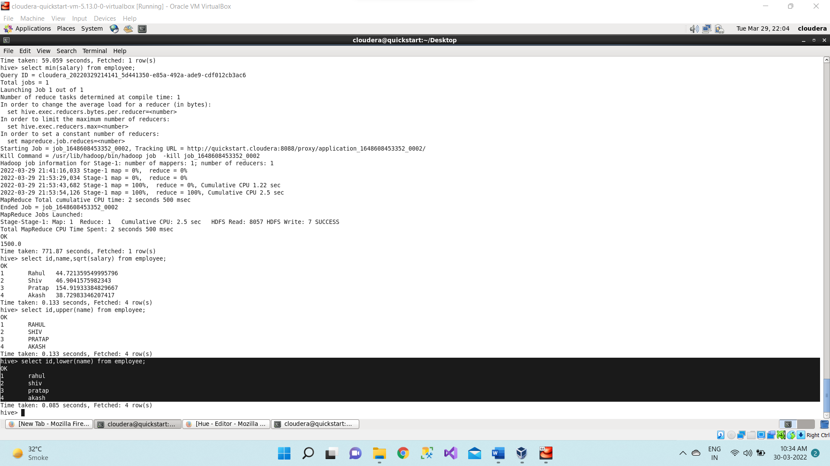

1. Creating another **employee2.csv** file with the same data as employee.csv but adding one more column as **Country** to it.

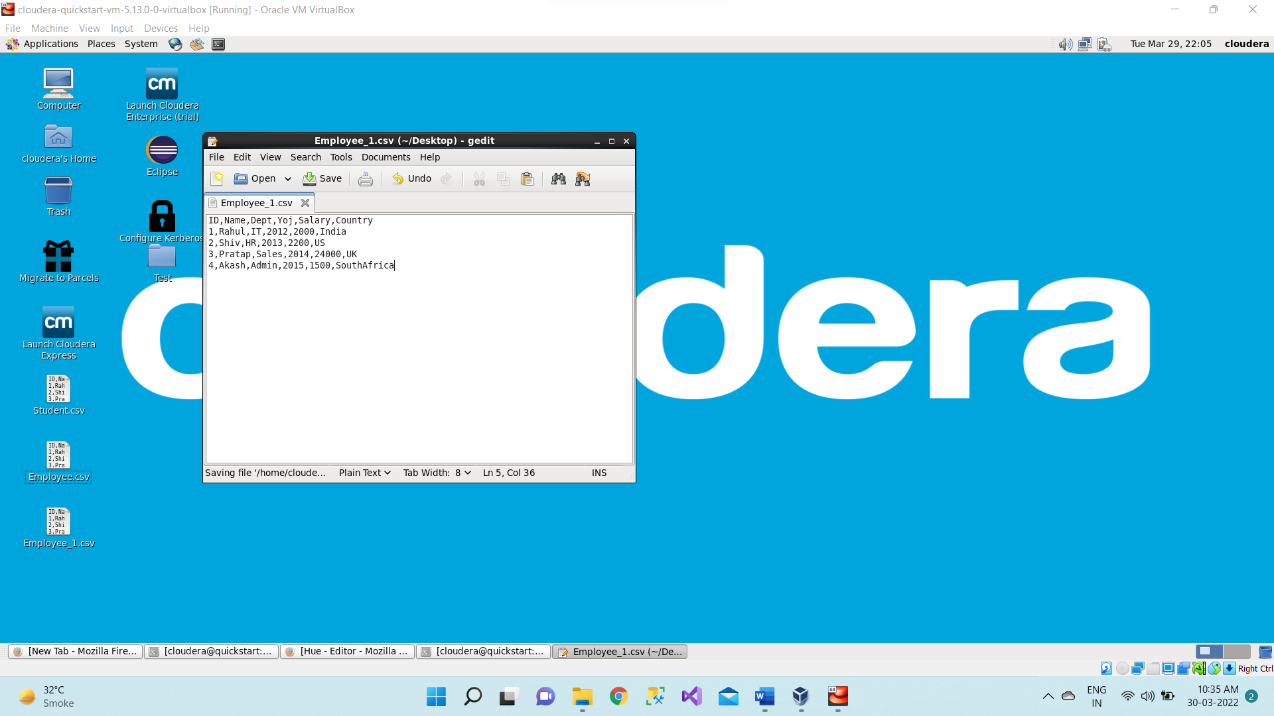

1. Creating a new table as **empgroup.**

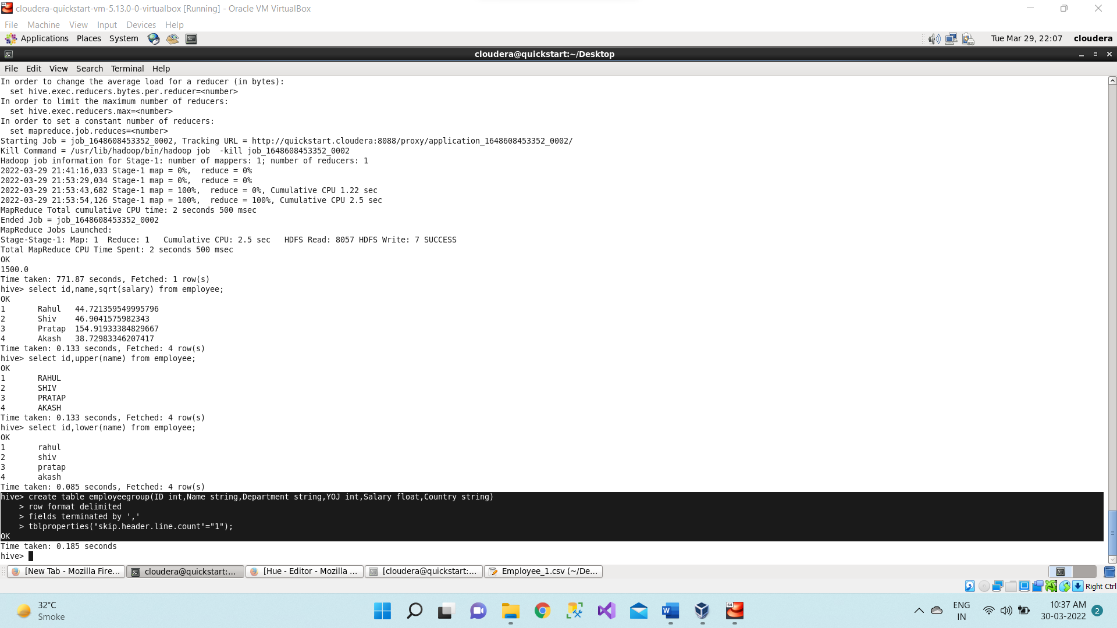

1. Loading the data into **empgroup** table from employee2.csv file which we have created and it is present in **/home/cloudera/Dekstop** directory.

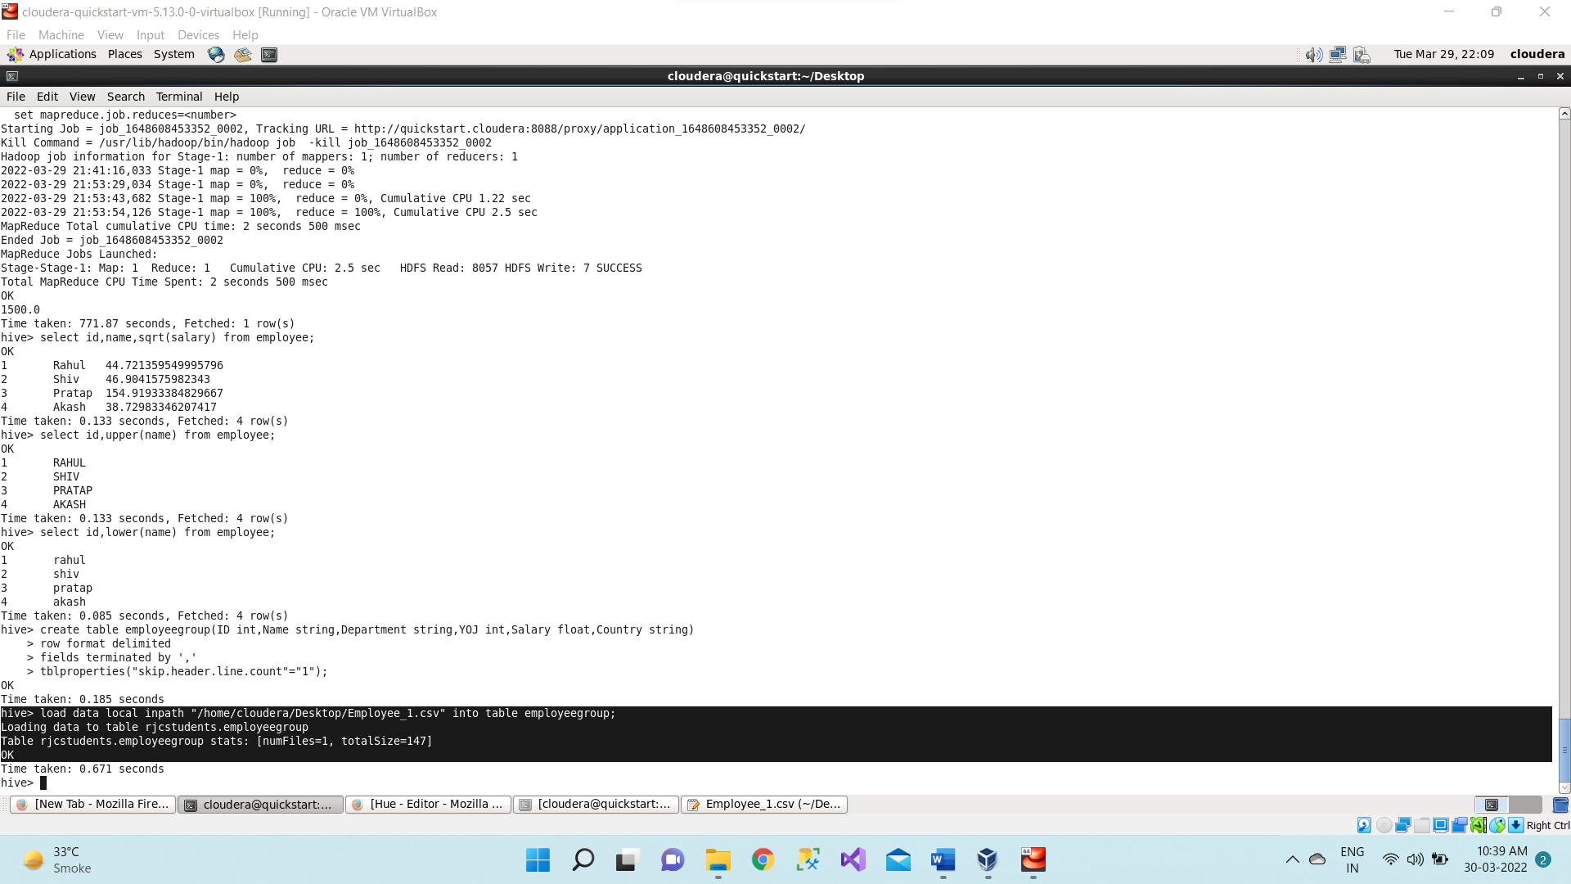

**Select * from employeegroup;**

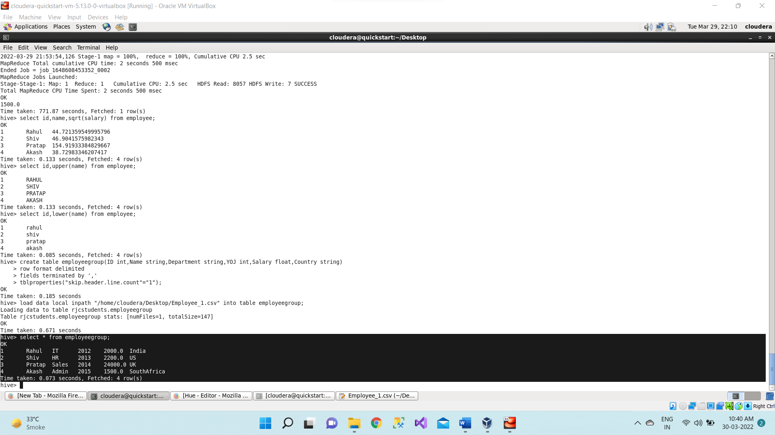

1. **Group by clause**

Now we display the total sum of salary of employees country wise using below command,

**select Country, sum (Salary) from empgroup group by Country;**

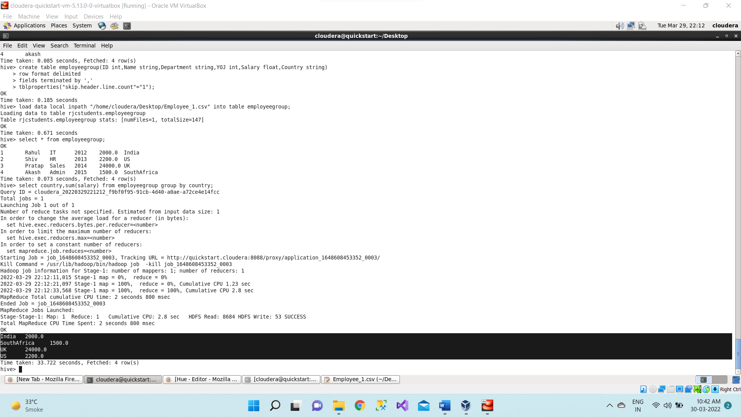

**Group by clause along with the having clause**

Taking the total sum of salary countrywise using group by clause and from that selecting or displaying those country whose total sum of salary > 22000 using having clause.

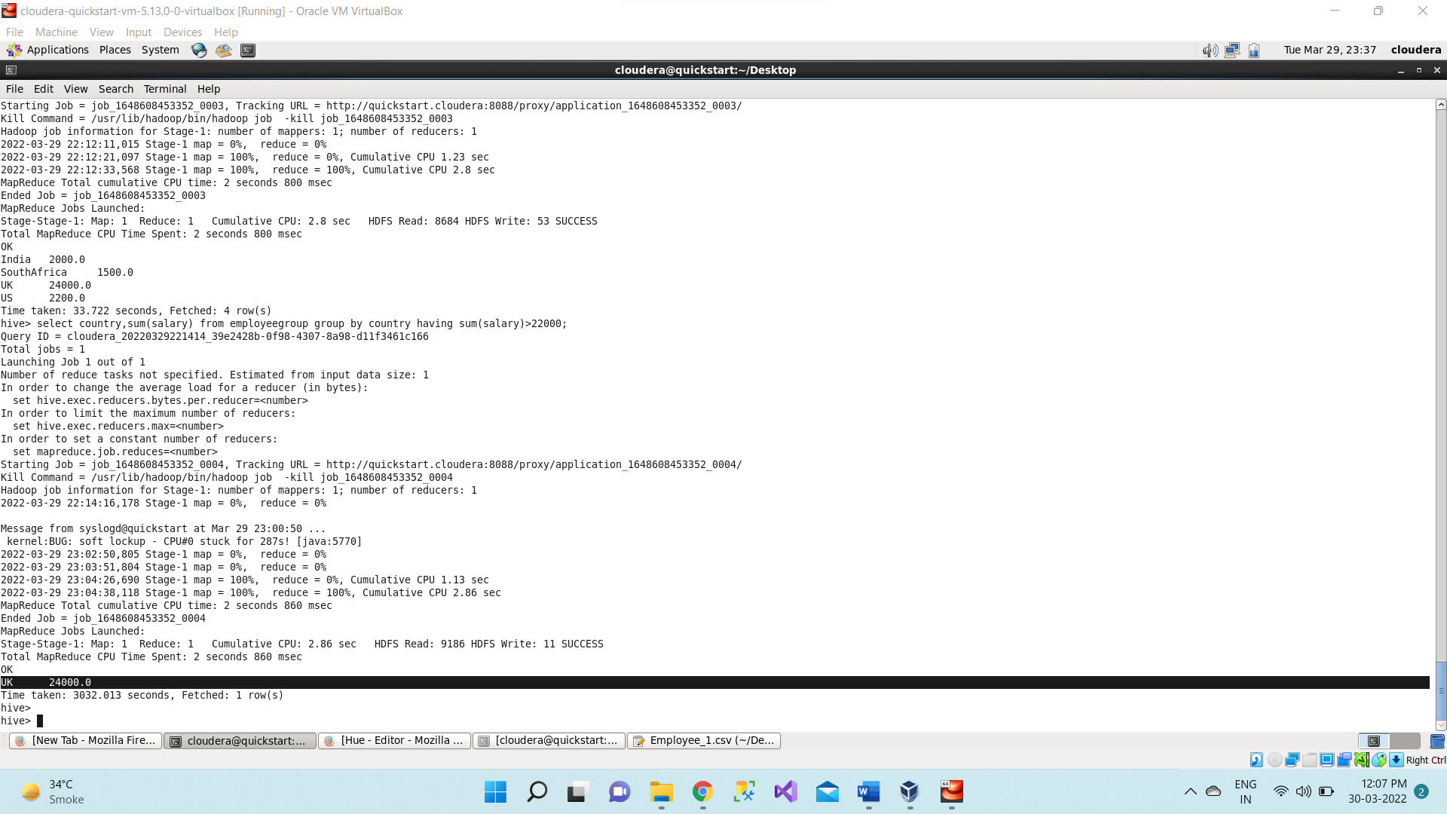

1. Now we are displaying the table by sorting the salary in descending order.

**select * from empgroup order by Salary desc;**

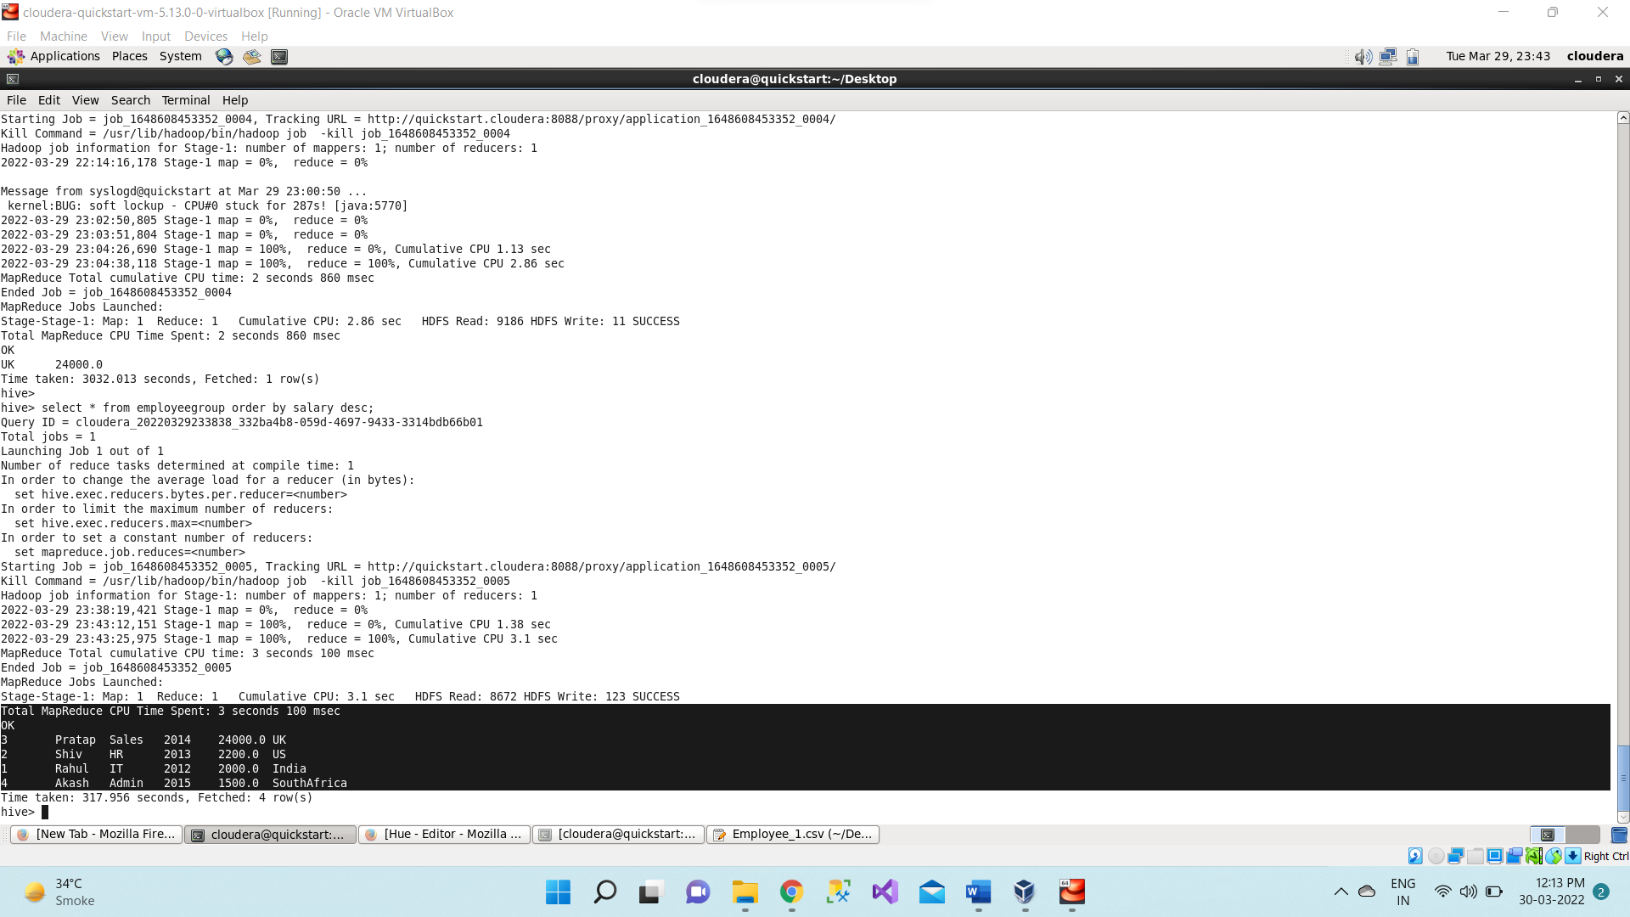

1. Now we are displaying the table by sorting the salary in descending order.

**select * from empgroup sort by Salary desc;**

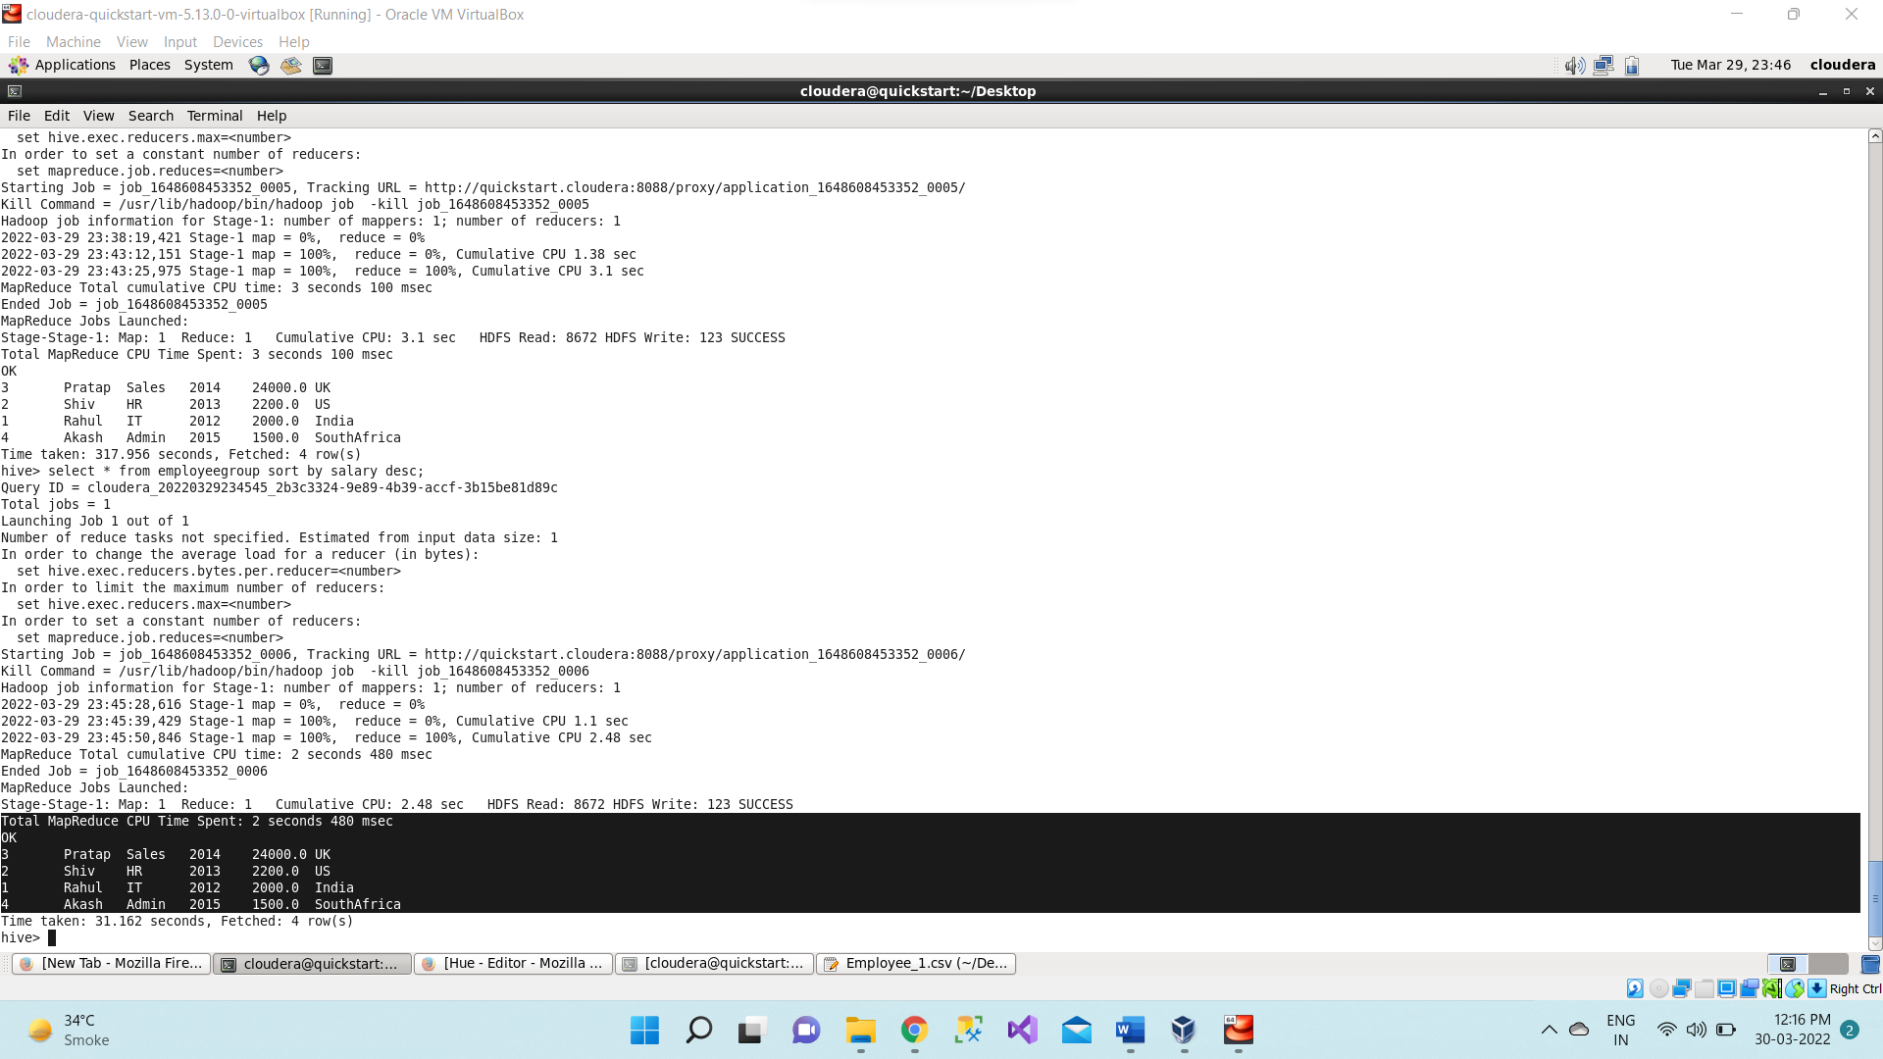

1. **Quit**

